# Game Design Document

## **Gravity Climb**

*TeamUp*

## Team Members

| **Name** | **Roles** | **E-mail & GitHub ID** |
| --- | --- | --- |
| *Utkarsha Mokashi* | *Team Captain, Level Design, Gameplay* | [*umokashi@usc.edu*](mailto:umokashi@usc.edu) *utkarshamokashi* |
| *Pranav Kolhe* | *Product Manager, Level Design, Gameplay* | [*pkolhe@usc.edu*](mailto:pkolhe@usc.edu)  *pranavko12* |
| *Shalini Sai Prasad* | *Stenographer, Physics, Gameplay* | [*saiprasa@usc.edu*](mailto:saiprasa@usc.edu)  *ShaliniSP* |
| *Aayan Shahnawaz Khan* | *Systems, UI Designer, Mechanic Designer* | [*aayansha@usc.edu*](mailto:aayansha@usc.edu) *aayan107* |
| *Yong-Han Chen* | *Physics, Gameplay, Mechanic Designer, Analytics* | [*yonghanc@usc.edu*](mailto:Email3@usc.edu) *YongHanChen* |
| *Augusto Rivas Costante* | *Mechanic Designer, Level Design, Gameplay* | [*rivascos@usc.edu*](mailto:rivascos@usc.edu) *arivas191* |

*Reference:* [*Roles & Role Resources*](https://docs.google.com/spreadsheets/d/1-jlsUV-nnvIsoDE0DU-hH7dpB0CvvQ_cN6vjL_bm-DA/edit#gid=0)

## 

## Important References

| GitHub Repository for GitHub Pages Host | [*Github IO Repo*](https://github.com/arivas191/GravityClimb) |
| --- | --- |
| Unity Project GitHub Repository | *GitHub* [*Classroom Repo*](https://github.com/CSCI-526/fall-2024-project-tuesday-teamupp) |
| Playable Alpha Progress Check Build | [*WebGL Build*](https://arivas191.github.io/GravityClimb/WebGL%20Builds/20241014/index.html) |
| Playable Alpha Build | [*WebGL Build*](https://arivas191.github.io/GravityClimb/WebGL%20Builds/20241021/) |
| Alpha Gameplay Video | [*Video link*](https://youtu.be/h6-CZBL0WSM?si=DP5mO2rQ7rJ1PVDl) |
| Alpha Survey | [*TeamUp - Alpha Prototype Feedback Form Template (Responses)*](https://docs.google.com/spreadsheets/d/1Fv83VdDGHE-pmnK7xTsNDtyvUjXTa_5gsHFe_kuneNk/edit?gid=826407174#gid=826407174) |
| Playable Beta Progress Check Build | [*WebGL Build*](https://arivas191.github.io/GravityClimb/WebGL%20Builds/20241104/index.html) |
| Playable Beta Build | [*WebGL Build*](https://arivas191.github.io/GravityClimb/WebGL%20Builds/20241112.2/index.html) |
| Beta Gameplay Video | [*Video link*](https://youtu.be/FF5-baKBPV0?si=oLhDyS_qY-Fmdk93) |
| Beta Survey | [*TeamUp - Beta Prototype Feedback Form (Responses)*](https://docs.google.com/spreadsheets/d/1CztO6hUorgWKiKRYvl5ZQMw_uUjK8W15YZ3a1jaO_LY/edit?usp=sharing) |
| Playable Gold Progress Check Build | [*WebGL Build*](https://arivas191.github.io/GravityClimb/WebGL%20Builds/20241125.2/index.html) |
| Playable Gold Build | [*WebGL Build*](https://arivas191.github.io/GravityClimb/WebGL%20Builds/20241202/index.html) |
| Gold Gameplay Video | [*Video link*](https://www.youtube.com/watch?v=43xuLUkcn7Y) |

# 

# 

# Game Introduction

## **Logline**

A 2D platformer game where you move and navigate through various platforms to ascend through levels as the camera and gravity rotate with your movement.

## **Player Goals / Win Conditions**

Collect all the stars and reach the flag without falling off the map.

## **Game Description**

Gravity Climb is an engaging 2D platformer where the angle and force of gravity along with the platforms themselves shift dynamically in response to the player’s movements. The primary objective for the player is to skillfully navigate either vertically or horizontally collecting stars through increasingly challenging environments to ultimately reach the top of the level and capture the flag. Along the way, the player will need to think strategically as they move left and right, collecting valuable power-ups that enhance their abilities, and occasionally dodging enemies scattered throughout the map. As an added challenge, the level continuously rotates in sync with the direction of the player’s movement, creating a heightened sense of urgency and tension. If the player misses a platform, they run the risk of falling off the map, adding a layer of difficulty that requires precise timing and careful planning to overcome.

## **Controls**

Movement: left and right arrow keys / A and D keys

Jump: Spacebar

Freeze Power Up: E key

# 

# Detailed Design

## **Game Mechanics (How to Play)**

* Movement: Use the left/right keys or A/D keys to move the player and consequently rotate the map
* Platforms: In our game, the platforms are also a mechanic because there are various types of platforms that the player can use to reach the goal. The different types of platforms are:
  + Anti-rotate platforms: rotate in the opposite direction to the map rotation.
  + Elevator platforms: lift the player upwards in the map.
  + Stabilizer platforms: stabilize the map’s rotation.
  + Auto-jump platforms: launch the player as soon as they land on it, which can be both antagonistic or a supporting mechanic.
  + Breaking platforms: begin shaking as soon as the player lands on it and breaks shortly afterward.
  + Size-changing platforms: change size from large to small and vice versa in a loop.
* Power-ups (Diamond Shaped Collectibles):
  + Freeze power-up pauses the rotation for some time, using the E key to activate it.
  + The shield power-up protects the player from enemy bullets and activates instantly.
* Bullets: The bullets from the enemies are an antagonistic mechanic that will push the player off their course. This creates an added challenge for the player to rotate/move and avoid the bullets while navigating the map.

## **Game Mechanic Research**

*<Rolling/Movement> Aayan Shahnawaz Khan*

| **Game Title** | *Bounce* |
| --- | --- |
| **Mechanic/System** | *Rolling/Movement* |
| **Interest** | *This mechanic is interesting as it combines easy controls with complex interactions. The ball’s rolling nature creates a rhythmic, pleasant motion that calls for skillful timing to master. The mechanic provides layers of mission by requiring players to manage the height and distance of their rolls while thinking about environmental hazards. It additionally adds versatility to degree layout, allowing developers to create intricate platforming puzzles and varied gameplay scenarios.* |
| **Interaction with other mechanics** | *The rolling mechanic in "Bounce" interacts with gravity, influencing the ball's speed and movement. Players must control their momentum when navigating platforms and avoiding obstacles like pits and spikes. Rolling also helps in collecting items placed along the levels. Proper control of rolling is crucial for progressing through the game. Overall, it affects both movement and level completion.* |
| **Utility** | *The central character in our game is a ball, chosen specifically because it allows us to incorporate the rolling aspect, which aligns seamlessly with the game's core gravity rotation*  *mechanic.* |

*<Rotation> Utkarsha Mokashi*

| **Game Title** | *FEZ* |
| --- | --- |
| **Mechanic/System** | *Rotation* |
| **Interest** | *The rotation mechanic transforms gameplay by introducing a sense of spatial awareness and depth perception. It encourages players to think outside the box, as the rotation angle changes. This mechanic fosters a unique sense of discovery and curiosity while playing.* |
| **Interaction with other mechanics** | *The rotation mechanic enhances the FEZ game's puzzle design, allowing for intricate challenges that require players to shift their perspectives to solve them. It interacts with platforming elements by changing the layout of obstacles, which can lead to new routes or hidden areas. Additionally, this mechanic adds an extra layer of engagement to the narrative, as players may uncover lore or contextual clues by rotating the environment, enriching the overall storytelling experience.* |
| **Utility** | *We are utilizing rotation mechanics to shift the player's perspective within a 2D world, where the level dynamically rotates in response to the player's movements. This innovative approach challenges players to navigate platforms in a more complex manner, requiring them to think critically about their paths. Players must strategize not only how to traverse platforms but also how to control the rotation effectively, adding depth to the gameplay and enhancing their overall experience.* |

*<Freeze> Augusto Rivas Costante*

| **Game Title** | *Fruit Ninja* |
| --- | --- |
| **Mechanic/System** | *Freeze* |
| **Interest** | *This mechanic provides the player with a window of time to maximize their actions and make precise moves. It changes the strategy taken by the player by allowing more deliberate decision-making during the duration of the mechanic.* |
| **Interaction with other mechanics** | *The freezing mechanic allows players to chain combos and score higher points by temporarily freezing the time and slowing down the speed at which the fruits come. This enables them to slice more fruits while avoiding any bombs that might appear.* |
| **Utility** | *We can use a similar freezing mechanic in our game by creating a power-up that the player can collect to temporarily freeze the rotation of the map. When the rotation is frozen, this gives a window of time for the player to traverse the map freely without worrying about gravitational and rotational changes.* |

*<Shield> Pranav Kolhe*

| **Game Title** | *Apex Legends* |
| --- | --- |
| **Mechanic/System** | *Shield* |
| **Interest** | *The Dome shield or Bubble shield mechanic in the Apex Legends game has a cooldown and can be used multiple times throughout a match. When activated, it creates a large, dome-shaped energy shield that blocks all incoming and outgoing fire. It lasts for 12 seconds. I find this interesting as it protects the player from the bullets that are being shot at him by the enemies for a few seconds, making it easier for the player to think about his next step and navigate the map* |
| **Interaction with other mechanics** | *This power-up interacts with the antagonistic bullet mechanic as the bullets no longer push the enemy. They are just destroyed as soon as they touch the player when the shield is activated.* |
| **Utility** | *We use a similar mechanism where if the shield power-up is collected, the player turns blue for 10 seconds and is protected from all the incoming bullets from the enemy.* |

*<Bullets/Displacers> Yong-Han Chen*

| **Game Title** | *Fall Guys* |
| --- | --- |
| **Mechanic/System** | *Fruits/Displacers* |
| **Interest** | *In the Fruit Chute minigame in Fall Guys, the fruits roll toward the players making the game more unpredictable because the player has to move quickly and avoid the fruits moving toward them to not get displaced* |
| **Interaction with other mechanics** | *The mechanic interacts with jumping and movement by taking precedence over them and creating an opposing force that will throw a player off course* |
| **Utility** | *We can use a similar concept with bullets instead of fruits as an antagonistic mechanic that can hit a player and displace the player in the direction of the bullet.* |

*<Magnets> Shalini Sai Prasad*

| **Game Title** | *Legend of Zelda: Four Swords Anniversary Edition* |
| --- | --- |
| **Mechanic/System** | *Magnets* |
| **Interest** | *The magnets help a player stick to a specific type of platform thus stabilizing a player and preventing them from falling* |
| **Interaction with other mechanics** | *In this version of Zelda, the player can collect magnetic gloves that can be activated once they are worn. This glove helps the player cross platforms and solve puzzles by attracting/repelling the player. The player can use this to stick to a specific type of platform and not fall down/off the map.* |
| **Utility** | *We can use a similar mechanic in the form of a collectible power-up that can be activated by the player once collected. This power-up will allow a player to stick to a platform while it is rotating to not fall off the map and stabilize themselves before jumping to the next platform.* |

*Reference:* [Example Mechanic Research](https://docs.google.com/document/d/15DhgDN6HW-ZC4Zmf2kwoQFDmAmgFuIlG9g4GahNUNZI/edit?usp=sharing)

## **Matrices**

### **Twist & Mechanics Matrix**

| **Mechanics** | **Description** | **Interaction with Twist** | **Affected Genre Elements** | **Supports** |
| --- | --- | --- | --- | --- |
| Rotation (Core Mechanic) | The map rotates in the direction in which the player moves. | If the player moves towards the right, the level rotates in a clockwise direction and vice versa. | Platforms, player, map, gravity | - |
| Rolling | The player can move by rolling using the arrow/a and d keys respectively. | As you move, the map and platforms rotate with you. | Platforms, player, gravity | - |
| Platforms | When the player moves using the arrow keys, the platforms also rotate. The platforms also have different types that can be supporting mechanics or antagonistic depending on the rotation angle. | Some platforms rotate based on the direction of the map and the player's movement. Some platforms launch the player against gravity while others allow the player to stabilize during rotation | Player | - |
| Freeze Rotation | This is a supporting mechanic that the player can collect. It can be activated by the player at any point by using the key E. | This freezes the screen at a particular rotation angle when you activate it. | Platforms | Freeze Power-up |
| Bullets | This is an antagonistic mechanic that is being provided by the enemies. | The bullets will displace the player in the direction of the bullet, influenced by the angle of the rotation. | Player | Enemy |

### **Mechanic Interaction Matrix**

| **Subject / Object** | **Player movement** | **Rotation** | **Platform** | **Bullets** | **Freeze Power-up** | **Shield** | **Star** |
| --- | --- | --- | --- | --- | --- | --- | --- |
| **Player movement (Rolling and Jumping)** | - |  |  |  |  |  |  |
| **Rotation** | As the player moves the level rotates in that direction | - |  |  |  |  |  |
| **Platform** | Some specific platforms will move the player upward, left, or right, or make the player jump automatically | The anti rotate platforms rotate in the opposite direction of the level rotation. |  |  |  |  |  |
| **Bullets** | The bullets will displace the player in the direction of the bullet | - | The bullets are absorbed when they hit a platform |  |  |  |  |
| **Freeze Power Up** | The player collects this power-up allowing them to move without being affected by rotation | This freezes the rotation of the level. | The platforms stop rotating when this power-up is activated |  |  |  |  |
| **Shield** | The player collects this power up to defend themselves from the enemies’ bullets | - | - | The shield makes the player immune to the bullets and remains up for 10 seconds |  |  |  |
| **Star** | The player has to collect all the stars. And once all the stars within that level are collected, the portal is activated. |  |  |  |  |  |  |

### **Single Mechanic Challenge Matrix (Beta)**

| **Challenge** | **Location** | **Difficulty** | **Player Must Learn** | **Instructions** | **Required Skills** |
| --- | --- | --- | --- | --- | --- |
| Movement (Rolling/Rotation) | Tutorial Move | Tutorial | How to move and rotate the level. | Intuitive with visual elements. | None |
| Movement (Jumping) | Tutorial Jump | Tutorial | The player learns the spacebar control for jump. | Explicit pop-up text. | None |
| Star collection and Portal navigation | Tutorial Portal | Tutorial | How to collect stars to activate and navigate through portals. | The Portal is disabled until stars are collected.  Explicit pop-up text. | None |
| Bounce Platform | Tutorial  Bouncy | Tutorial | The player learns how to leverage the bounce platform to jump higher | The arrow guides the player to use the yellow platform | None |
| Bullet dodging | Tutorial enemy | Tutorial | How to dodge the enemy bullets to not fall off the map | Explicit pop-up text. | Fundamental skills |
| Basic Platform traversal | Level 1 | Easy | How to leverage platforms to collect stars based on the map-rotation | None | Basics of moving, jumping, star portal navigation, and rotation |
| Freeze Rotation | Level 2 | Medium | How to use the freeze power-up | Explicit pop-up text | Adapting to new rotation mechanic |
| Shield | Level 3 | Easy | The player learns the functionality of the shield and how to time its collection | Explicit pop-up text | Basics of moving, jumping, and bullets |
| Breaking Platform | Level 4 | Medium | The player learns the functionality of the cyan platform and timing the jump | Intuitive with visual elements | Intermediate skills in rotation and jumping |
| Advanced Platform Traversal | Level 4 | Hard | How to leverage multiple platforms | None | Proficient |
| Leveraging Bullets | Level 4 | Hard | How to use the push from the bullets to propel the player in the direction of the goal | None | Proficient |

### 

### 

### 

### **Tutorialization implementation for Mechanics (Beta)**

We have created an optional tutorial level that players can easily access from the main menu screen to learn some basic mechanics:

* Tutorial Move: The player is given a singular challenge to reach the end of the puzzle by moving and rotating the level
* Tutorial Jump: The player learns that the spacebar controls the jump
* Tutorial Bouncy: The player learns how to leverage and use the bouncy platform to jump higher than normal.
* Tutorial Portal: The player learns how the portals work and that they can be used to reach the final goal
* Tutorial Enemy: The player learns how to either dodge enemy bullets to avoid being displaced or use the bullets to propel them in the direction of the goal

Info Text (Within Gameplay): Players can see the info text that pops up whenever a power-up is collected so that they can learn how and when to use that power-up

Tutorial 1 - Understanding how to move in the game

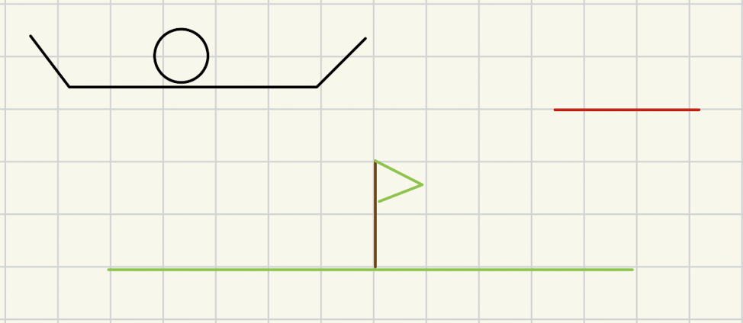

Tutorial 2 - Understanding how to jump within the game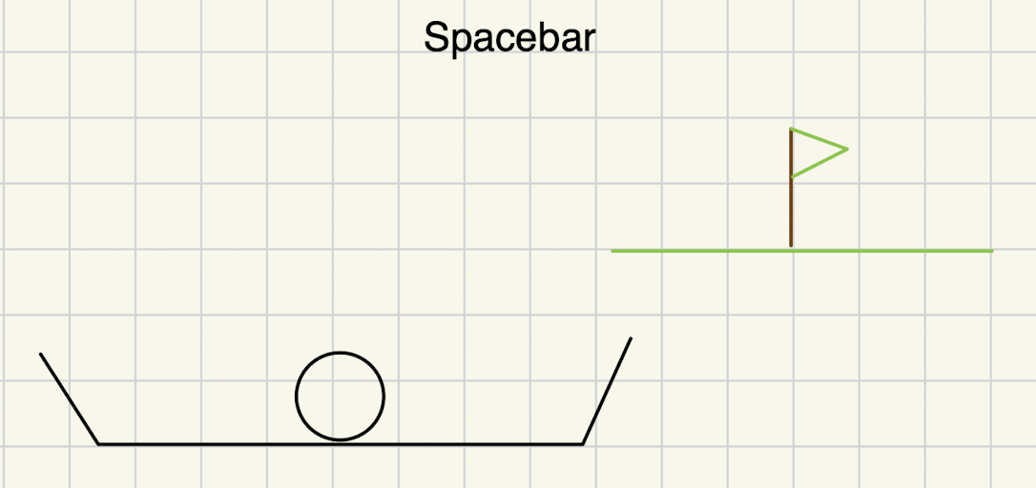

Tutorial 3 - Understanding how to use the bouncy platform

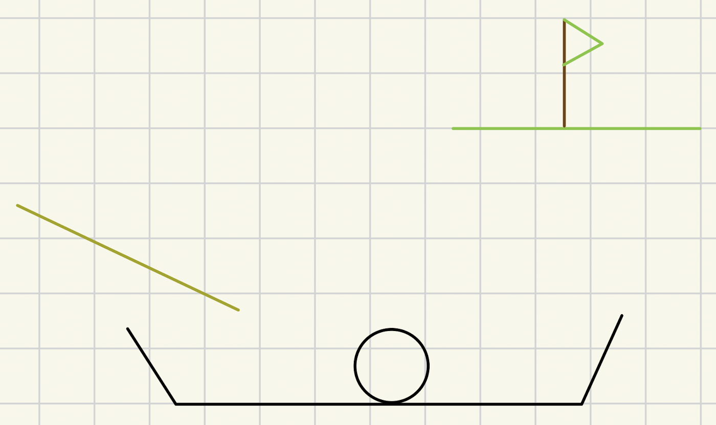

Tutorial 4 - Understanding how to collect stars and hence activate the portal

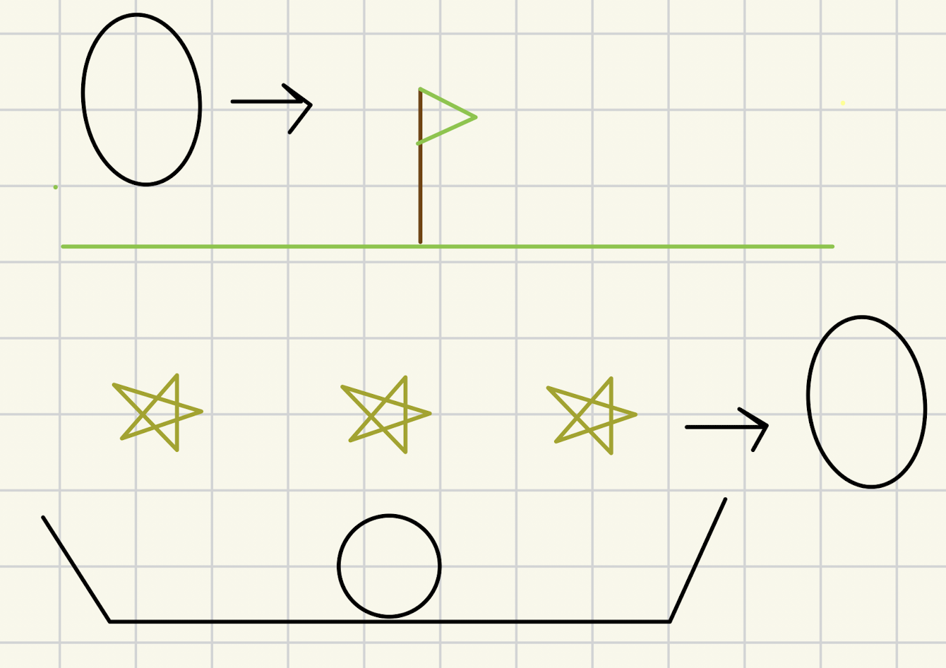

Tutorial 5 - Understanding how to dodge enemies

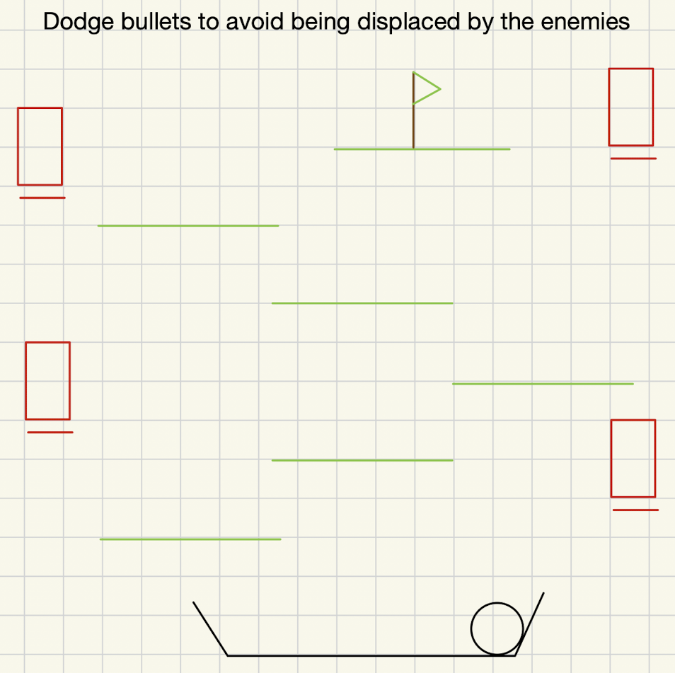

## **Sketches and Diagrams**

### **Gameplay Loop**

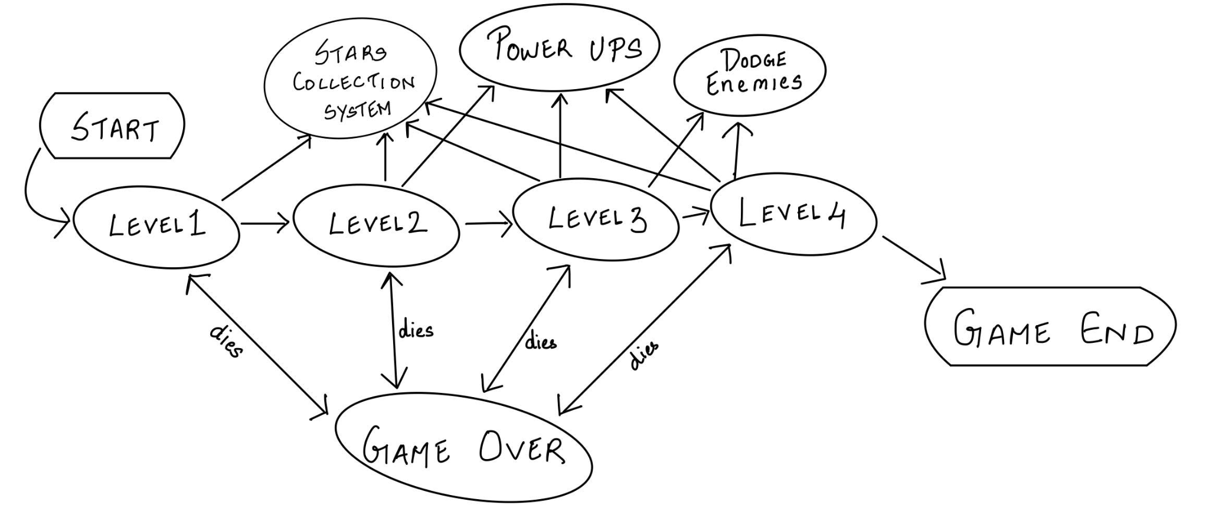

### **Level Designs**

Level 1 Example sketch:

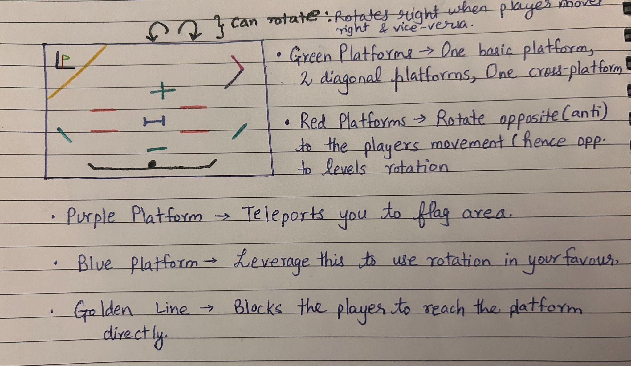

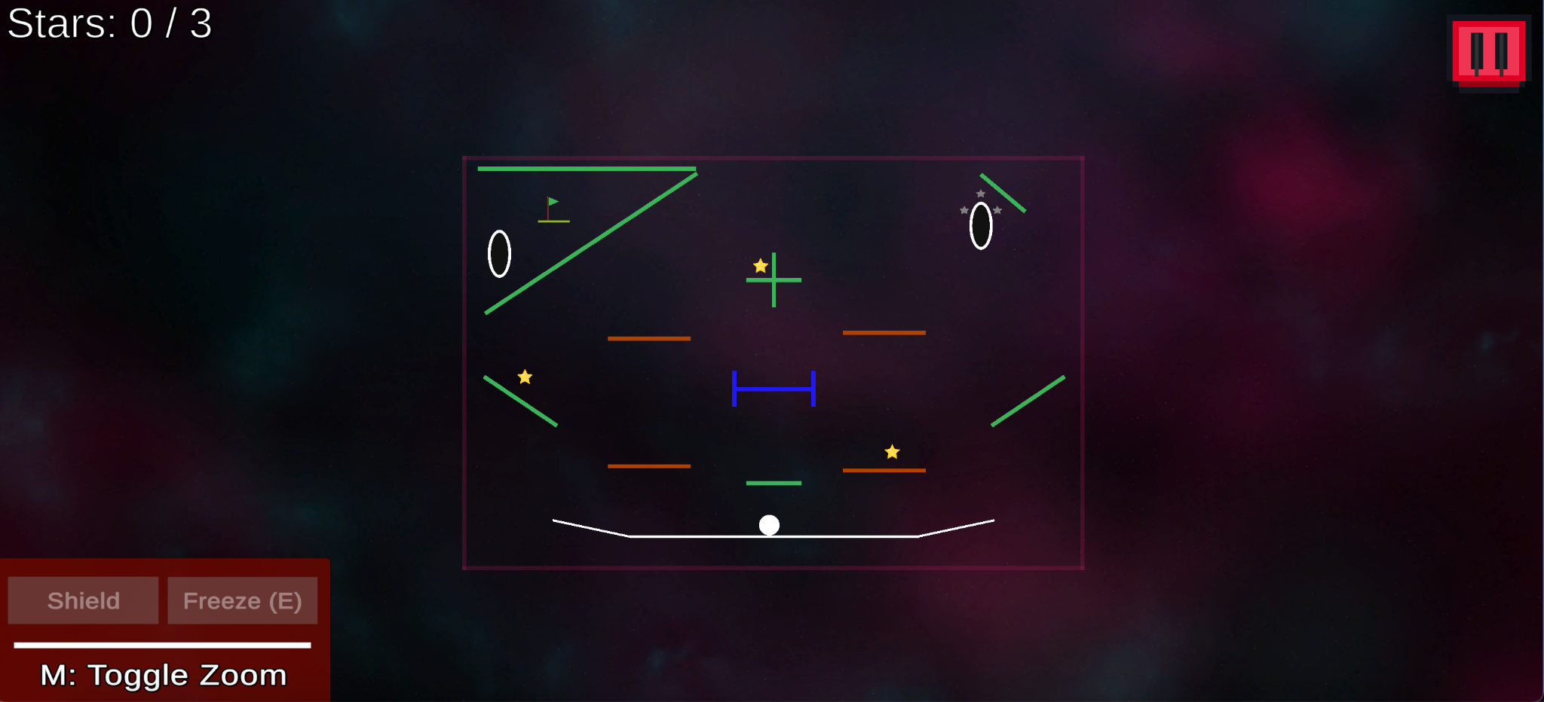

*This introductory level familiarizes players with core gameplay elements. Through basic platforms and straightforward objectives, players learn the mechanics of movement, rotation, and portals. The level hints at future challenges, setting the stage for more complex gameplay.*

Level 2 Example sketch:

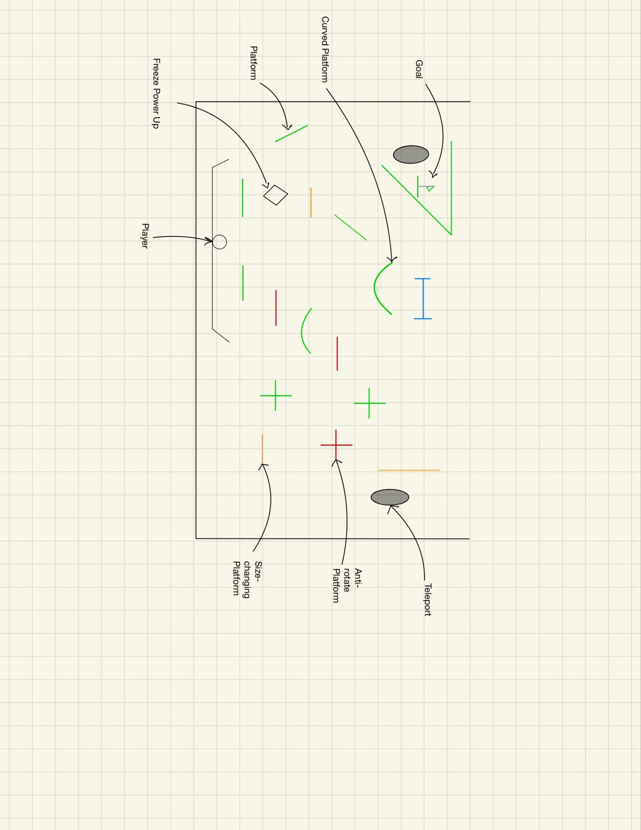

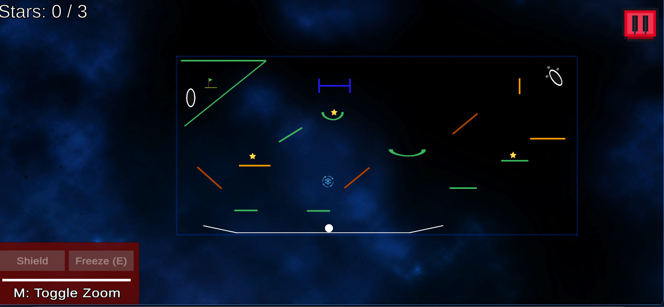

*Building on the fundamentals, this level introduces the Freeze Power-Up and resizing platforms. These elements encourage players to think strategically as they navigate more dynamic obstacles. It’s a gradual step up from Level 1, offering players a deeper understanding of power-ups and environmental challenges.*

Level 3 Example sketch:

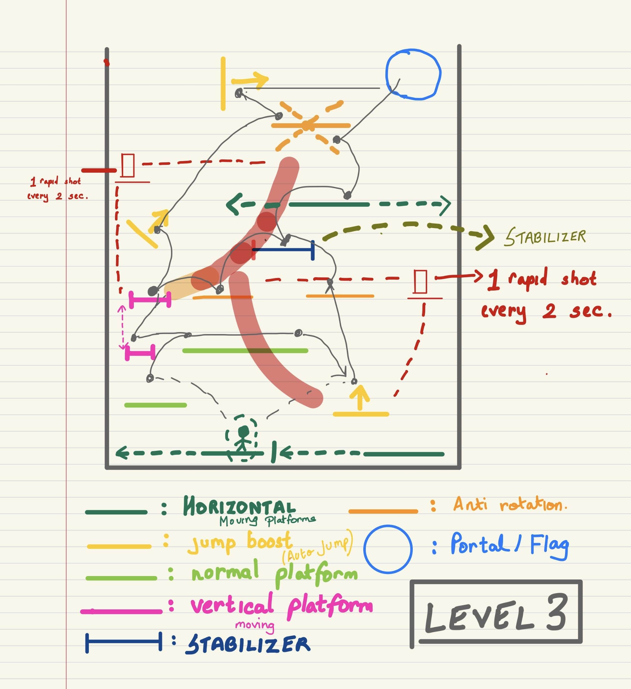

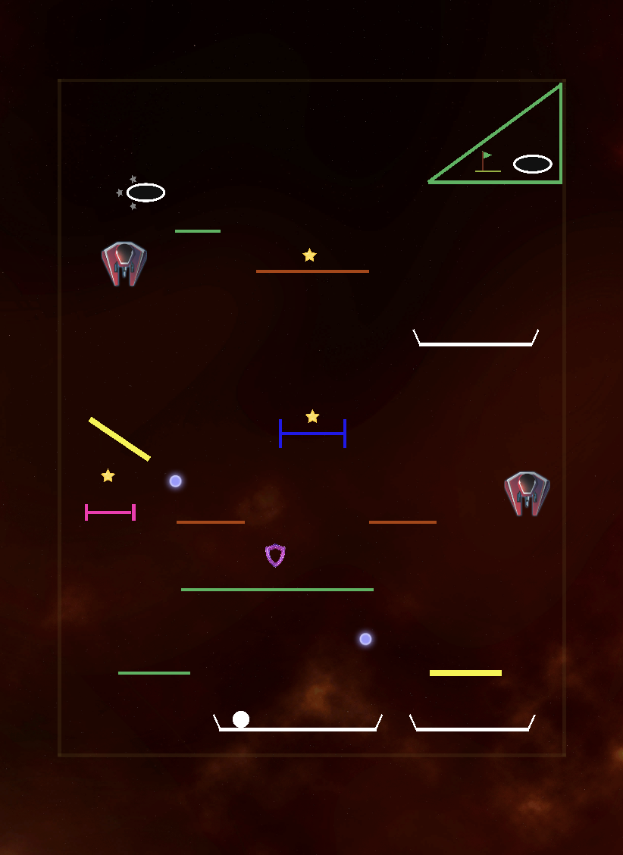

This critical level brings enemies and bullets into the game, creating a more intense atmosphere. To help players manage these new threats, the Shield Power-Up is introduced. Players also encounter varied platform types, such as moving platforms and auto-jump trampolines that launch them across gaps. The gameplay becomes more skill-intensive, encouraging quick reflexes and strategic power-up use.

*Level 4 Example sketch  
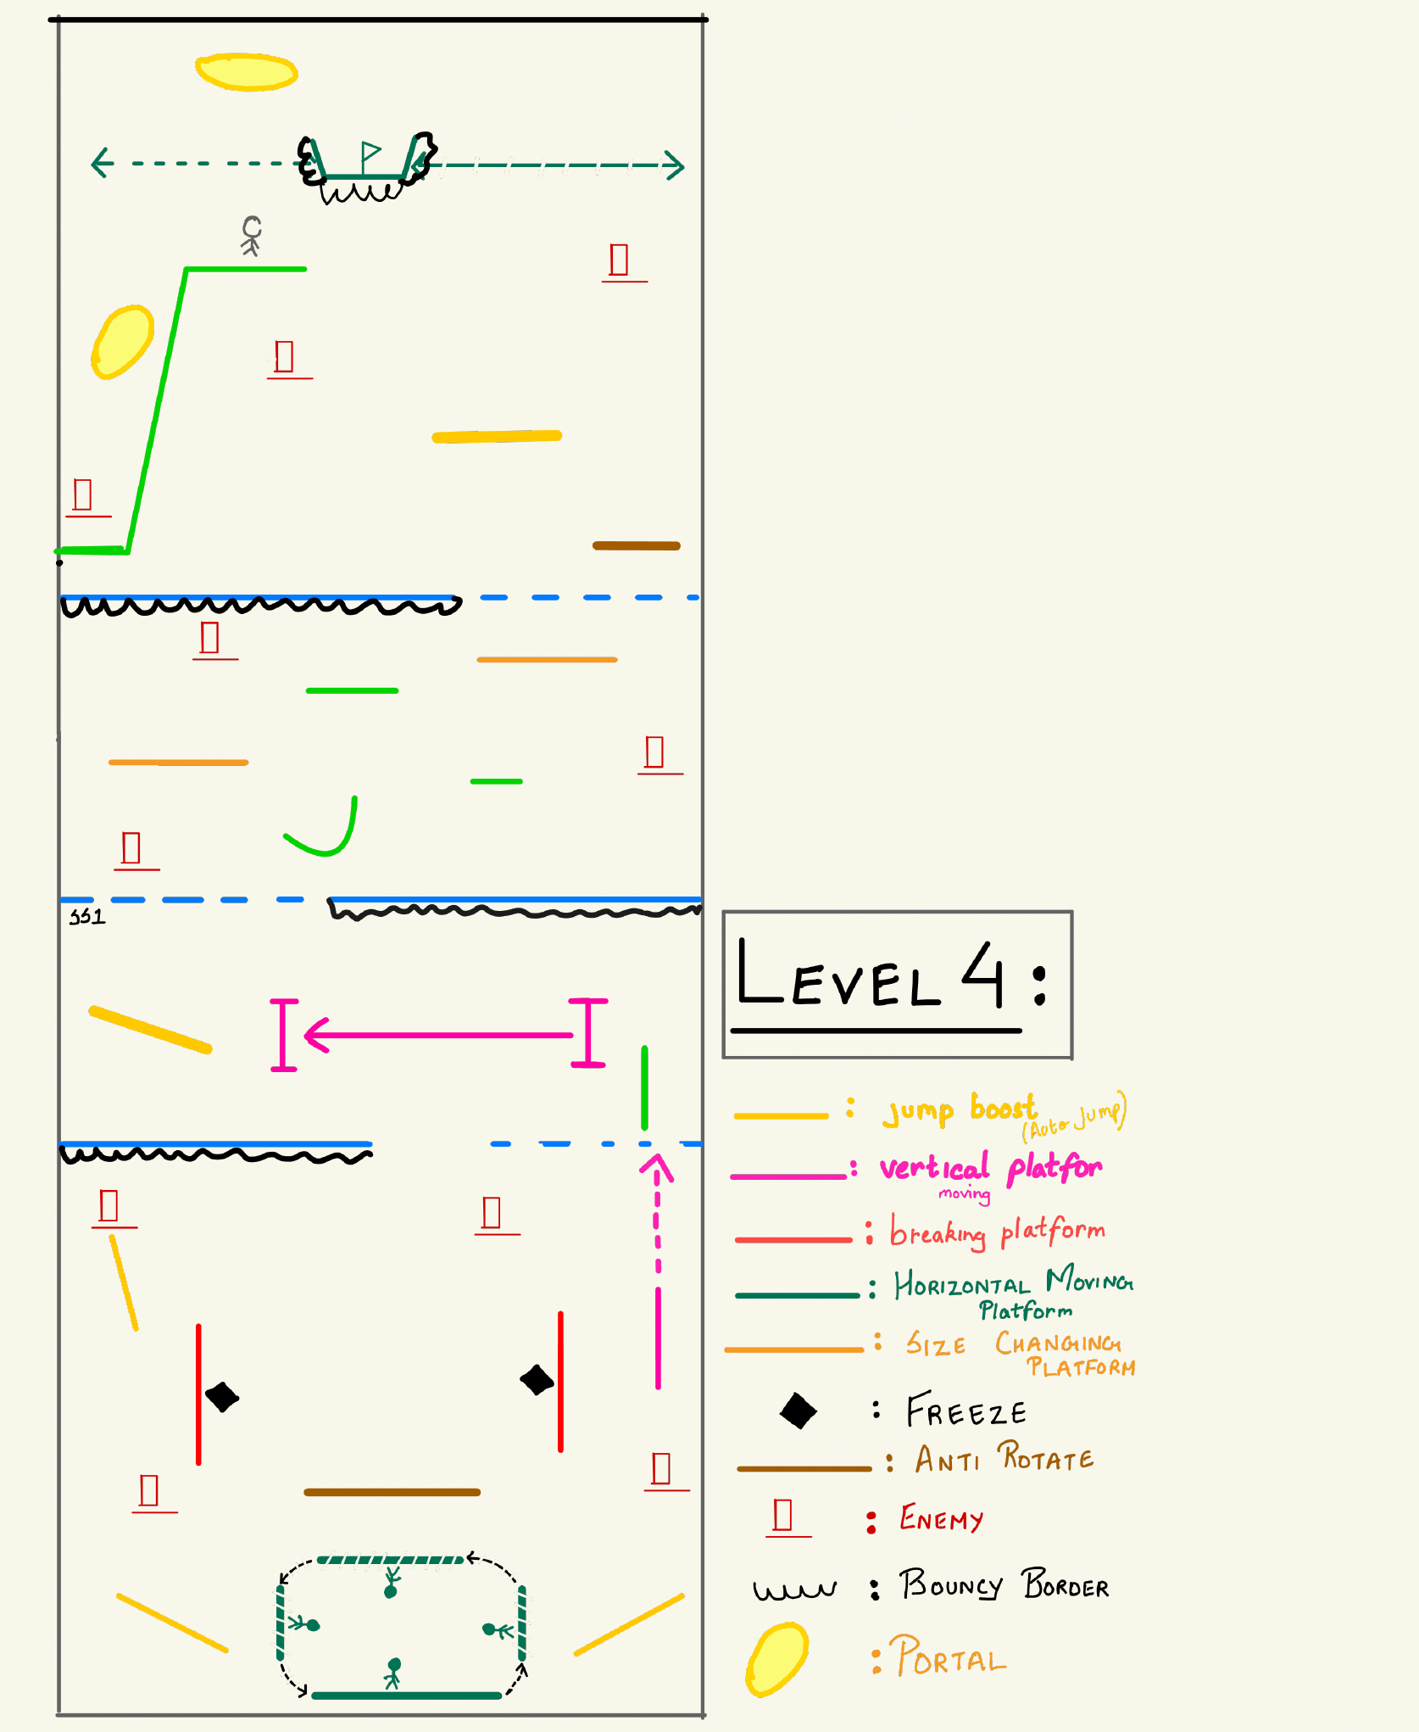*

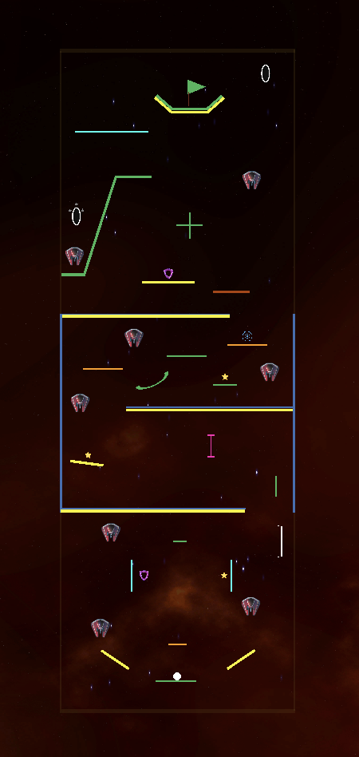

*In this fourth level, players face a mix of all previous elements: enemies, power-ups, and diverse platforms. New features include breaking platforms that require precise timing and checkpoints that demand well-timed jumps. This level combines all learned skills into a challenging and rewarding experience, culminating in an exciting test of player mastery.*

### **Mechanic/Level Sketches (Beta)**

Basic Sketch for Teleport redesign

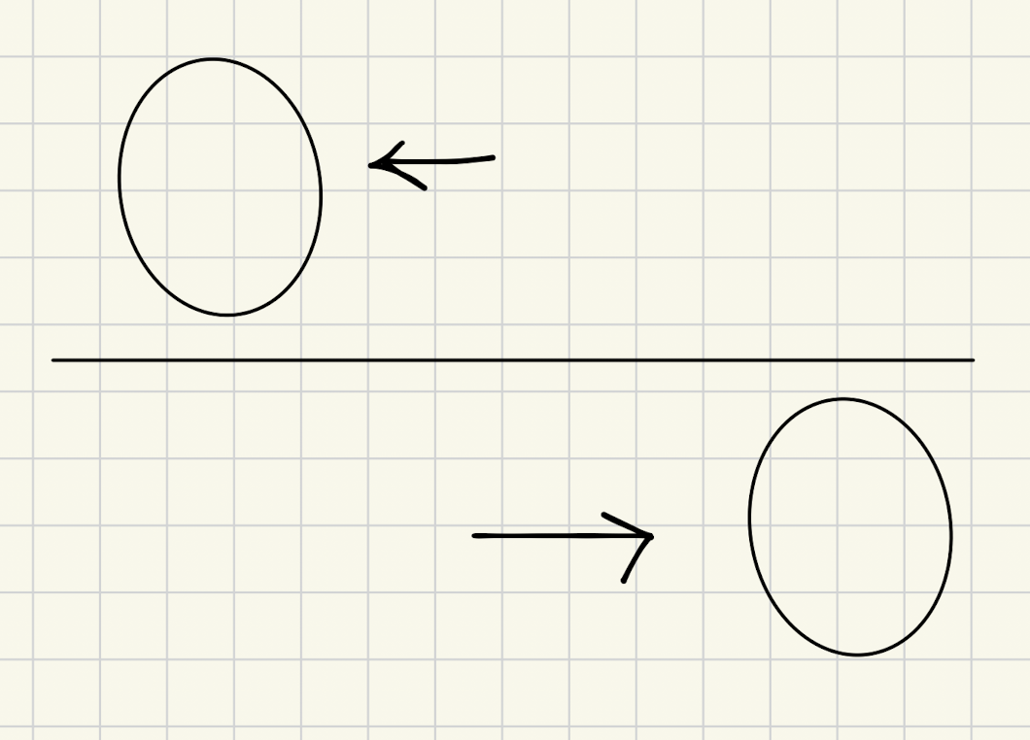

Size-changing platform

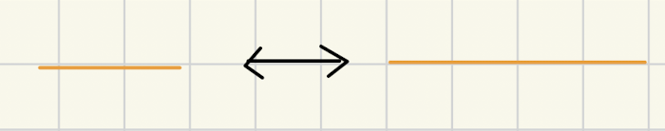

Breaking platform

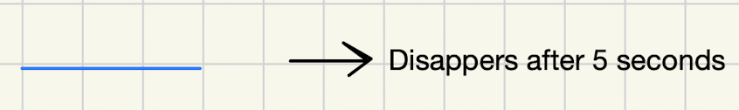

Anti-rotate platform

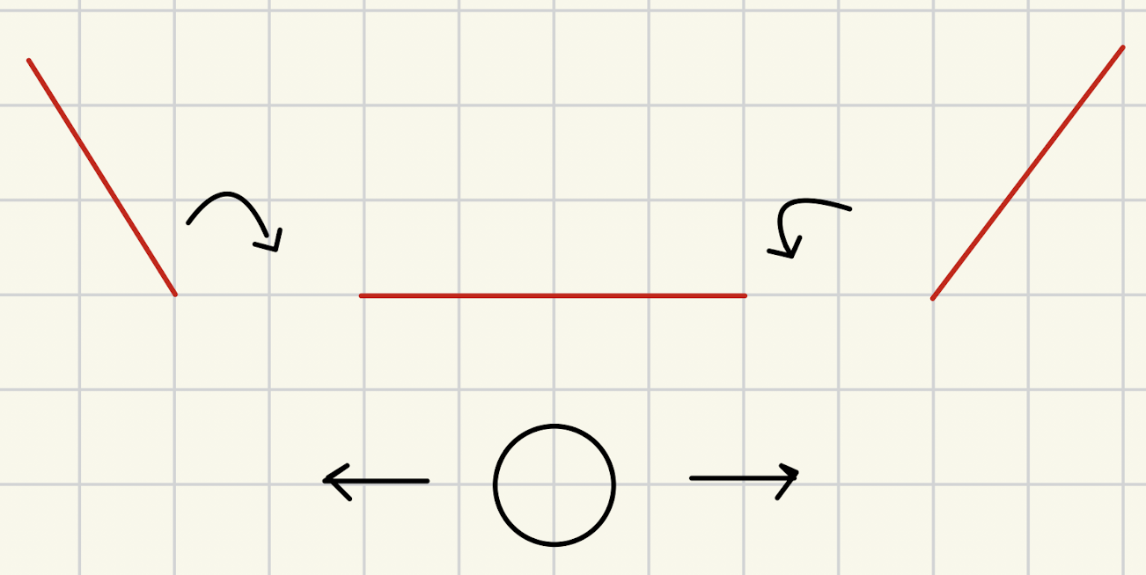

Freeze power-up

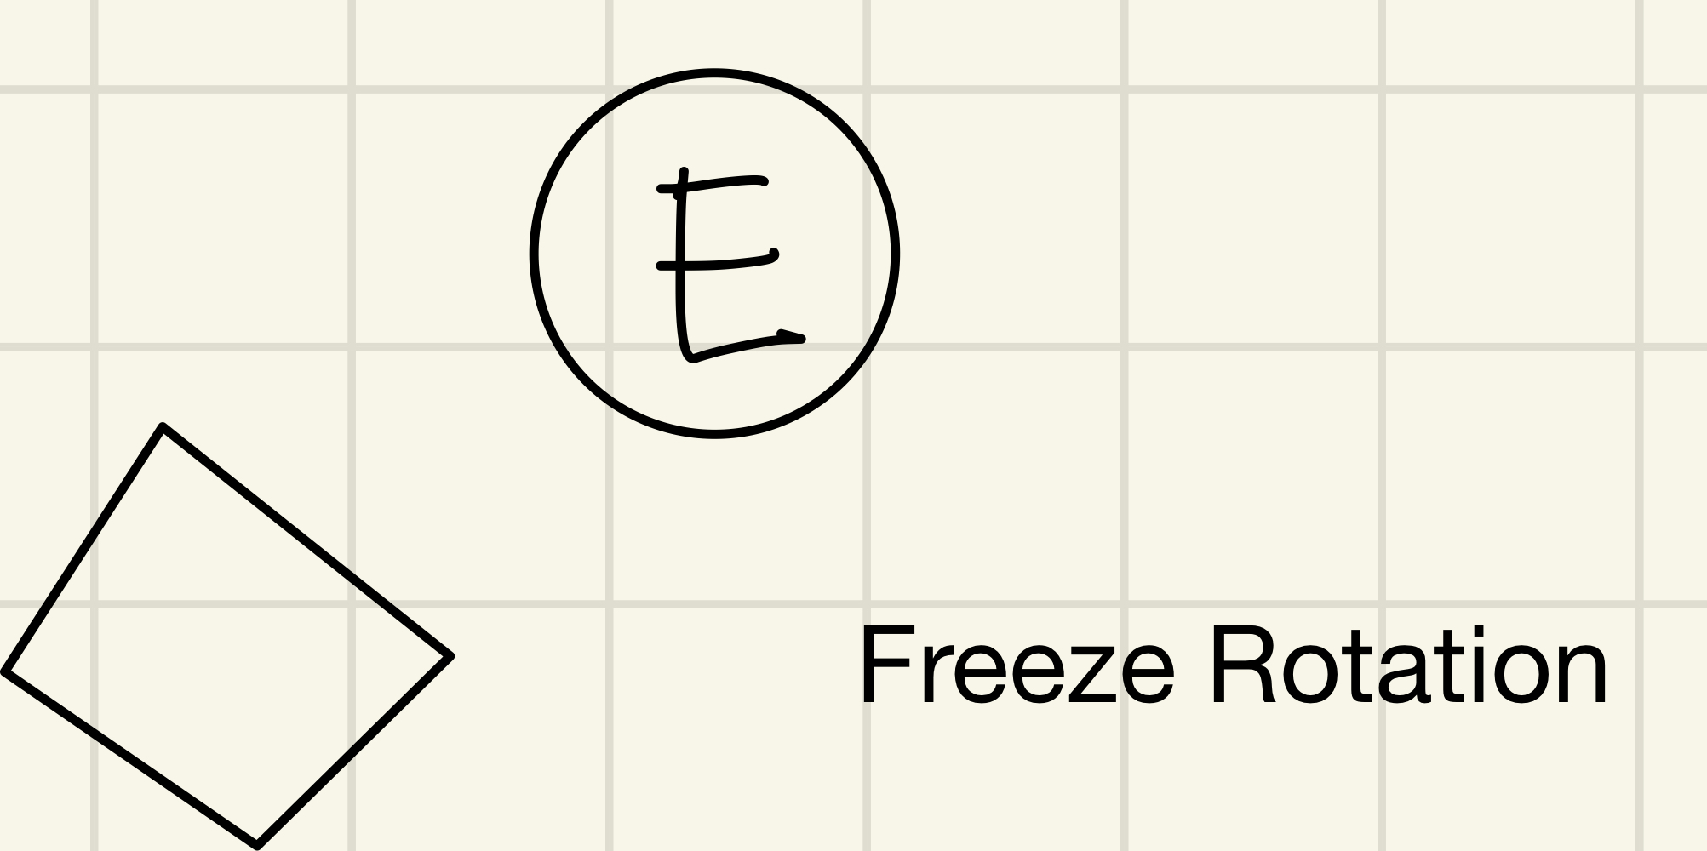

Shield collectible

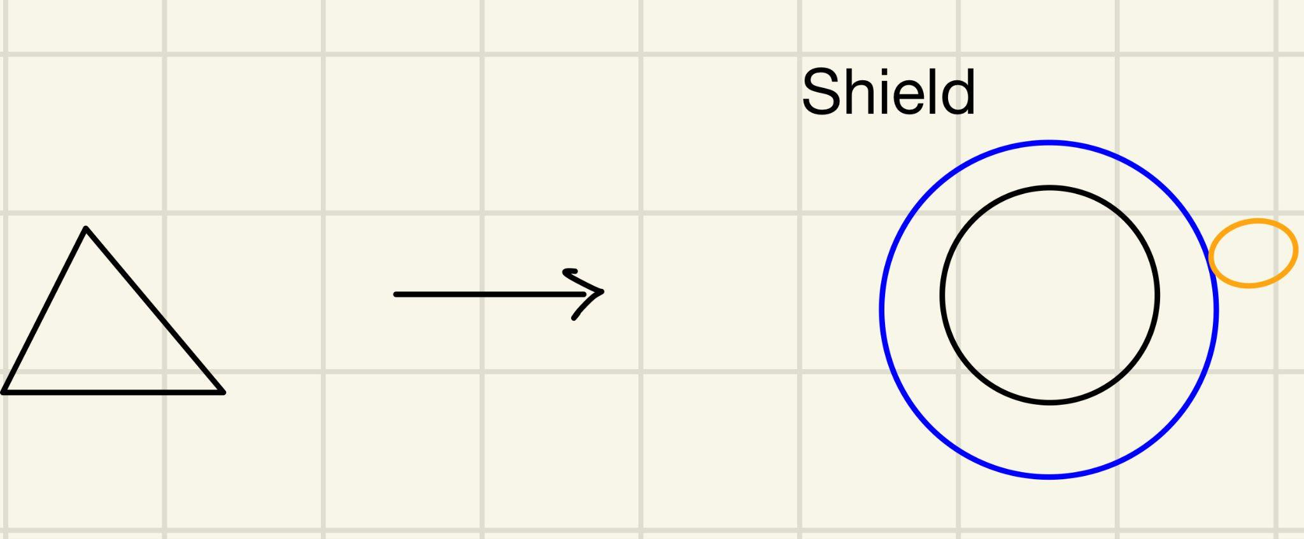

Enemy/Bullets

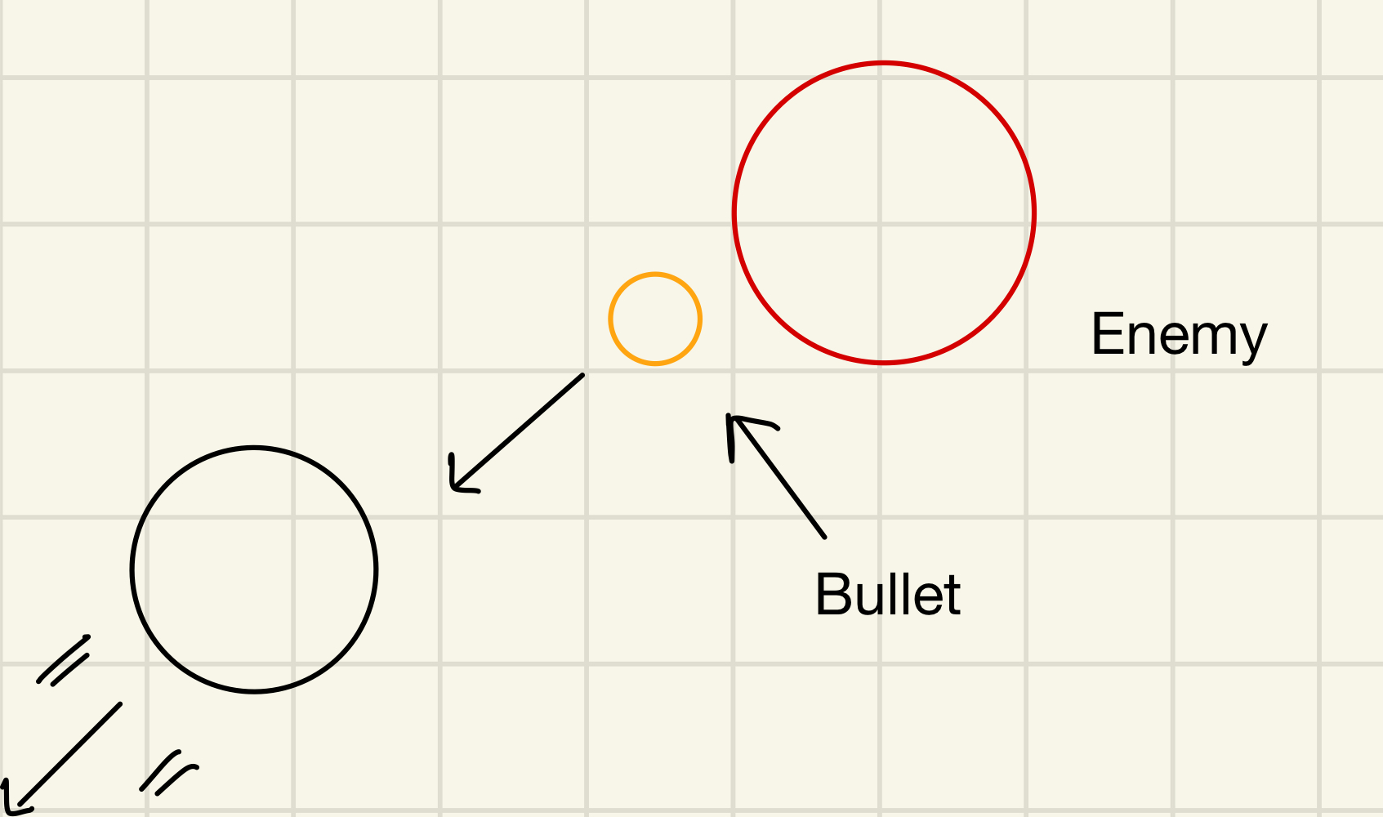

Auto-jump platform

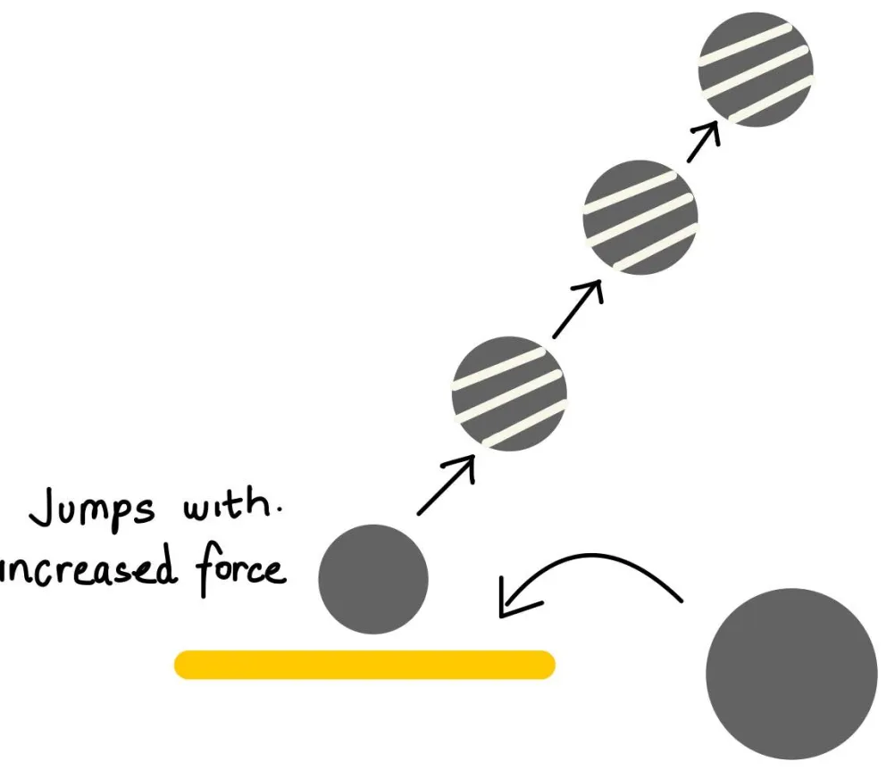

Elevator Platform

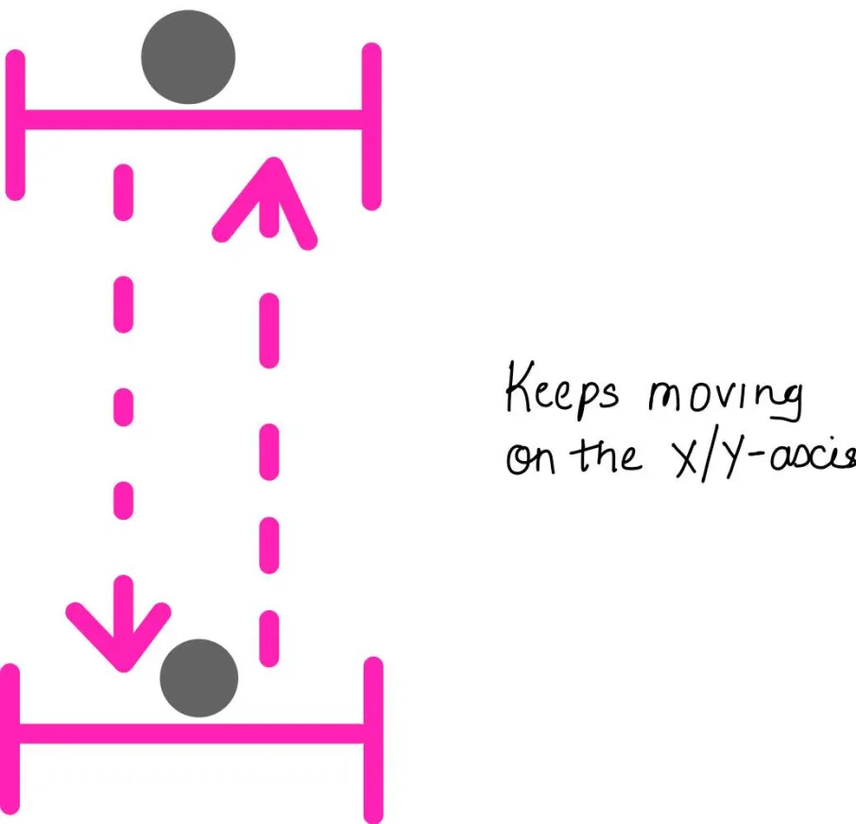

Stars which are required to be collected for activating the portal

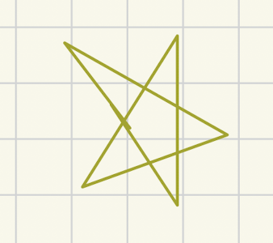

## 

## 

## **Game UI - (Beta)**

### **Menus**

*Start Screen*

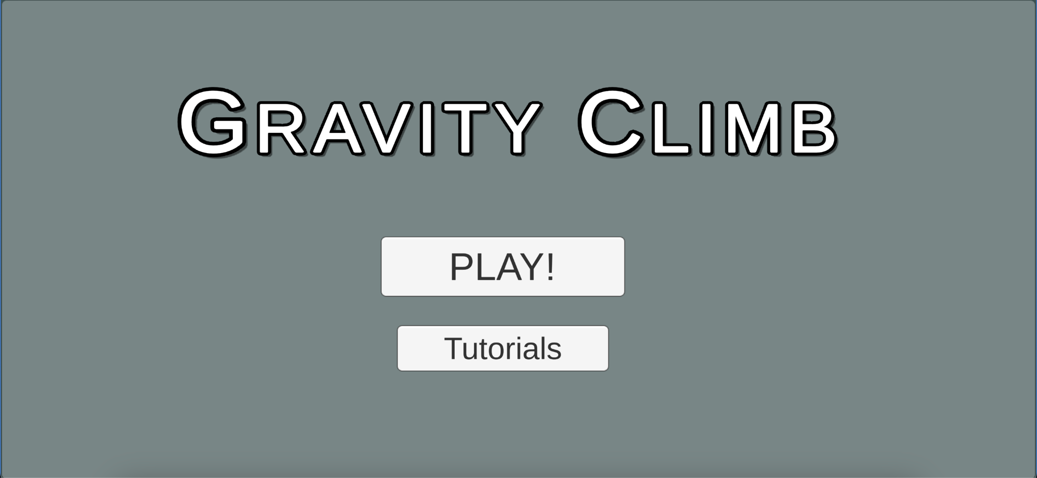

*Level Selection Screen*

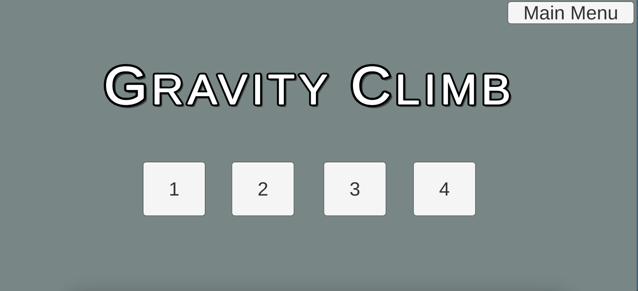

*Tutorial Selection Screen*

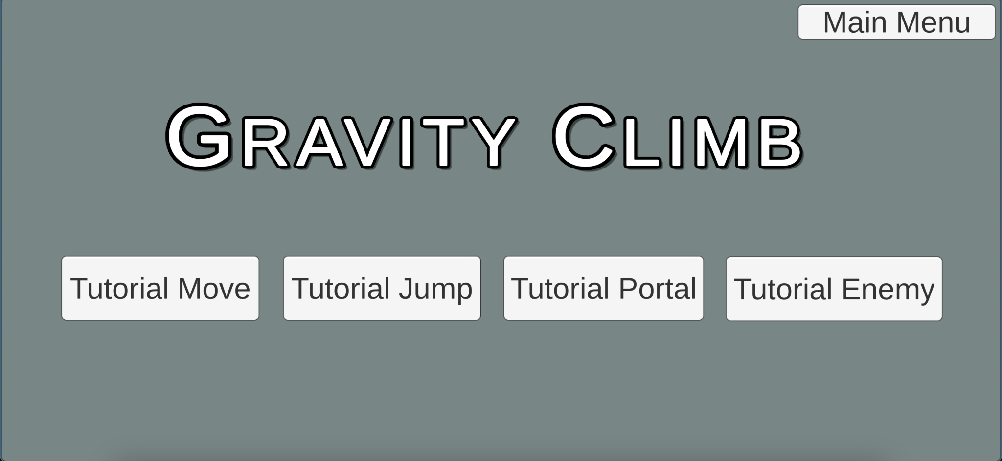

### **HUD**

*HUD Interface*

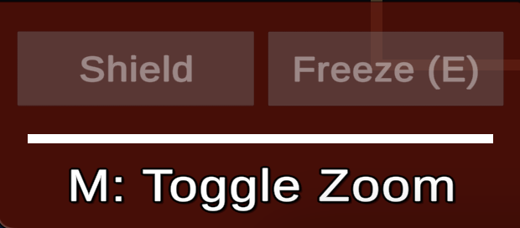

*HUD with freeze power-up activated*

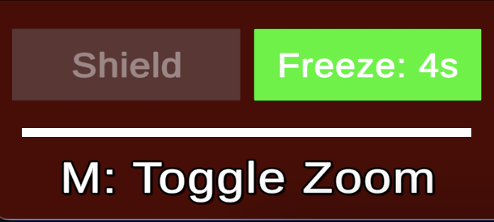

*HUD with shield power-up activated*

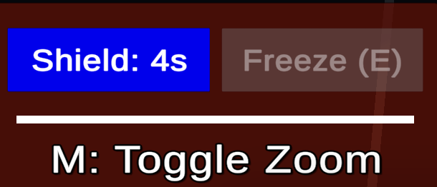

*UI Screens flow*

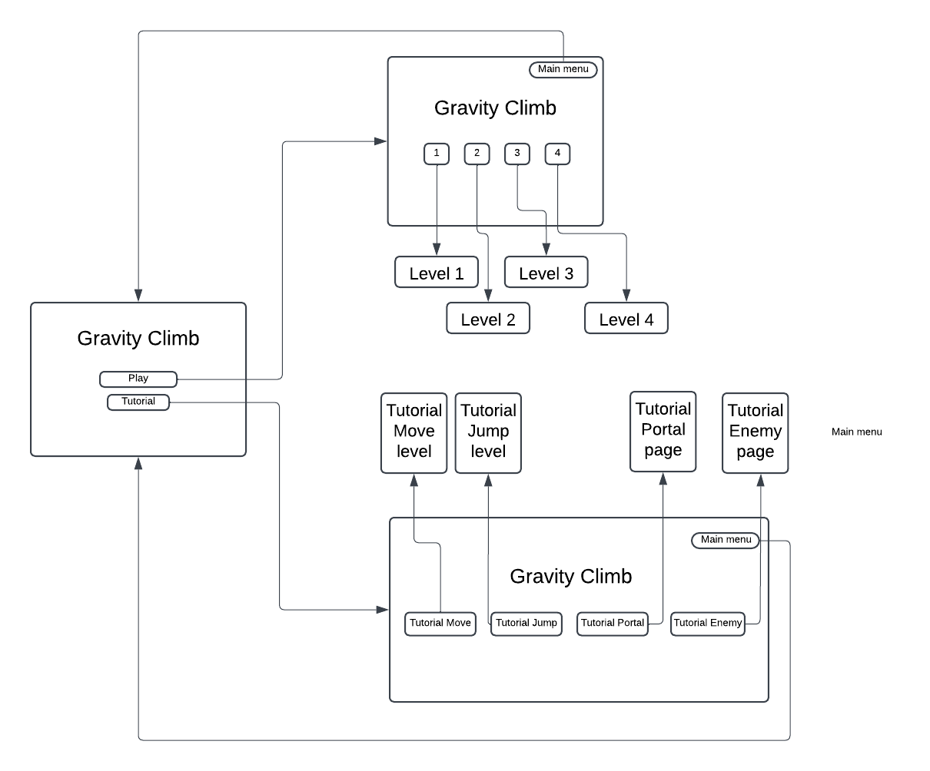

## **Game UI - (Gold)**

### **Menus**

*Start Screen*

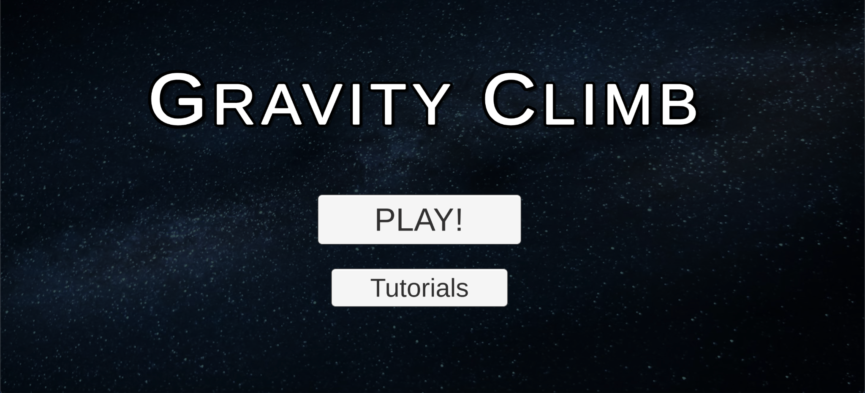

*Level Selection Screen*

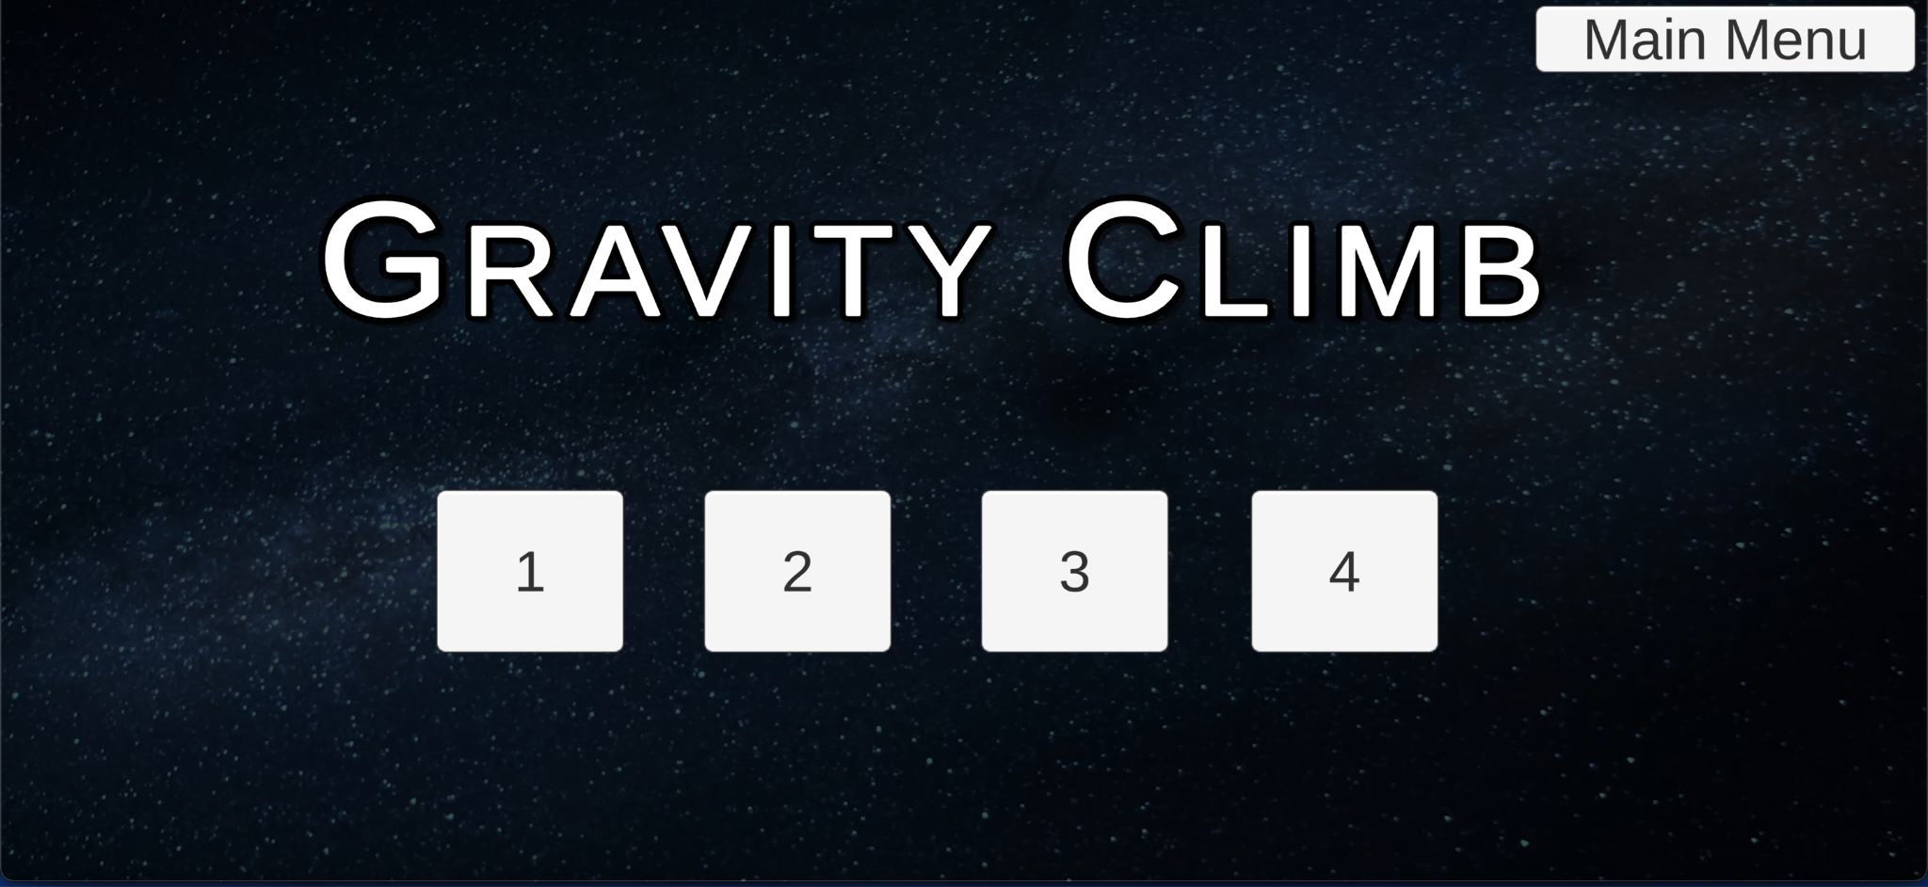

*Tutorial Selection Screen*

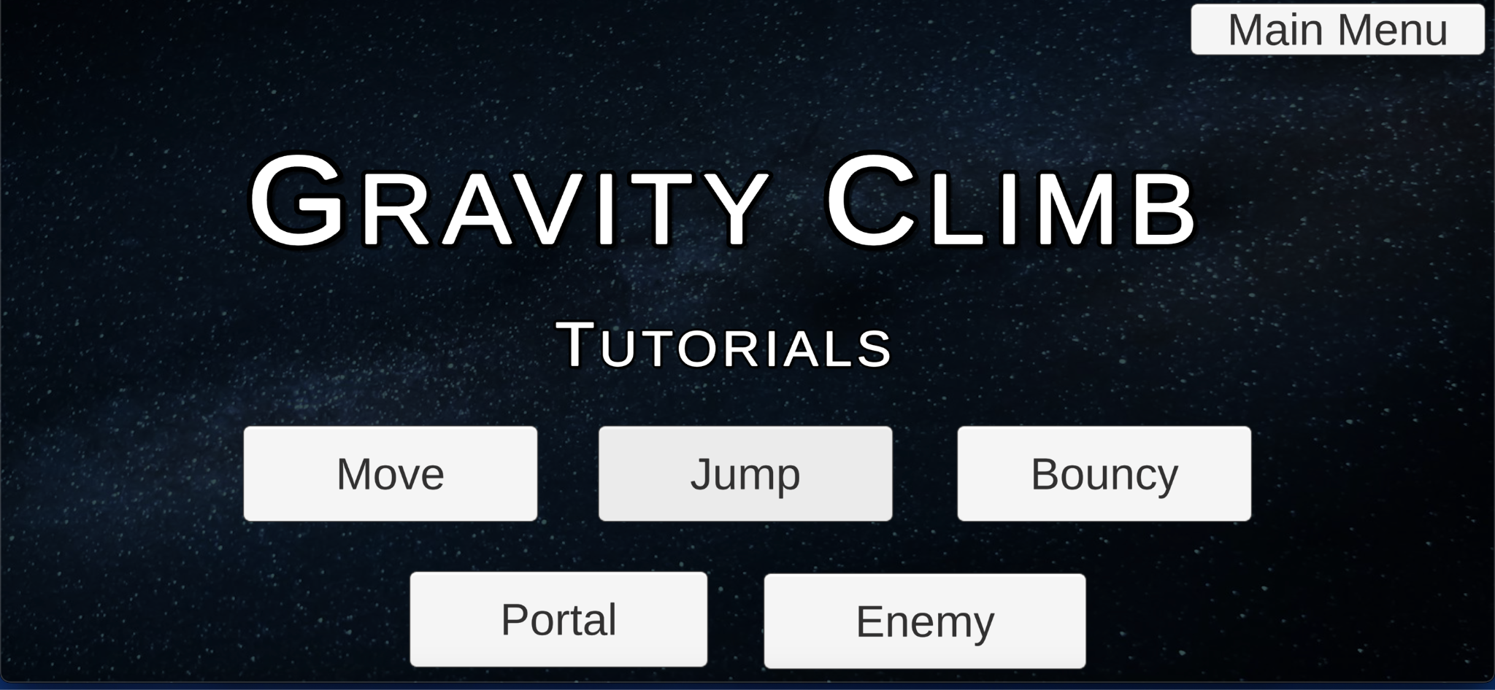

*UI Screens flow*

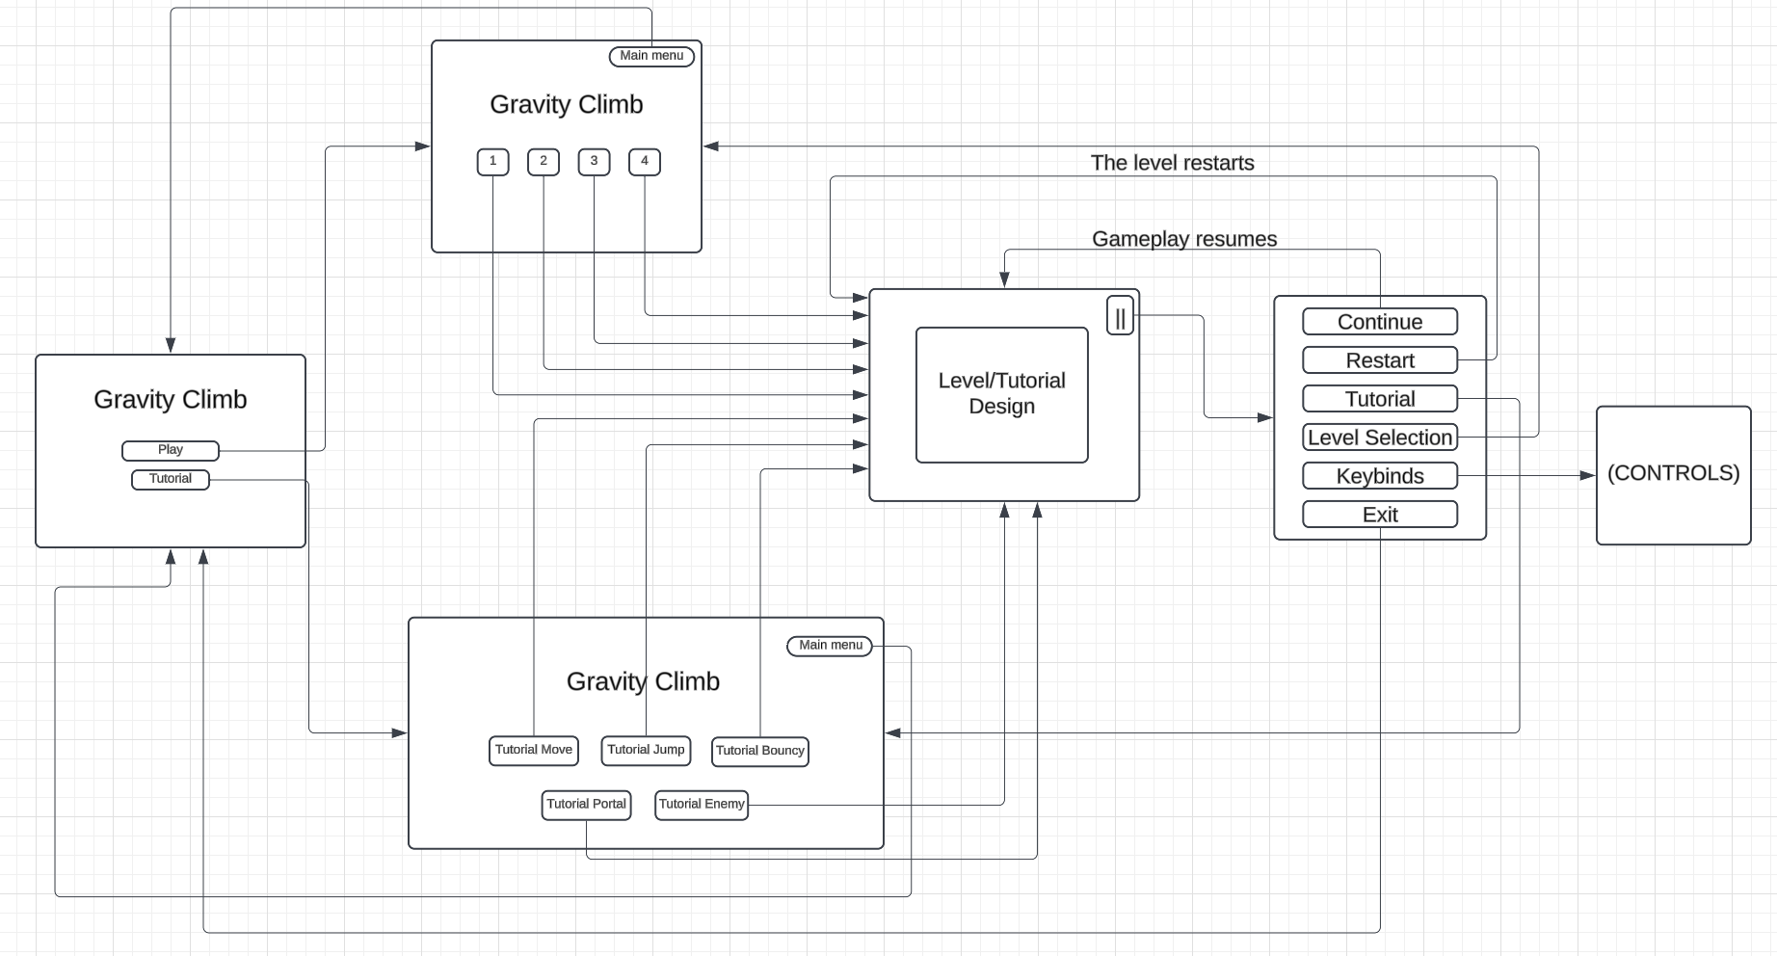

# Analytics

## **Metrics**

**Metric #1**: Player Route Preference

**Description:** Thismetric is to monitor player behavior to determine which path a player takes to complete a level. The metric checks whether the player directly heads towards the flag shown on the screen or whether they follow the overhead tracker towards the portal.

**Methodology Used:**

1. Data Collection:
   * Player Route Preference: Used distance between player and flag vs. player and portal to determine the route that players pick more. Based on the route, updates the google form with session id and player preference
   * [Google Form Link](https://docs.google.com/forms/d/1IVCQrVpOiSqGH-S1HR1xG_2ennOJtFJakeXBVxbbmts/edit#responses)
2. Data Visualization:
   * Bar Graphs generated by Google Forms data in Excel Sheet.

**Graph:**

**Level 1:**

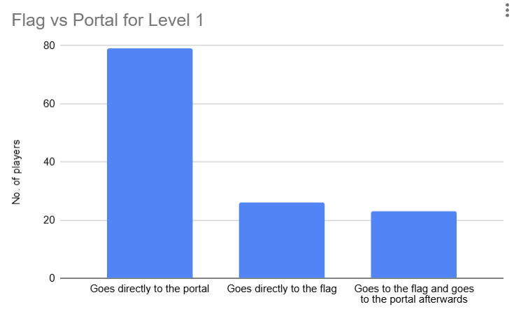

64% went directly to the flag while 80% of people found their way to the portal

**Level 2:**

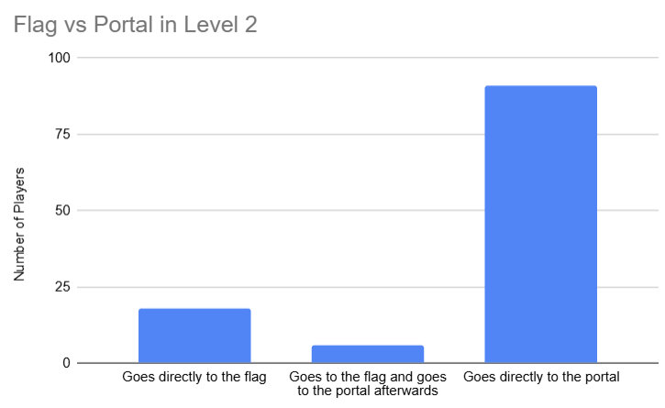

79% went directly to the flag while 85% of people found their way to the portal

**Justification:**

This metric was chosen to assess whether a player can interpret the functionality of the overhead tracker. The main goal of the tracker is to intuitively point the player in the direction of the portal which will teleport them to the flag without textual explanation.

At the beginning of the level, both the portal and the flag are visible to the player. Following the tracker will allow a player to finish the level with ease. There is, however, a challenging alternate route that allows the player to bypass the portal and go directly to the flag, though navigating past the final platform is difficult.

Data collected from this metric will indicate how helpful the tracker functionality is and whether it needs to remain in the game or if it needs to be removed for exploratory freedom.

**Interpretation:**

* The majority of players head towards the flag:
  + The player is uncertain about the tracker or did not notice it. Need more instructions.
  + If players ignore the tracker in the second level as well, the tracker needs to be removed/redirected
* The majority of players head towards the portal:
  + Tracker functionality understood. No further changes
* The majority of players head towards the flag, but later go to the portal:
  + The player is exploring the map.
  + The player saw the flag first but later saw the portal.
  + The player figured out the use of the tracker after trying to go to the flag.

**Hypothesis:**

1. If players successfully find the portal in Level 1, they will be less likely to attempt going directly to the flag in Level 2. This data can vary based on the number of players who want to explore the map rather than just win. We can give more incentives to players who choose to explore the map with power-ups/collectibles that can be used in further levels.

**Working data collection and visualization pipeline:**

1. Get the bar graphs in level 1 and level 2 by checking Google Form responses

**Metric #2**: Power-Ups Used

**Description:** Thismetric is to check if the power-ups are being used in Level 2,3 and 4.

**Methodology Used:**

1. Data Collection:
   * If the player uses the power-ups, the counter is updated to true.
   * On level restart, death of the player or Level Completion, it is checked if the player has used the power-up or not based on the value of the counter, updates the google form with session id and value of the counter.
   * [Google Form Link](https://docs.google.com/forms/d/1IVCQrVpOiSqGH-S1HR1xG_2ennOJtFJakeXBVxbbmts/edit#responses)
2. Data Visualization:
   * Bar Graphs generated by Google Forms data in Excel Sheet.

**Graph:**

**Freeze Power-up:**

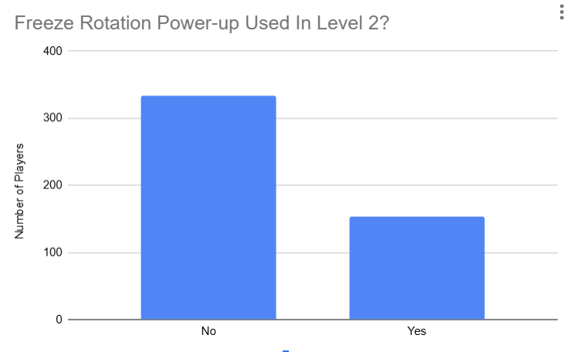

Before (32% of players have used freeze power-up)

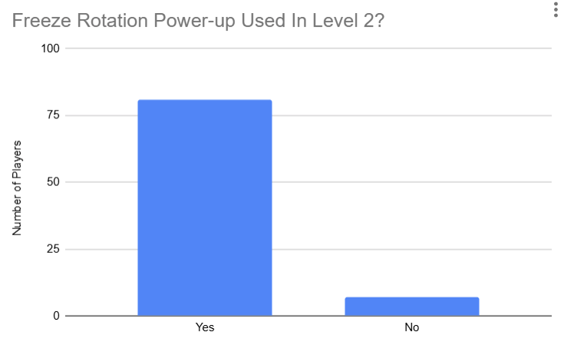

After (92% of players have used freeze power-up)

**Shield Power-up:**

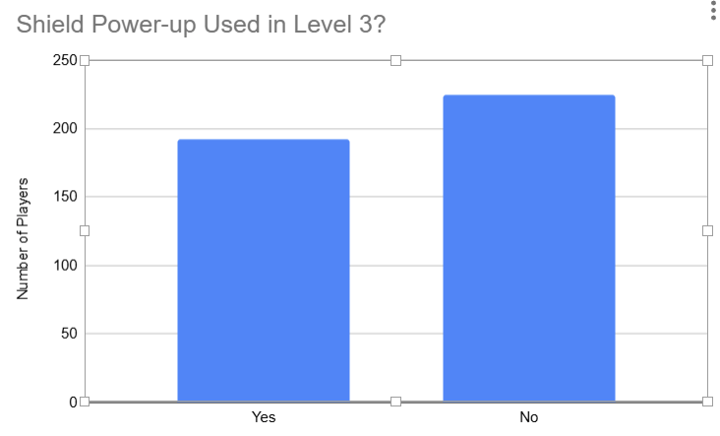

Before (46% of players have used shield power-up)

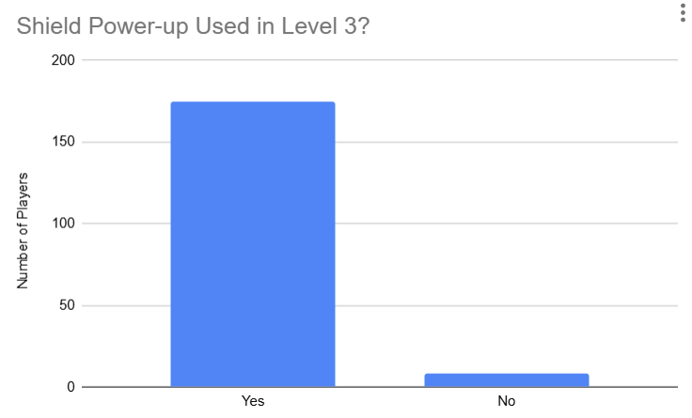

After (95% of players have used shield power-up)

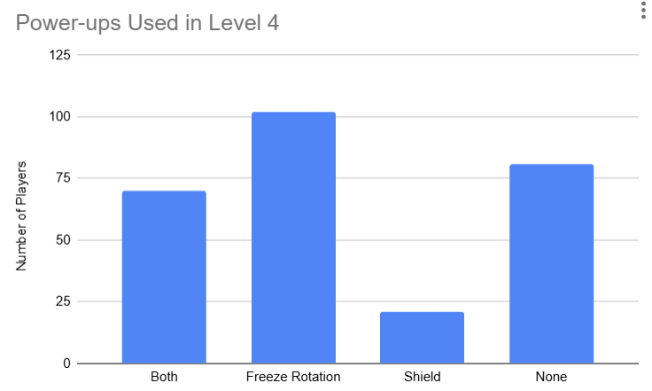

**Justification:**

This metric was chosen to assess the appeal of power-ups from the player's perspective, evaluating both the attractiveness of these power-ups and whether or not they are being used. This data can guide improvements, such as enhancing underused power-ups or making the power-ups more accessible, ultimately refining game design to better engage players.

**Interpretation:**

* If a lot of players use the power-ups, it suggests they view these features as beneficial or enjoyable, indicating strong appeal. Low usage may signal that the power-ups lack sufficient appeal or perceived value.
* This metric also provides insight into player engagement and strategy. High usage might indicate that power-ups are well-integrated into gameplay, encouraging players to actively use them as part of their approach. Conversely, if usage is low, it might indicate that the power-ups don’t fit naturally into gameplay, or that players don’t find them strategically advantageous.

**Hypothesis:**

1. If the player uses power-ups in either Level 2 or Level 3, they are more likely to continue leveraging them in subsequent, higher levels.

**Working data collection and visualization pipeline:**

1. Get the bar graphs in level 1 and level 2 by checking Google Form responses.

**Metric #3**: Player Death Causes

**Description:** Thismetric is to track how many times a player dies by falling off a map naturally or being pushed off the map by bullets in level 3 and level 4

**Methodology Used:**

1. Data Collection:
   * Used a boolean variable to track whether the player was hit by a bullet. When the player dies, get the boolean value and add it to the Google Form. If True, the player died from a bullet; if False, the player died naturally.
   * Once the player is hit by a bullet and collides with anything other than the bullet, the boolean variable will be set to False.
   * [Google Form Link](https://docs.google.com/forms/d/1IVCQrVpOiSqGH-S1HR1xG_2ennOJtFJakeXBVxbbmts/edit#responses)
2. Data Visualization:
   * Bar Graphs generated by Google Forms data in Excel Sheet.

**Graph:**

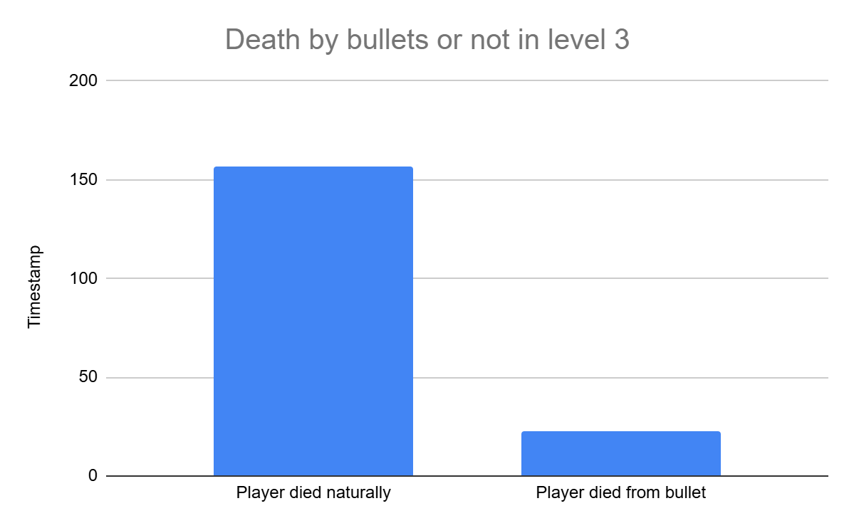

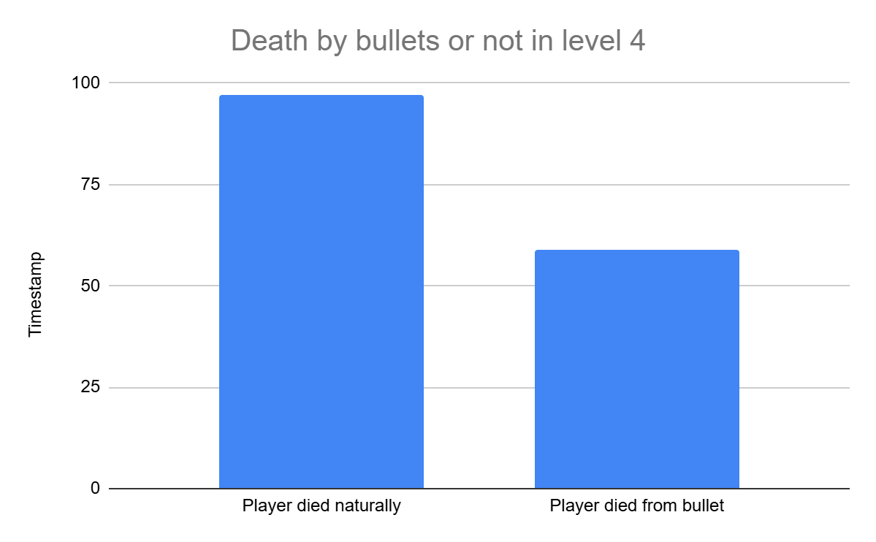

As level 3 was the introduction of the bullet mechanism, we did not want the difficulty to be too high which is indicative of the analytics for that level. Level 4 is a test of skill for the players which is why the death by bullets is higher than the previous level but not greater than natural deaths indicating the right amount of difficulty and enemy aggression.

**Justification:**

This metric was chosen to determine the placement and aggressiveness of the enemy attackers in levels that have the bullet mechanic. This data will allow us to know how much force the bullets need and assess the difficulty progression for each level

**Interpretation:**

* The majority of players die without encountering bullets: Enemies are not potent enough. The level design needs to be changed
* The majority of players die being pushed off the map with bullets: Enemies are too aggressive. Level difficulty needs to be reduced or more power-ups like the shield are needed

**Hypothesis:**

1. Players in higher difficulty levels are more likely to die from bullets than falling.

**Working data collection and visualization pipeline:**

1. Get the bar graphs in level 3 and level 4 generated by Google Forms data in Excel Sheet.

**Metric #4**: 180 Degree Speedrun

**Description:** This metric is to check whether or not the player is speedrunning the game.

**Methodology Used:**

1. Data Collection:
   * Number of jumps: We count the number of times the player presses the spacebar and sends this value to the Google Form when they complete the level.
   * Number of platforms used: We count the number of distinct platforms the player uses in each level and send this data to the Google Form when they complete the level.
   * [Google Form Link](https://docs.google.com/forms/d/1IVCQrVpOiSqGH-S1HR1xG_2ennOJtFJakeXBVxbbmts/edit#responses)
2. Data Visualization:
   * Box plots generated by Matplotlib and Seaborn (Python packages)

**Graph:**

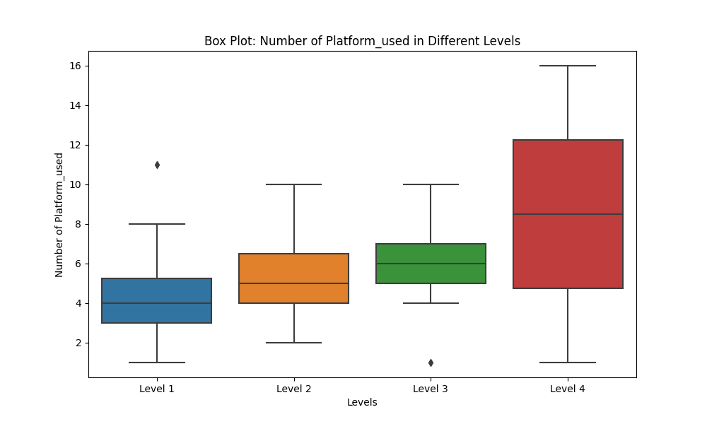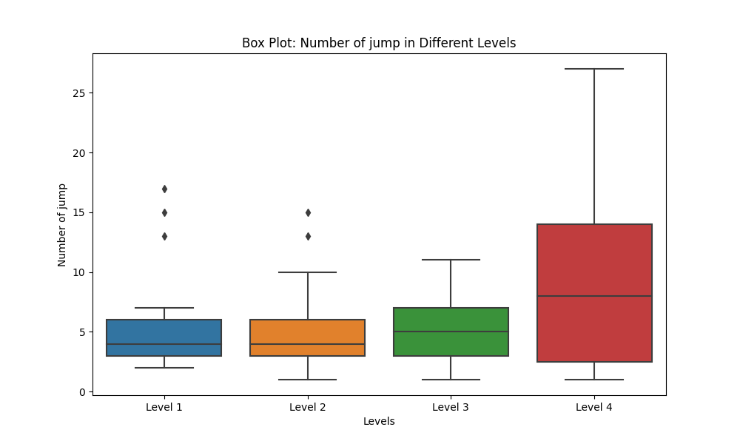

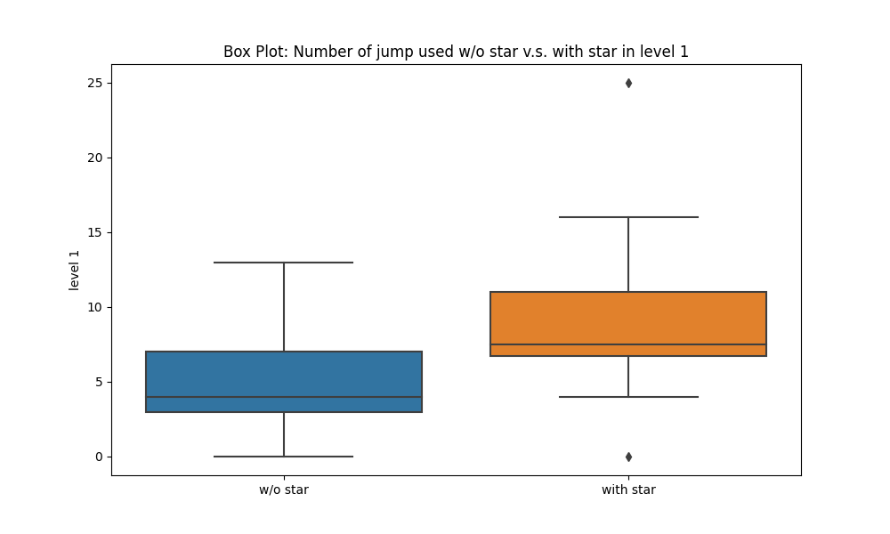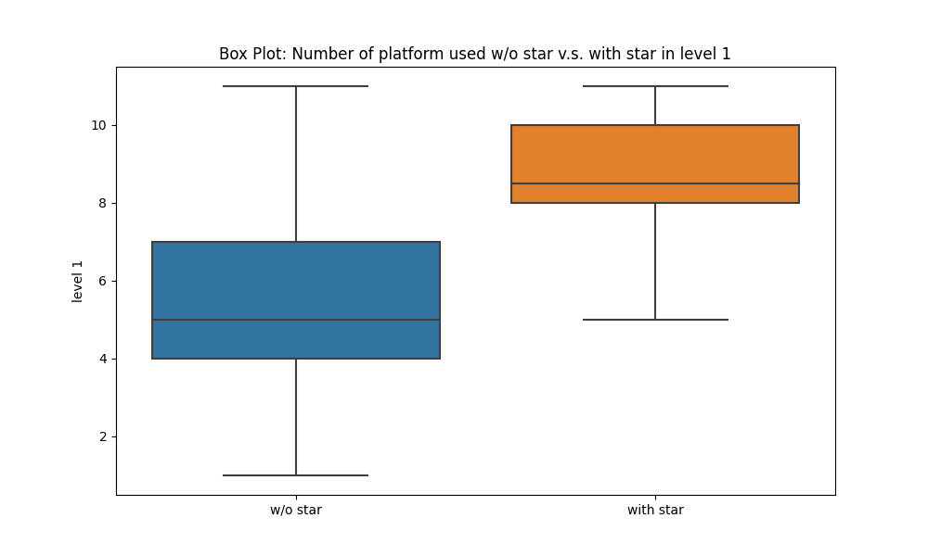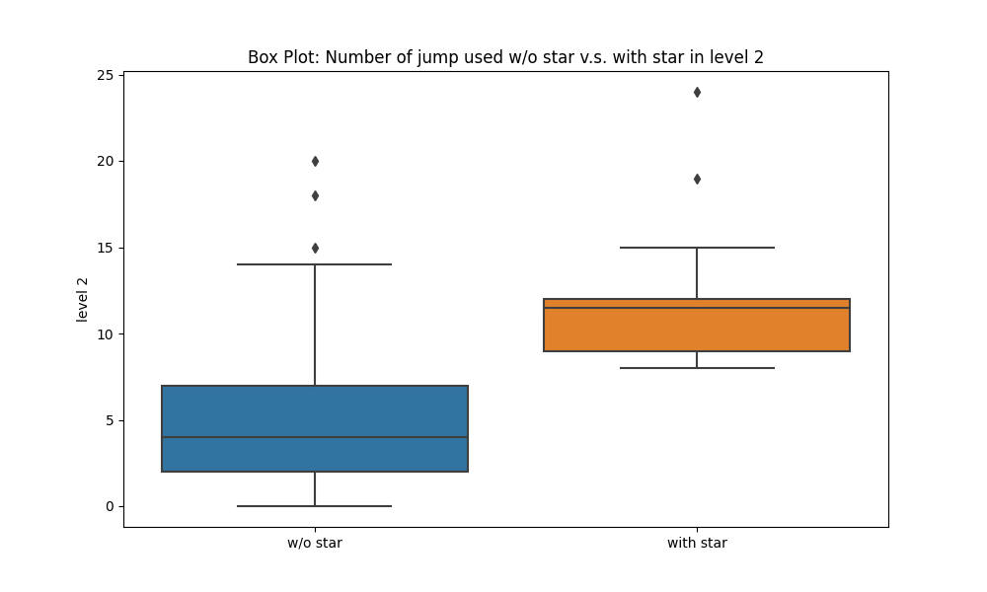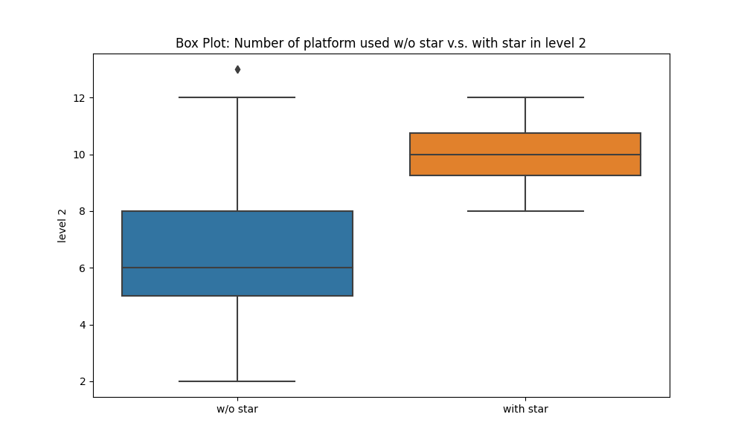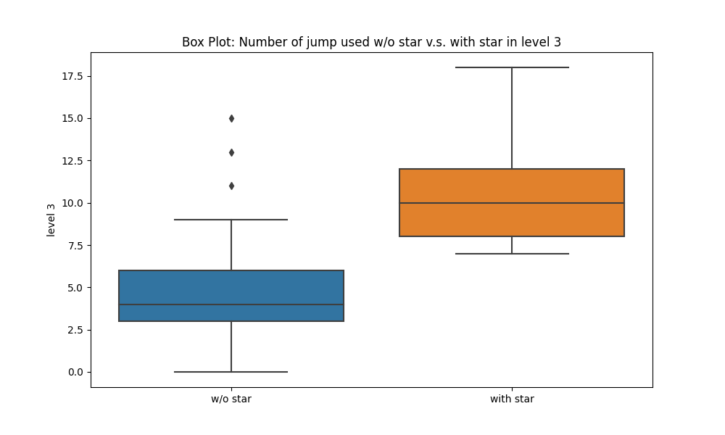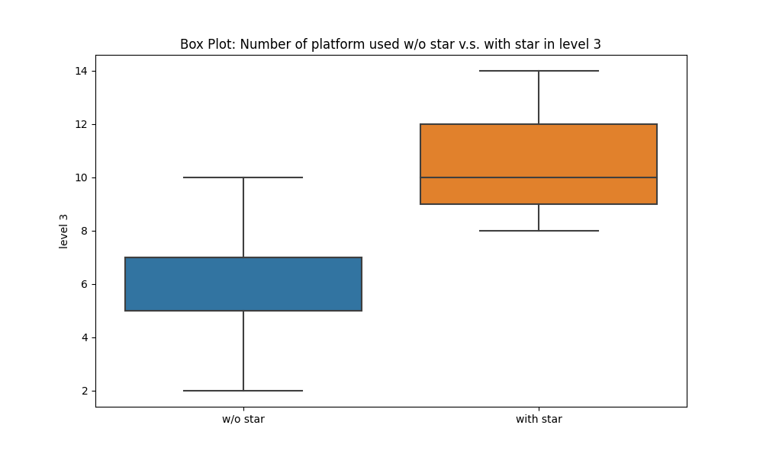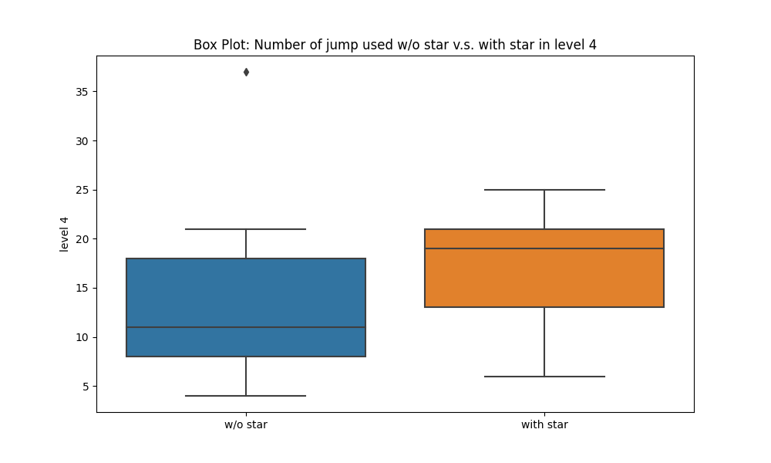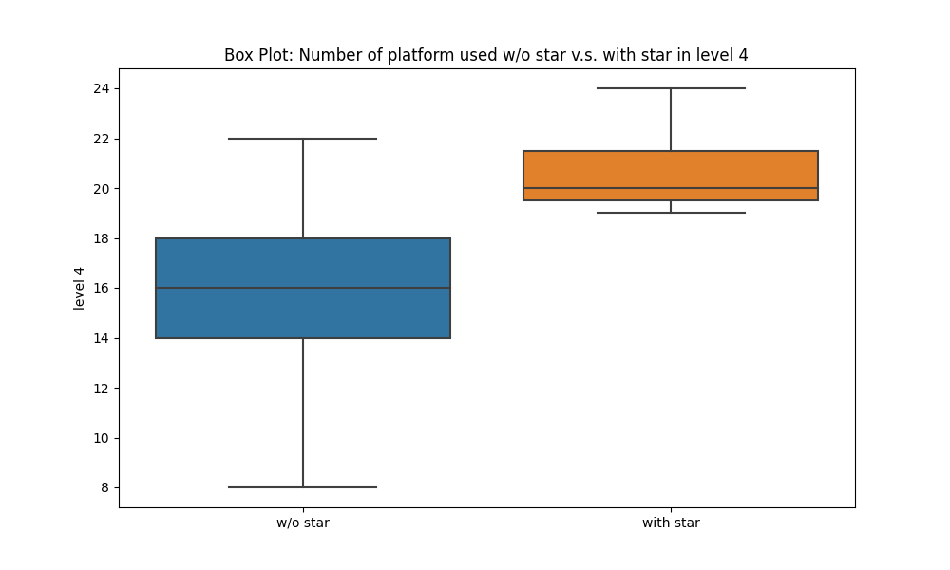

**Justification:**

This metric was chosen to assess whether players actually traverse a level and make use of the mechanics provided to them.

This data will help us determine if further incentives are needed to make a player engage with the variety of platforms and power-ups.

**Interpretation:**

* The number of jumps and the number of platforms used are high:
  + Players traverse the level across multiple platforms and jump between platforms instead of simply rotating the map to speedrun
  + The level design does not need to be changed. Incentives are enough
* The number of jumps and the number of platforms used are too low:
  + Players simply rotate the map to speedrun
  + Platforms need to be more engaging
  + Incentives need to be added
* The number of jumps and the number of platforms are higher in the lower level
  + Level difficulty needs to be addressed

**Hypothesis:**

1. Players are more likely to reach the goal by only rotating the map

**Working data collection and visualization pipeline:**

1. Collect “the number of jumps to complete the level” and “Which level did the players complete”
2. Convert the column names to "Level 1," "Level 2," "Level 3," and "Level 4." Each level name should be a separate column with the value as the number of jumps.
3. Use Matplotlib and Seaborn (Python packages) to read the converted table and draw a box plot for each level.
4. Repeat steps 1 to 3 to create a plot for the "Number of Platforms Used."

# Weekly Prototype Descriptions

**Week-7:**

* Created three levels for the players to navigate through
* Added new platforms - curved, auto-jump, elevate
* Designed power-ups - shield and freeze
* Created enemies who challenge the players with bullets
* Added a tracker for the player to know which direction they needed to go

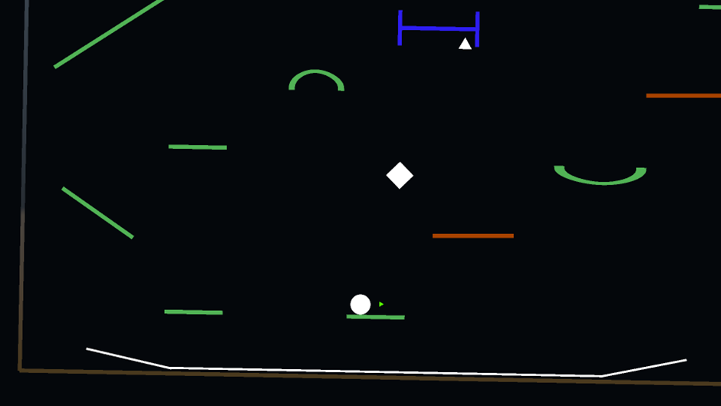

Level 2 design with power-ups and checkpoint

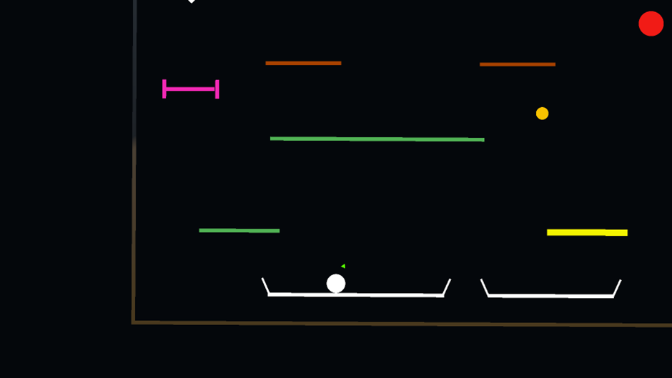

Level 3 design

**Week-8:**

* Focused on making the game more intuitive
* Created info-text for different game elements - powerups, shield, portals, checkpoints
* Added the heads-up display to show the player current angle of rotation, and which power-ups are active
* Changed the original location of the level 2 portal so that the player explores the level more
* Implemented back-end analytics

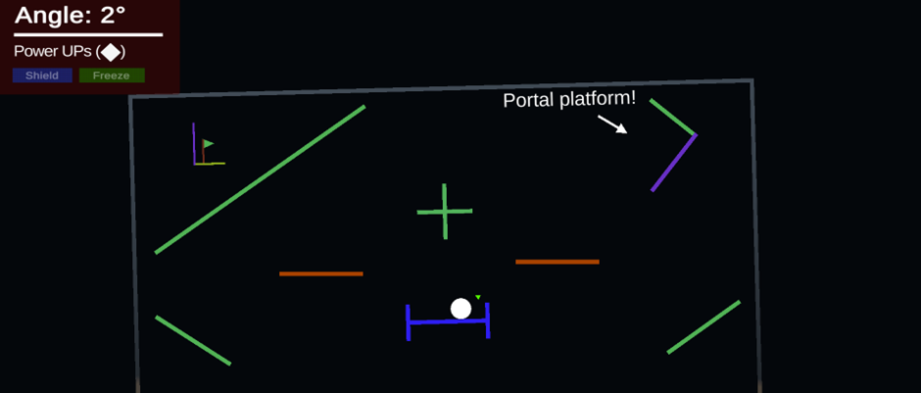

Portal Platform text and HUD

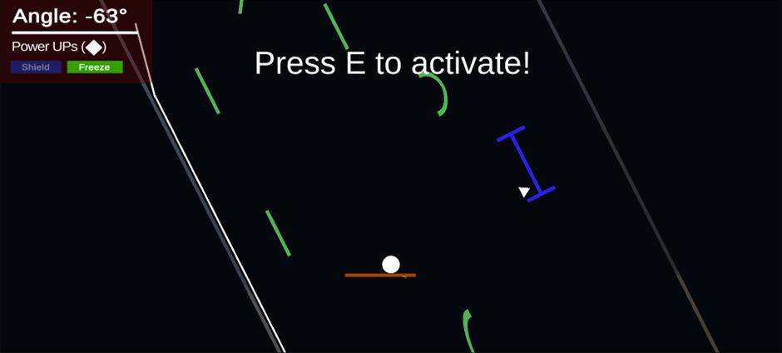

Text to activate the freeze power-up

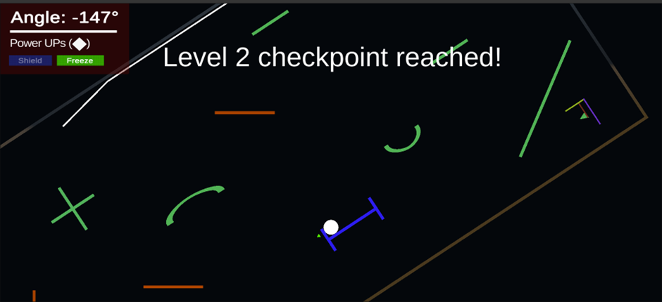

Text generated on collecting a checkpoint

**Week-9:**

* Players did not understand the portal so we changed the portal design to be more intuitive
* Created text for portals
* Added new platforms - size-changing platforms
* Fixed bug where freeze power-up did not reset after dying

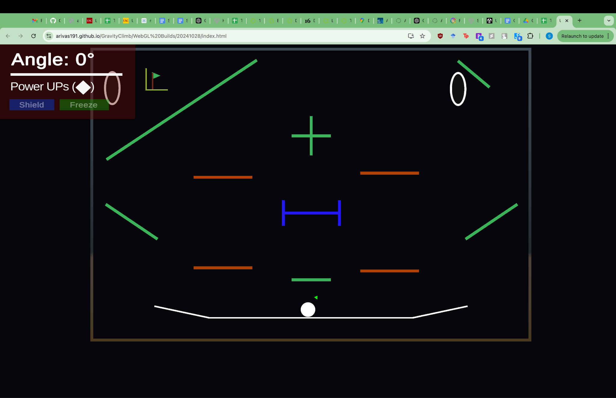

Redesigned Portals

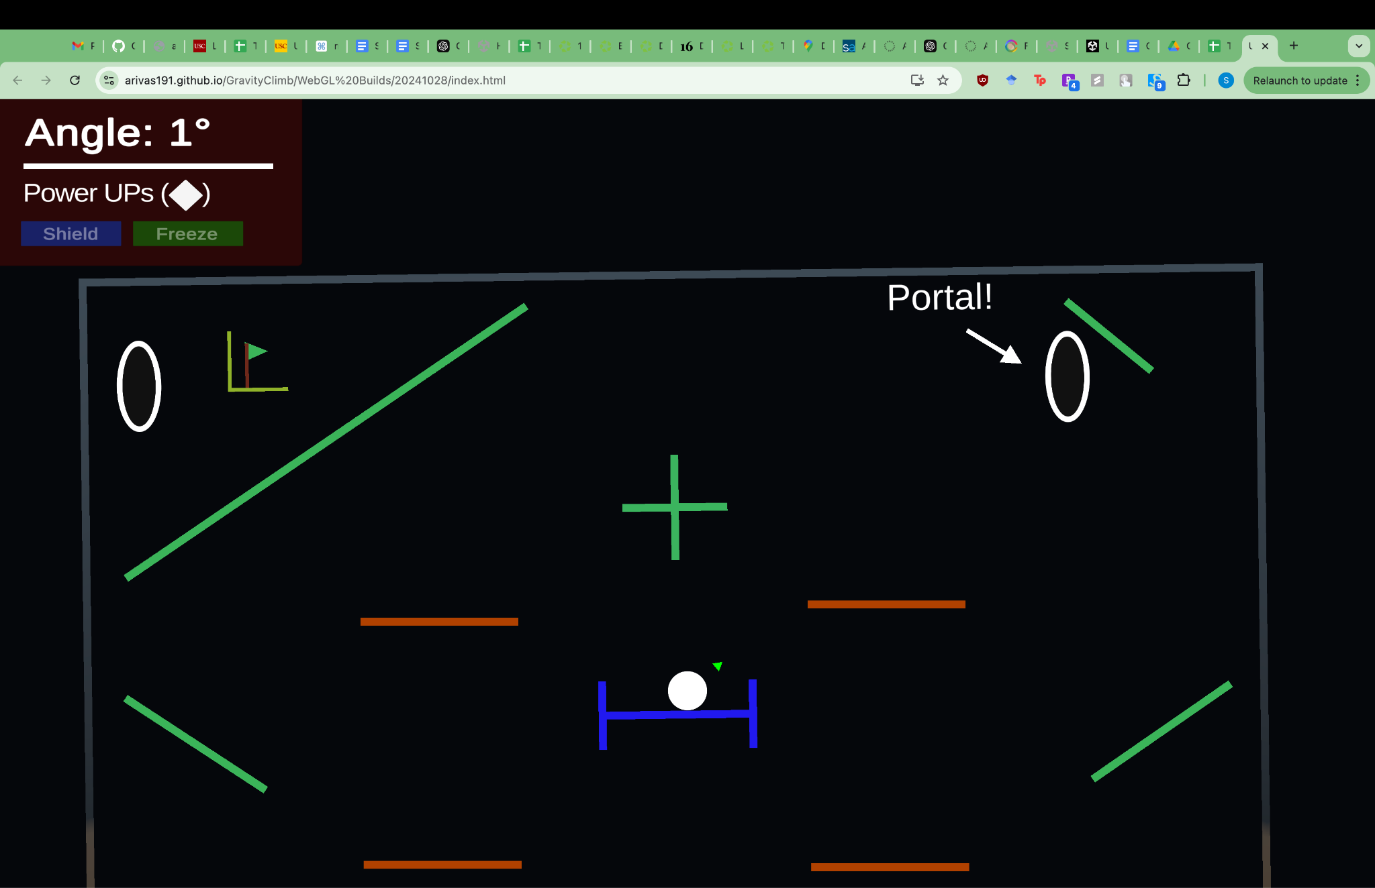

Added Portal Text

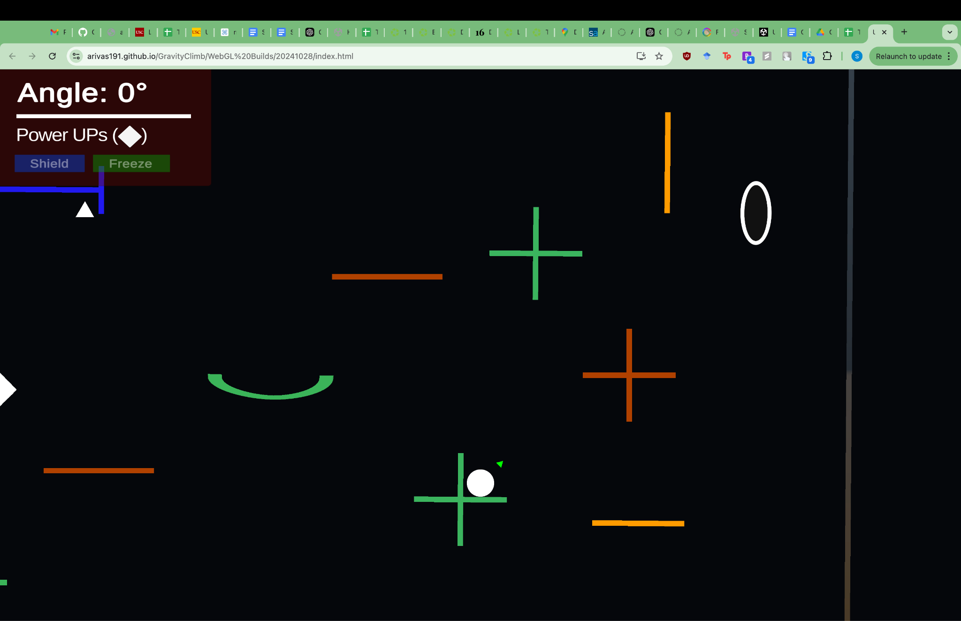

Size Changing Platforms (Orange)

**Week-10:**

* Added Tutorial levels for basic mechanics based on feedback about difficulty
* Changed freeze power up to automatically auto-freeze
* Changed level 2 design
* Changed HUD

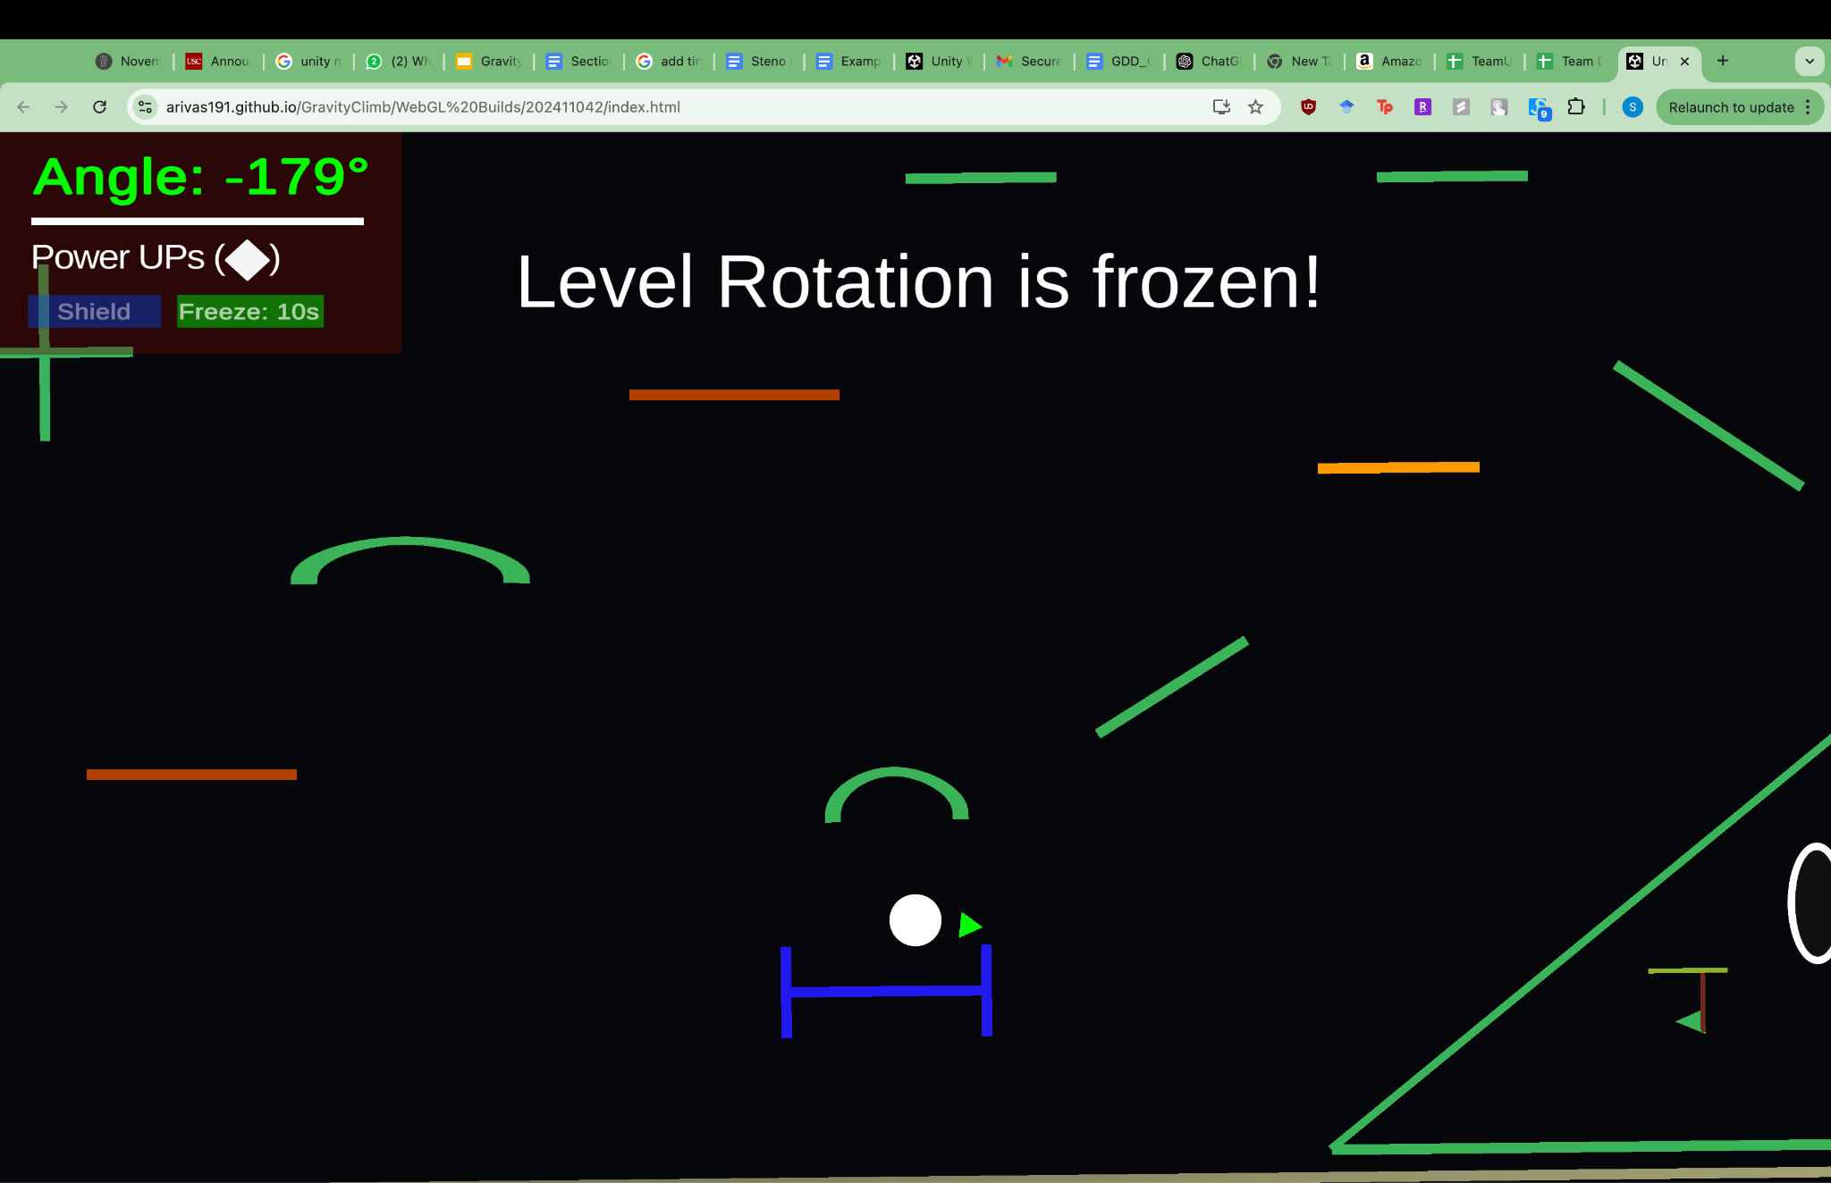

Auto-freeze PowerUp

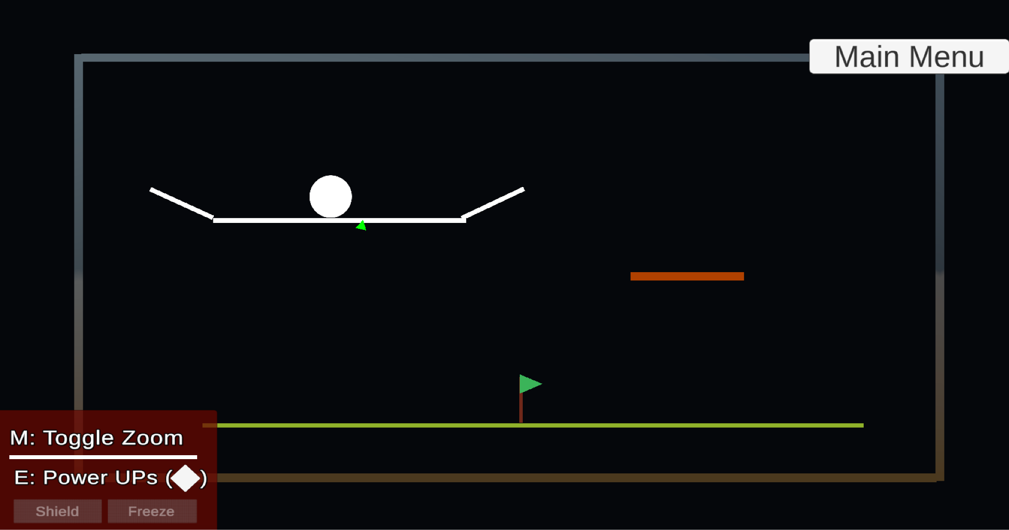

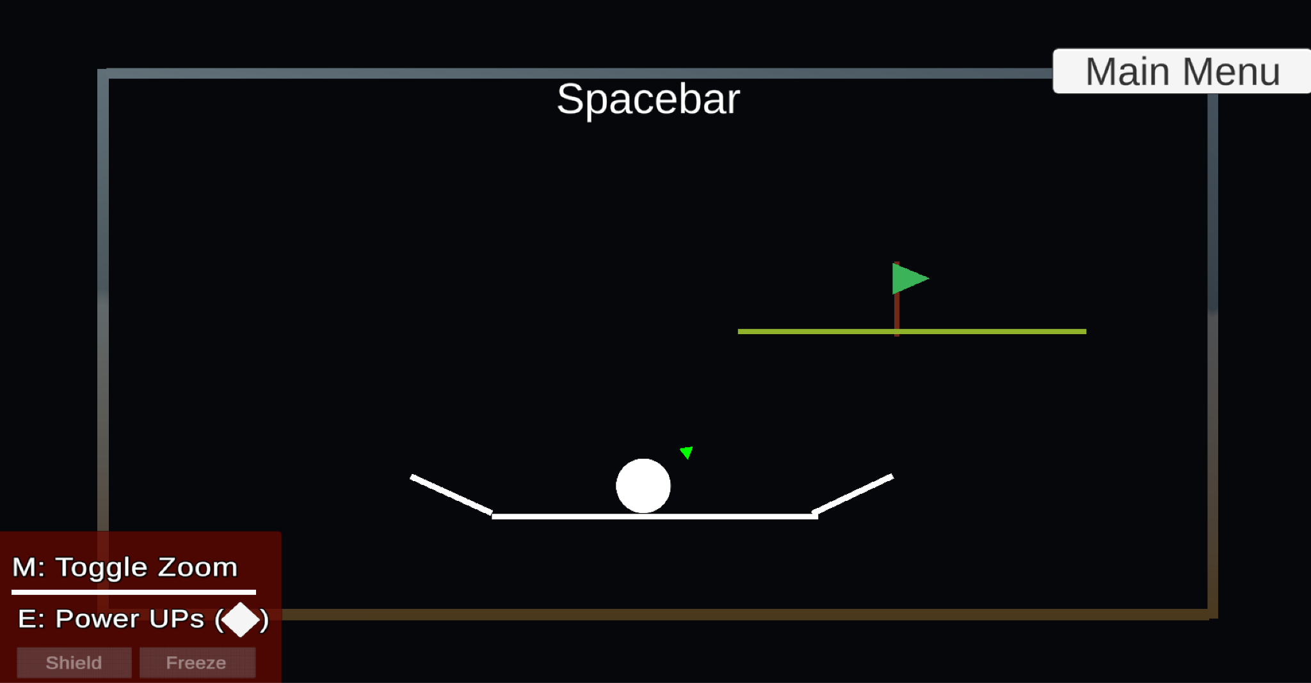

Tutorial Levels

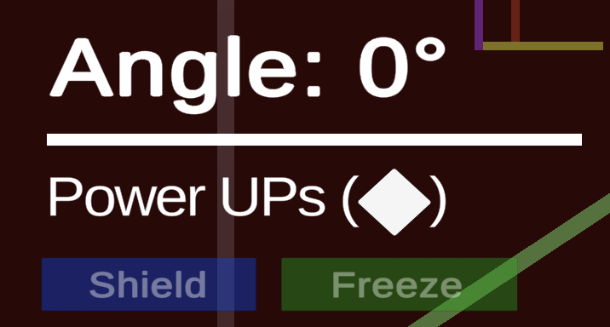

New HUD

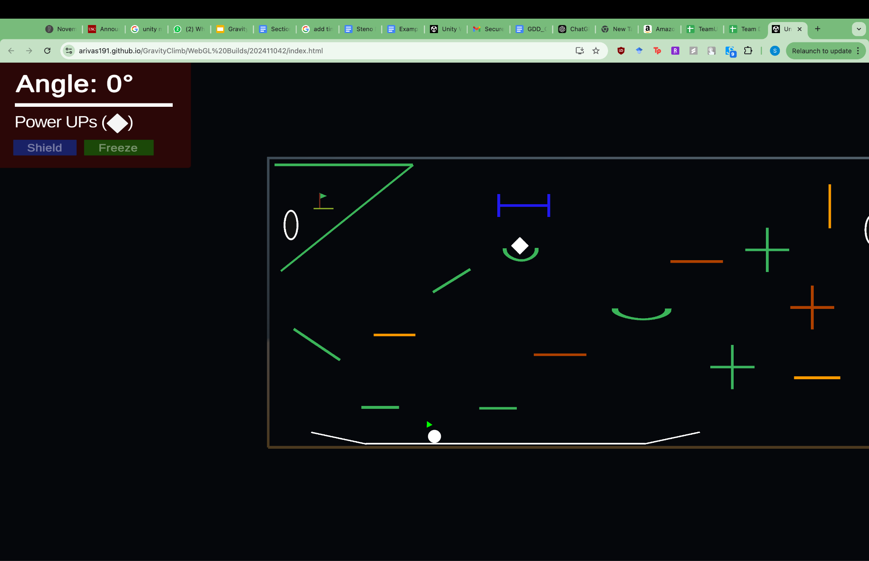

Level 2 Redesign

**Week-11:**

* Added Level Select Screen
* Created Level 4
* Added Enemy Tutorial and redesigned portal tutorial to be more self explanatory
* Redid power ups(shapes) to differentiate between shield and freeze
* Added a toggle zoom feature, portal tutorial with arrows - multiple player feedback about not knowing where to go

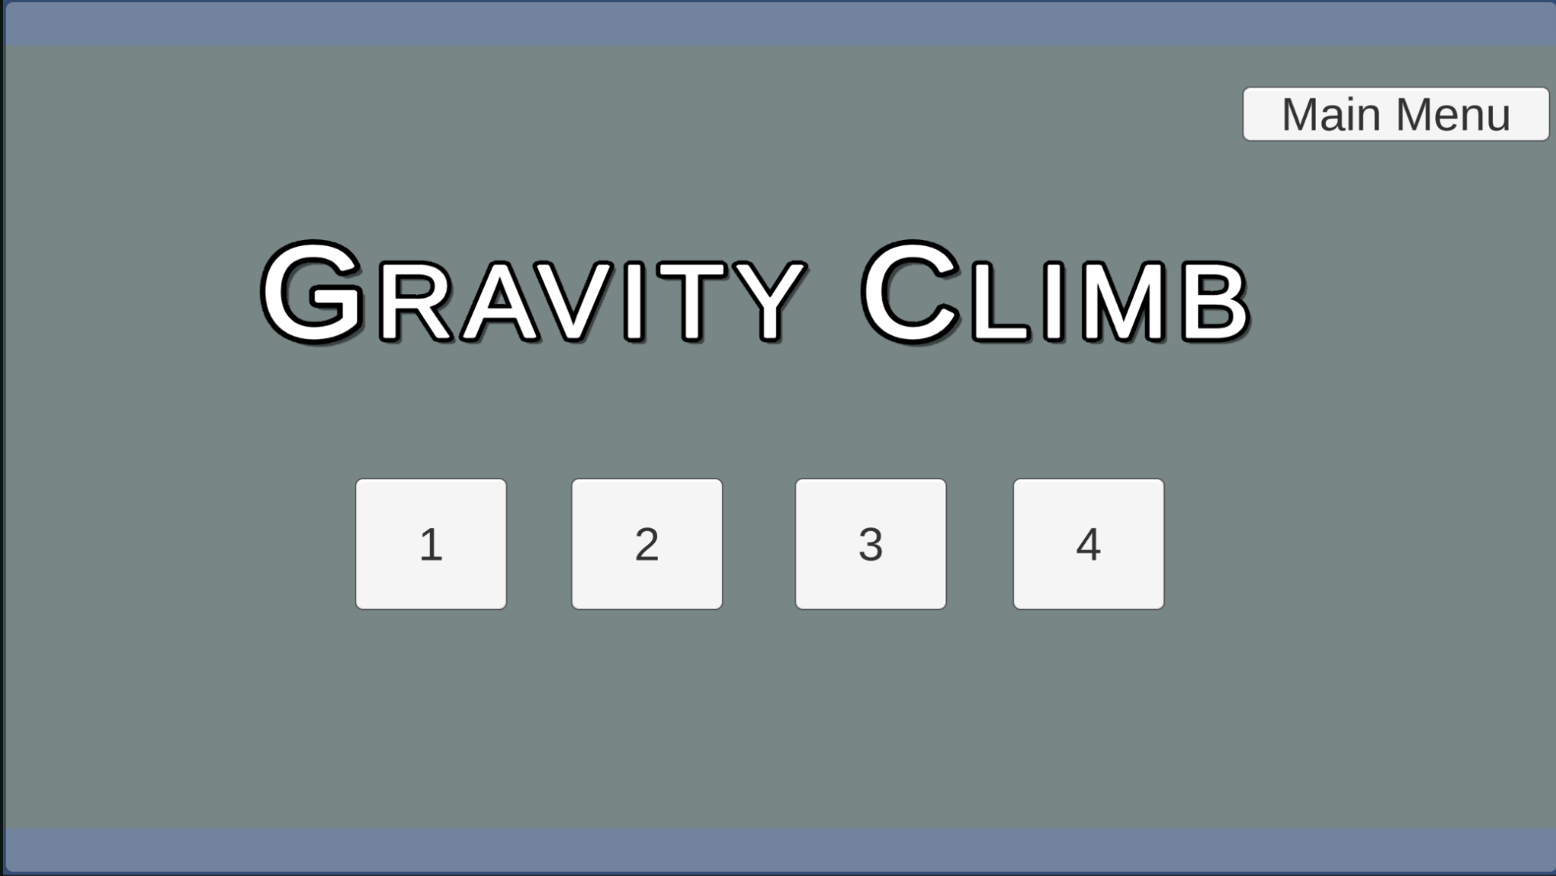

Level Selection

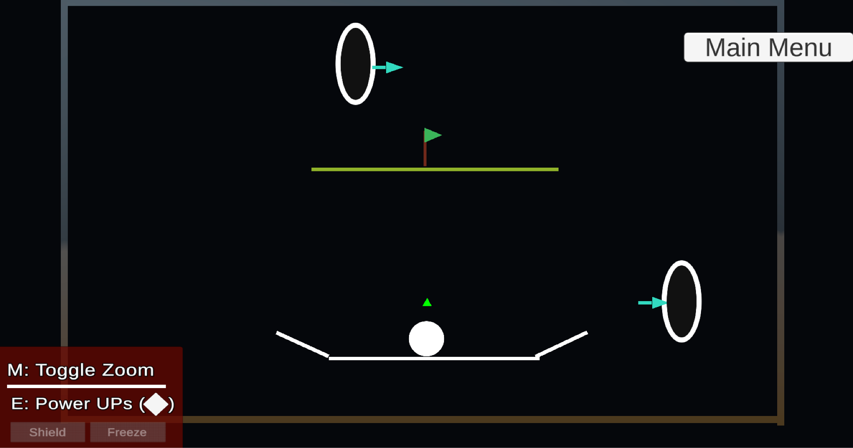

Portal Tutorial

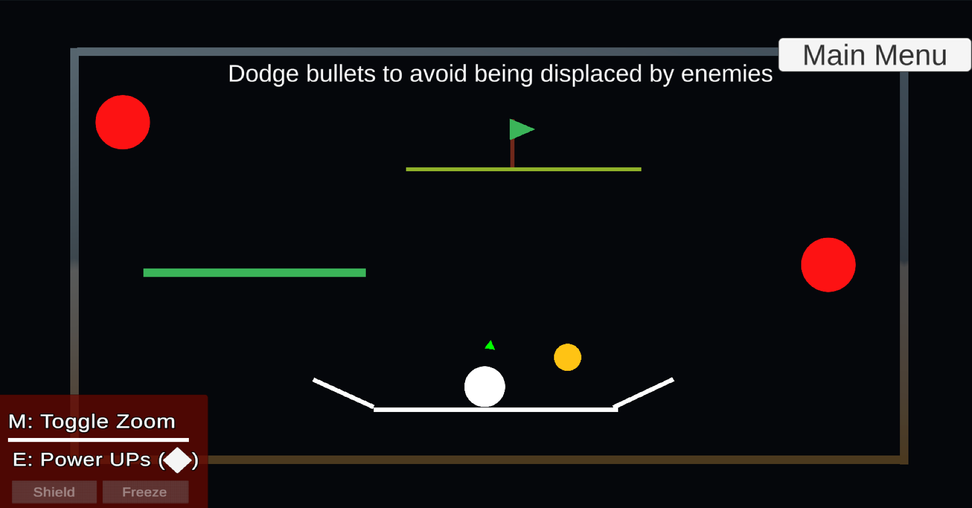

Bullet Tutorial

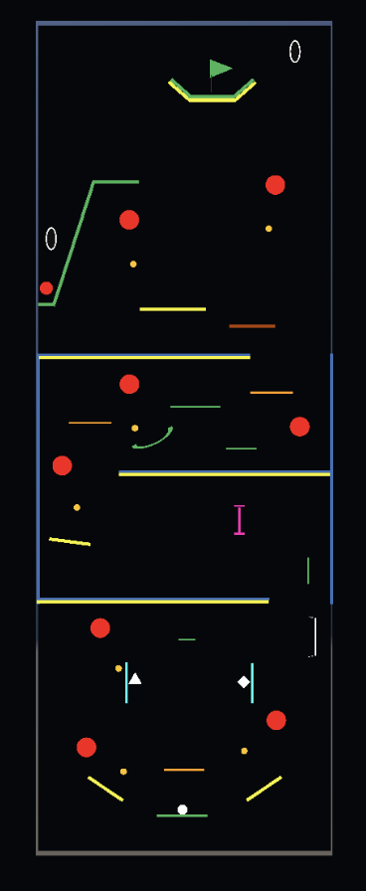

Level 4

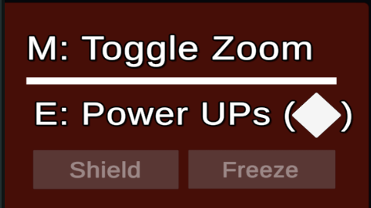

Toggle Zoom Feature

**Week-12:**

* Added backgrounds to levels
* Added Tutorial select screen
* Reworked menu options
* Added pause screen
* Refactored Level 2 and UI
* Added skins to powerups, enemies, and bullets

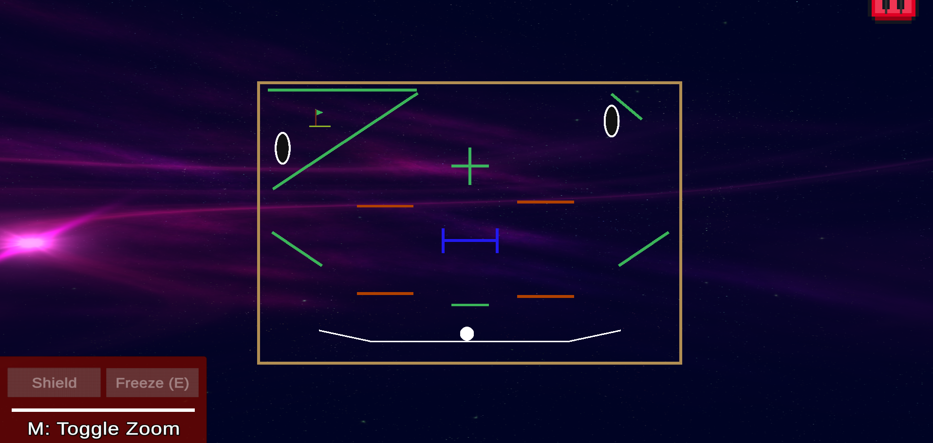

Background in level 1

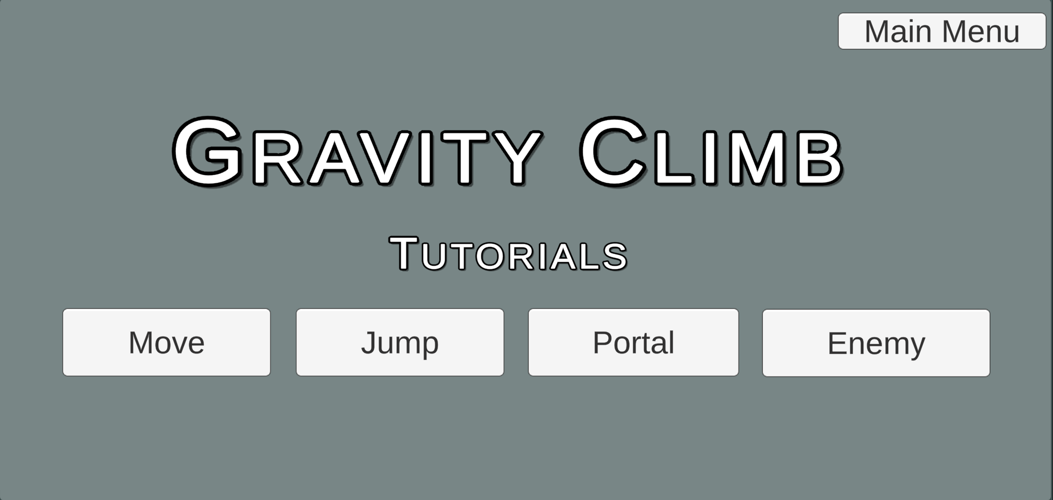

Tutorial select screen

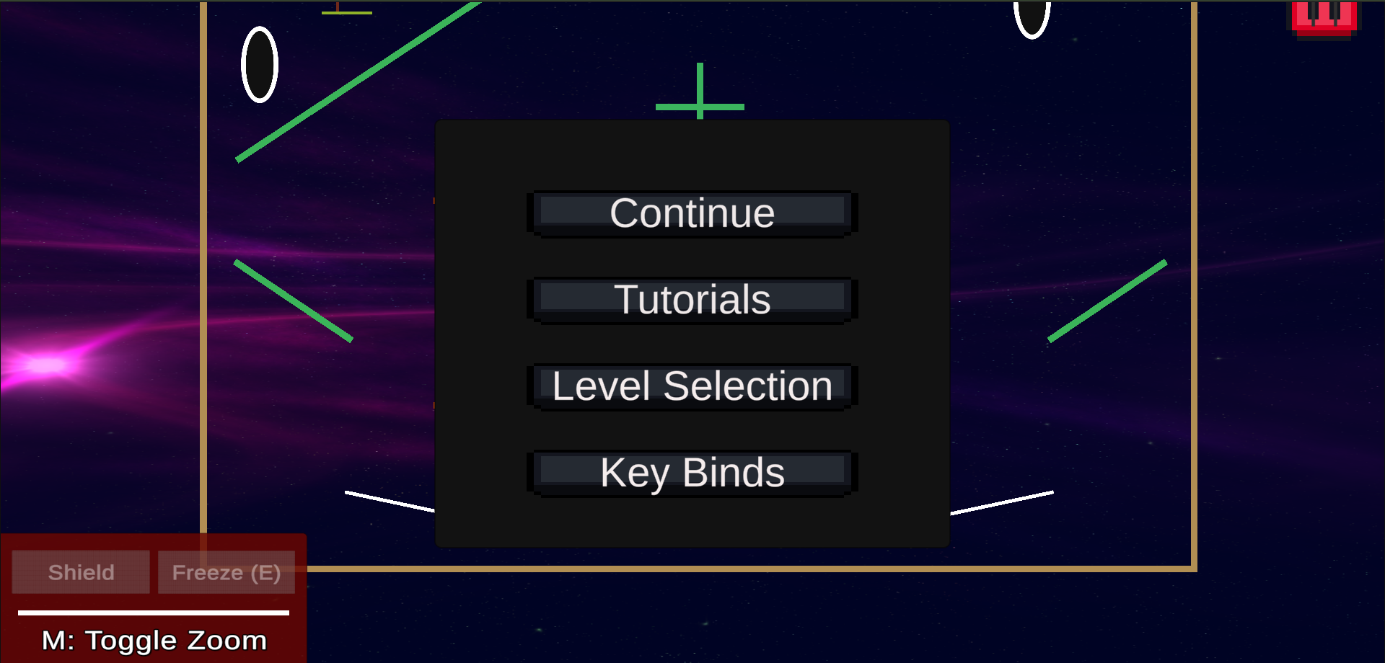

Pause screen

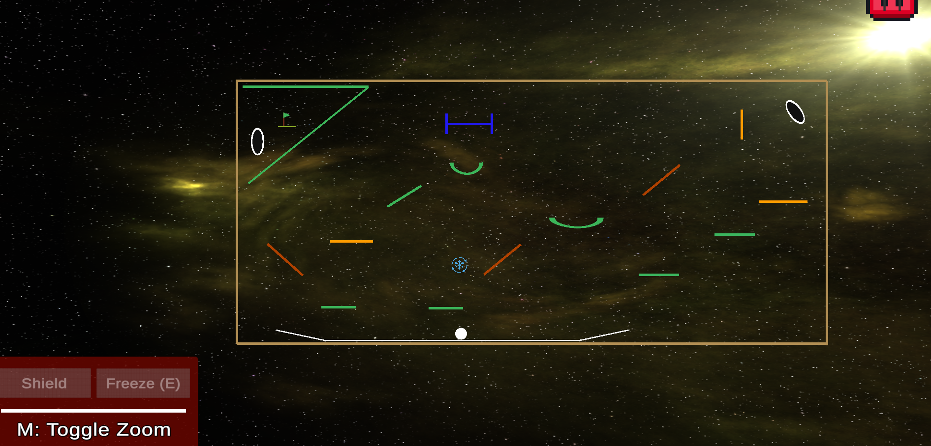

Refactored level 2

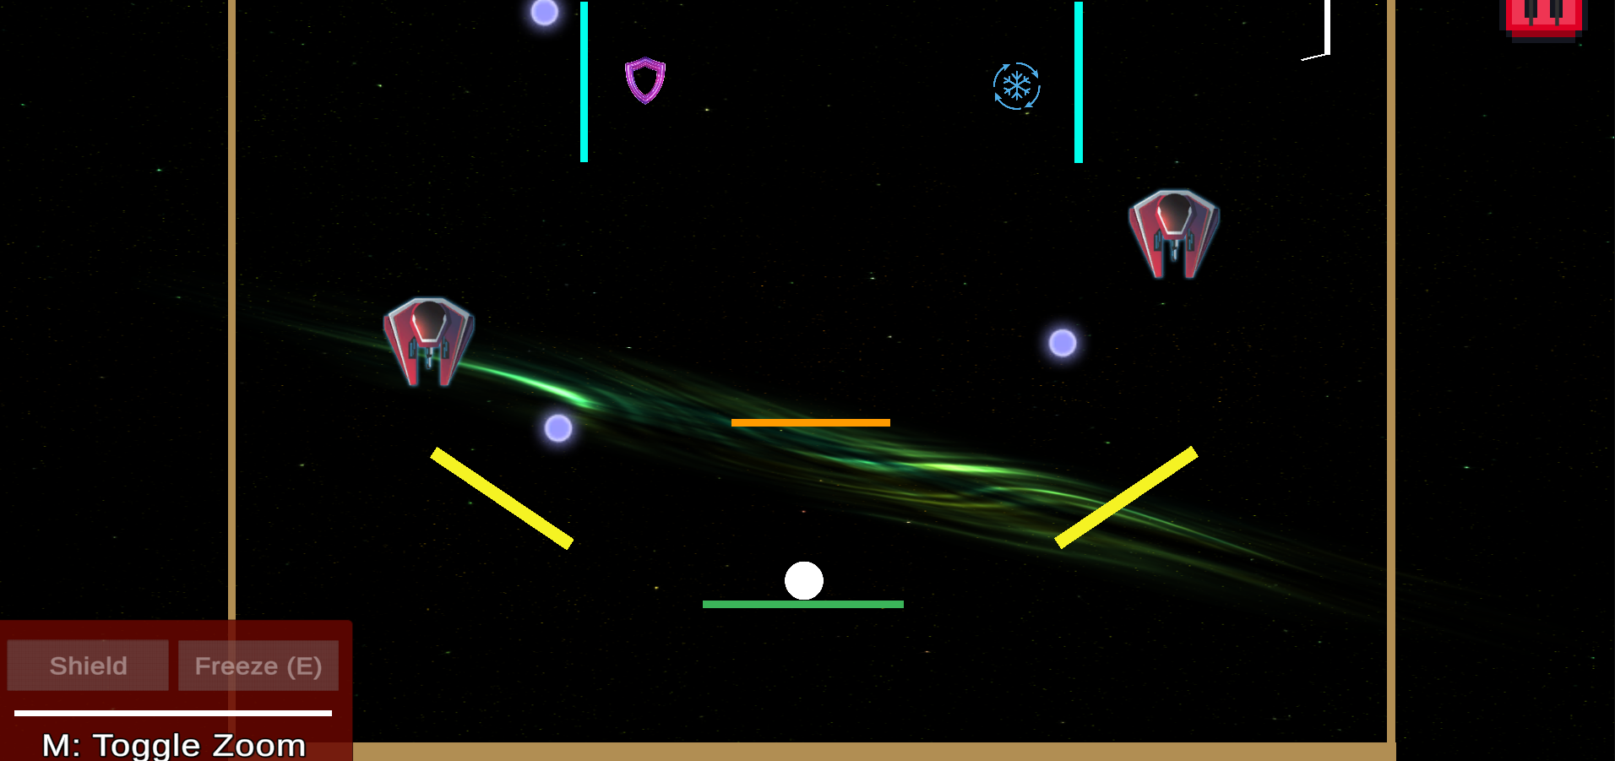

Skins to freeze and shield power-ups, enemies, and bullets

**Week-13:**

* Star system added
* Reworked portal functionality
* Changed jump logic
* Changed backgrounds of level screens and levels
* Added tutorial for bouncy platforms
* Reworked enemy tutorial
* Added shield tutorial

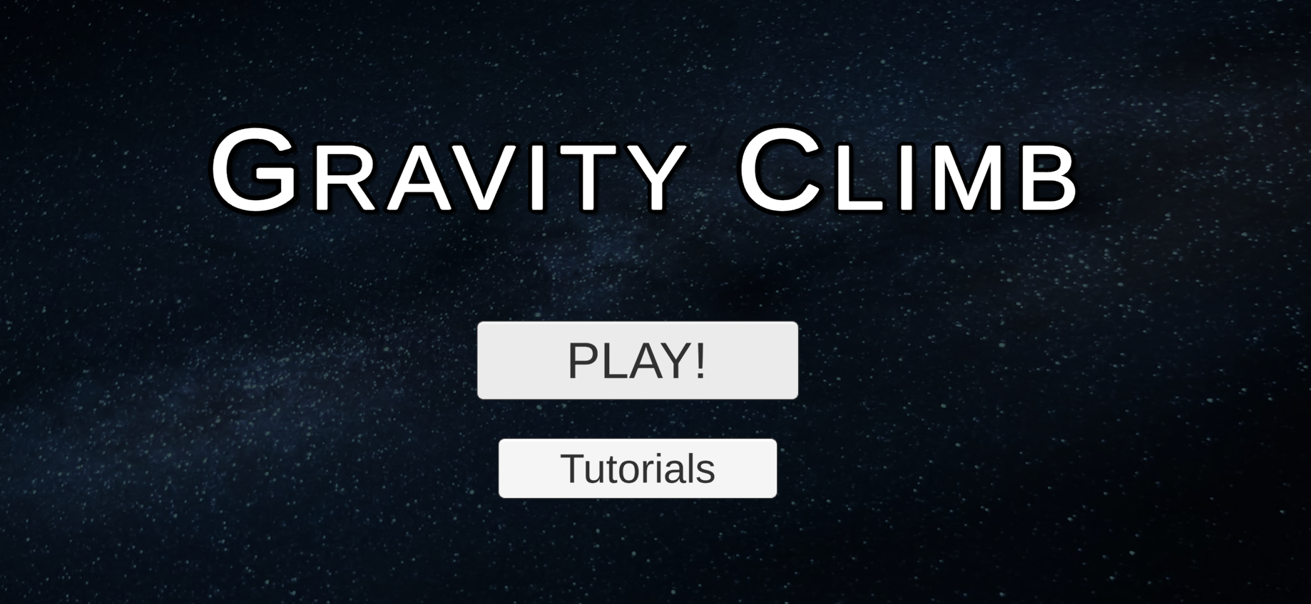

Background of main screen

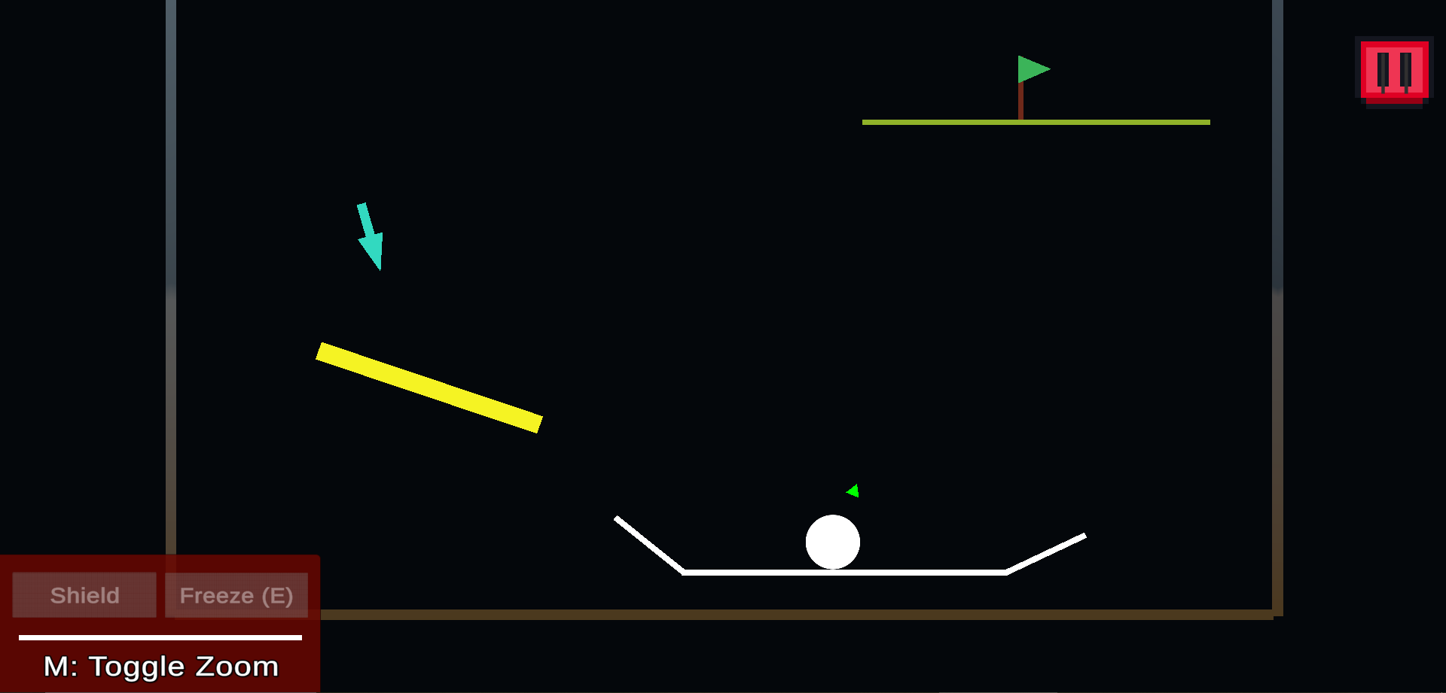

Tutorial for bouncy platform

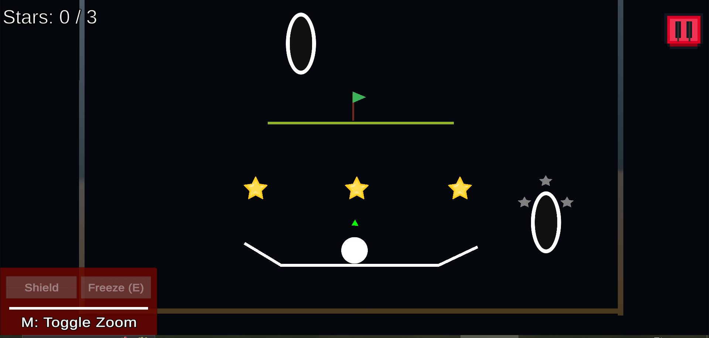

Start systems added, reworked portal tutorial

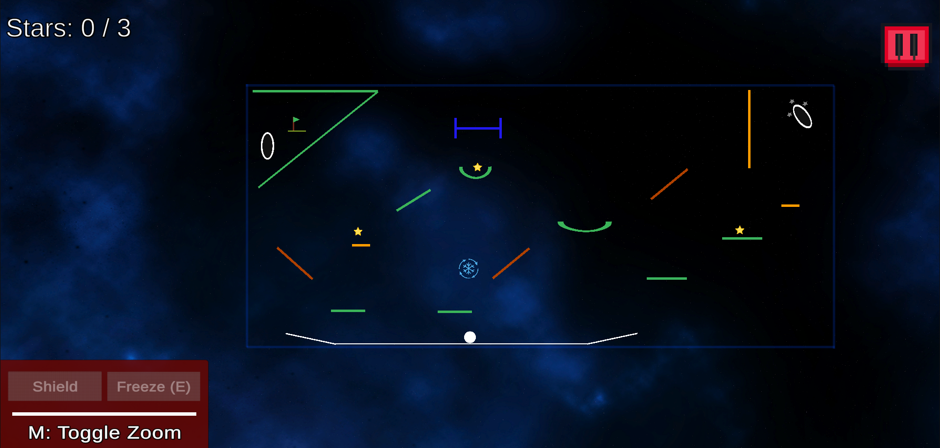

Star systems added in levels, changed level backgrounds

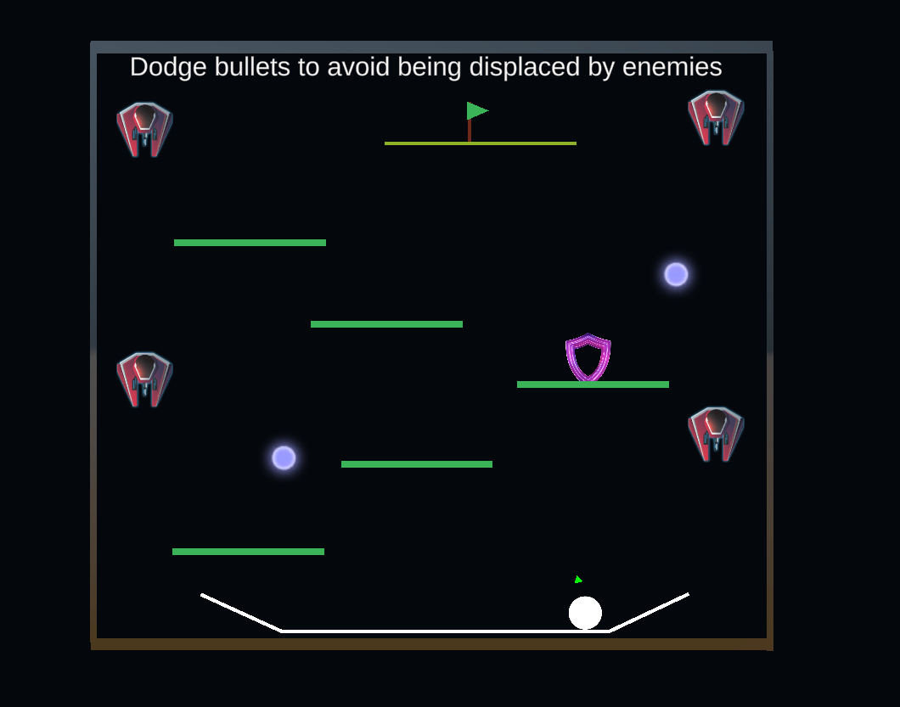

Reworked enemy tutorial, added shield in the tutorial

**Week-14:**

* Added restart menu button
* Added the ability to respawn power-ups
* Added the ability to respawn the disappearing platforms
* Fix: 3rd level ball falling from the platform
* Fix: Level 4 zoom fix

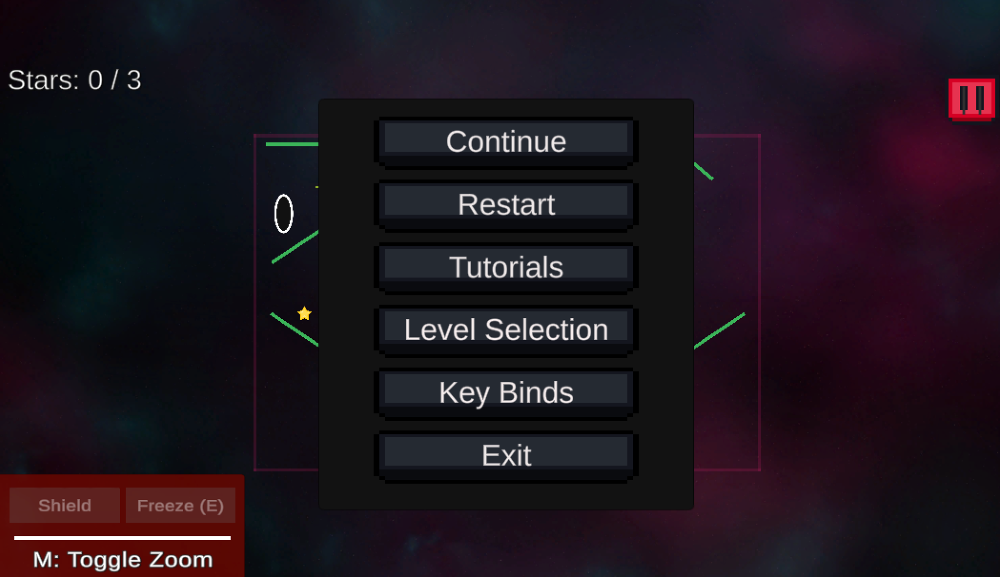

Restart button on the menu

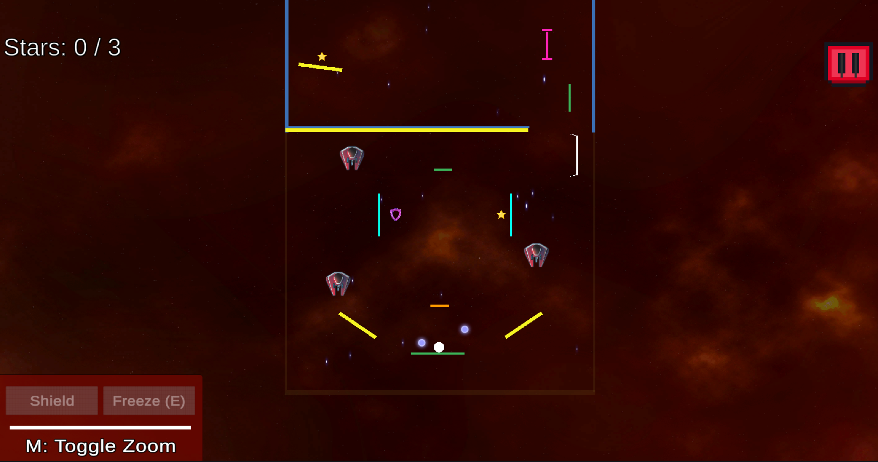

Level 4 zoom out fix

# 

# 

# 

# 

# 

# 

# 

# Weekly Progress

| **Week Number** | **Team Member** | |
| --- | --- | --- |
| **Week 6** | ***Utkarsha Mokashi*** | ***Aayan Shahnawaz Khan*** |
| *- Added Level 2 design*  *- Added the freeze powerup mechanism and working*  [*Level 2 design*](https://github.com/CSCI-526/fall-2024-project-tuesday-teamupp/commit/a660200b6e16a88417a2a3c44b859265fcd57a70)  [*Freeze Power-up*](https://github.com/CSCI-526/fall-2024-project-tuesday-teamupp/commit/276ad58f3dc765990cc107d0b036cdb7a84150ef) | *- Conceptualized Level 3 design and implemented,*  *- Added dynamic platforms* [*level 3 design*](https://github.com/CSCI-526/fall-2024-project-tuesday-teamupp/commit/1d698c9ed2da5ee09973d991c43b6179b3dda8b1)[*dynamic platforms*](https://github.com/CSCI-526/fall-2024-project-tuesday-teamupp/commit/0e9c27a54faa0ab2fddac3474e3970d8e0a0c369) |
| ***Yong-Han Chen*** | ***Pranav Kolhe*** |
| *- Level 2 design*  *- Restart the game if the player collects the triangle, check the collision*  *( save mechanic)*  [*save mechanic*](https://github.com/CSCI-526/csci-526-classroom-f24-tue-fall-2024-project-tuesday-Unity-Template/commit/92054db5e5e8dadfe430bd34bf7d90e938b208d1) | *- Level 3 design*  *- Shield Power Up*  *(Commits on week 7)* |
| ***Augusto Rivas Costante*** | ***Shalini Sai Prasad*** |
| *- Level 3 design iterations and discussions*  *- Enemy design*  *- Power-ups design*  *(Commits on week 7)* | *Level 2 design,*  *Fixed issues with the gravity and jumping*  *Added the tracker to the ball to indicate where the player needs to go*  *-*[*Gravity Fixes, Goal Tracker*](https://github.com/CSCI-526/csci-526-classroom-f24-tue-fall-2024-project-tuesday-Unity-Template/commit/1b347a6243d407b08e912b4cbd646b10634d451b) |
| **Week 7** | ***Utkarsha Mokashi*** | ***Aayan Shahnawaz Khan*** |
| *- Fixed the glitch with the curved platform introduced in layer 2*  *- Added level transitions*  [*Curved platform glitch*](https://github.com/CSCI-526/fall-2024-project-tuesday-teamupp/commit/5eb5dafd8efcab299a93569c386885df8df75754)  [*Level transitions*](https://github.com/CSCI-526/fall-2024-project-tuesday-teamupp/commit/da9020954e3cac16f99d5cc00f47fe128bb3824a) | *- Brought changes and uniformity to platforms on all levels* [*level 3 platform update*](https://github.com/CSCI-526/fall-2024-project-tuesday-teamupp/commit/e230fab88a3d31773e834c5e78374709dfbc8537) |
| ***Yong-Han Chen*** | ***Pranav Kolhe*** |
| *- Fix the save mechanic (triangle)*  *- Fix the shield mechanic*  *- Add tracker to level 1*  [*fix save mechanic*](https://github.com/CSCI-526/csci-526-classroom-f24-tue-fall-2024-project-tuesday-Unity-Template/commit/a43c0ce16670f3a808fe62b7e77849dba64a035a)  [*fix shield mechanic*](https://github.com/CSCI-526/csci-526-classroom-f24-tue-fall-2024-project-tuesday-Unity-Template/commit/35328cfb232d40688f4f63c80192405e1ee3a898)  [*add tracker to level 1*](https://github.com/CSCI-526/csci-526-classroom-f24-tue-fall-2024-project-tuesday-Unity-Template/commit/233b2716e4134dccdcda4f3f491bb03b54ab2cb5) | *- Checkpoint added to level 3*  *Tracker added to level 3*  *- Worked on the auto jump mechanic*  [*Shield Mechanic*](https://github.com/CSCI-526/fall-2024-project-tuesday-teamupp/commit/9f2bb2ca702242eb2d2a234c1f213d47c96d3dc6)  [*Checkpoint update*](https://github.com/CSCI-526/fall-2024-project-tuesday-teamupp/commit/cf5039d6320553c23d0762d33d8fad99dc145215) |
| ***Augusto Rivas Costante*** | ***Shalini Sai Prasad*** |
| *- Added enemies/bullets and configured them to shoot at the player’s position periodically*  *- WebGL Build*  [*Enemies and bullets*](https://github.com/CSCI-526/fall-2024-project-tuesday-teamupp/commit/737abfa0460d87d2c7088c014a65fb56d3d139a6)  [*GitHub Pages build*](https://github.com/arivas191/GravityClimb/commit/93acf975c7680c0646816a44b21df4ff0ad572bc) | *- Added the game over condition based on crossing the border of the level*  *- Create the curved platform prefab and added to level 2*  [*Border Collision Detection, Curved Platforms Prefab*](https://github.com/CSCI-526/csci-526-classroom-f24-tue-fall-2024-project-tuesday-Unity-Template/commit/30b5b13f7d56d774cf50846c5d91442ea2e70b89) |
| **Week 8** | ***Utkarsha Mokashi*** | ***Aayan Shahnawaz Khan*** |
| *- Improved teleport logic, to not allow self-teleport at the 2nd platform*  *- Made Design changes in Level 2*  [*Teleport and Level 2 Design changes*](https://github.com/CSCI-526/fall-2024-project-tuesday-teamupp/commit/c57e13f22696b70dfbe12264b1241473219ef460) | *- Implemented HUD: Angle counter, and Power Ups*  *- Fixed UI scaling issues for HUD over for different OS* [*Implement HUD*](https://github.com/CSCI-526/csci-526-classroom-f24-tue-fall-2024-project-tuesday-Unity-Template/commit/b3df0259ee120fc10d396e7820272595ad085d49)[*HUD scaling size fix*](https://github.com/CSCI-526/csci-526-classroom-f24-tue-fall-2024-project-tuesday-Unity-Template/commit/f677e93280febe4b26aaf17acc9d34c49066c6e0)[*HUD UI bug fix*](https://github.com/CSCI-526/csci-526-classroom-f24-tue-fall-2024-project-tuesday-Unity-Template/commit/5eb959c5cdab5b30af8329e87a82df2d8619f535) |
| ***Yong-Han Chen*** | ***Pranav Kolhe*** |
| *- Save mech across different levels*  [*save mech for diff levels*](https://github.com/CSCI-526/csci-526-classroom-f24-tue-fall-2024-project-tuesday-Unity-Template/commit/9b9b1b6436dae7416ec28709ea956ab2f8d30af1)  *- Write a common function for sending data to Google form*  [*sending data to google form*](https://github.com/CSCI-526/csci-526-classroom-f24-tue-fall-2024-project-tuesday-Unity-Template/commit/b81a3e457e15051e56566ce18de3263d6fc5800c) | *- Implemented the Flag vs Portal path Analytics.*  *- Worked on sending the data to Google forms*  [*Flag vs Portal Path Analytics*](https://github.com/CSCI-526/csci-526-classroom-f24-tue-fall-2024-project-tuesday-Unity-Template/commit/7fb75918a9f90d61ef5e0fb88ace7605c5158c6a) |
| ***Augusto Rivas Costante*** | ***Shalini Sai Prasad*** |
| *- Added a pop-up for the power-up collection in level 2*  *- Enhanced the design of the prefab for the pop-ups and added the portal text in level 1*  [*Pop-up for level 2*](https://github.com/CSCI-526/fall-2024-project-tuesday-teamupp/commit/cac98875493e6896065a04eaebf934debac8d9d1)  [*Pop-up enhancement*](https://github.com/CSCI-526/fall-2024-project-tuesday-teamupp/commit/320ded2f8e5bdfe3657ac6dc5a101692c93fad43) | * *Created the text overlay prefab* * *Made the overlay dynamic so that info-text can be added for any element through a function call*   [*Text Overlay*](https://github.com/CSCI-526/csci-526-classroom-f24-tue-fall-2024-project-tuesday-Unity-Template/commit/ce62f810552016fe580f1fbdd00322f38aa32b80) |
| **Week 9** | ***Utkarsha Mokashi*** | ***Aayan Shahnawaz Khan*** |
| *- Fixed the freeze power-up bug, this fixed the freeze continuing to the next levels or the freeze staying even after dying, this fix resets the freeze after dying or changing level.*  [*Freeze fix*](https://github.com/CSCI-526/fall-2024-project-tuesday-teamupp/commit/5b1df48680b9b2da355ffe2d19eeb07425991256) | * *Implemented Resizable platforms for Level 2 with prefabs*   [*Implemented Resizable Platforms*](https://github.com/CSCI-526/fall-2024-project-tuesday-teamupp/commit/cf2324f94cb3231534ceebbd4027f04543e62036) |
| ***Yong-Han Chen*** | ***Pranav Kolhe*** |
| *- Write the function for checking the player go to the flag and go to the portal afterward*  [*Analytics(go to flag or portal)*](https://github.com/CSCI-526/csci-526-classroom-f24-tue-fall-2024-project-tuesday-Unity-Template/commit/0d7ad7bf2251a998459d54e0e6b71fc1bf4bfa18)  *- fix: change the time for sending data to Google form*  [*fix: change the time for sending data to Google form*](https://github.com/CSCI-526/csci-526-classroom-f24-tue-fall-2024-project-tuesday-Unity-Template/commit/567fe869020c8db55c90336c117bedb5ff3fd467) | *- Incorporated the go-to flag or portal metric in Level 2*  *- Fix: Data in the Google form updates independently for each level upon completion.*  [*Analytics implementation and Fix*](https://github.com/CSCI-526/csci-526-classroom-f24-tue-fall-2024-project-tuesday-Unity-Template/commit/4aea143dfbb65173b491e9ea18af99908cf03d8b) |
| ***Augusto Rivas Costante*** | ***Shalini Sai Prasad*** |
| * *Created new prefabs for the entry and exit portals and enhanced their design* [*Portal redesign*](https://github.com/CSCI-526/fall-2024-project-tuesday-teamupp/commit/ed832e20a688be6ac42af2e862cd0cc1c7a5de25) | * *Tutorial design* * *Prefab creation for tutorial*   [*Tutorial Design*](https://github.com/CSCI-526/csci-526-classroom-f24-tue-fall-2024-project-tuesday-Unity-Template/commit/623086ed22f806c7d26b8f18bbd54b3eb931b226) |
| **Week 10** | ***Utkarsha Mokashi*** | ***Aayan Shahnawaz Khan*** |
| * *Updated freeze logic to happen automatically without needing any key press.* [*Auto-freeze update*](https://github.com/CSCI-526/fall-2024-project-tuesday-teamupp/commit/4217c4334960a8b1c7a3fff540958566489f02d9) * *Revamped the border logic for game over part for all the three levels* [*Game over border revamp*](https://github.com/CSCI-526/fall-2024-project-tuesday-teamupp/commit/5fcd8f68eff89ece23d1b61f3b5ec60437093f40) | * *Fixed Level 3 spawn bug* * *Changed Zoom-in implementation for camera*   [*Fix: Level 3 spawn bug*](https://github.com/CSCI-526/fall-2024-project-tuesday-teamupp/commit/bef1727f72f4ee8cf859eb6144bf00bfbd3b4e2c) [*Added camera zoom-in delay*](https://github.com/CSCI-526/fall-2024-project-tuesday-teamupp/commit/abe13debffca582a8ac33033096ede3f6fc2c6a9) |
| ***Yong-Han Chen*** | ***Pranav Kolhe*** |
| *- fix: google form for level 3*  [*fix: google form for level 3*](https://github.com/CSCI-526/csci-526-classroom-f24-tue-fall-2024-project-tuesday-Unity-Template/commit/8ddac59030a1ebf4d55c82f6923478c1bb59bfd2)  *- remove checkpoints*  [*remove checkpoints*](https://github.com/CSCI-526/csci-526-classroom-f24-tue-fall-2024-project-tuesday-Unity-Template/commit/fe1104c089ab6f553644991ffbffaead322a2343) | * *Fix: Enhanced Level 2 design to increase the challenge of reaching the flag.* * *Refined the tracker to make it more noticeable.*   [*Level 2 design and tracker update*](https://github.com/CSCI-526/csci-526-classroom-f24-tue-fall-2024-project-tuesday-Unity-Template/commit/09ef10f150f8d26a9f5c353874106f9b4f83fd70) |
| ***Augusto Rivas Costante*** | ***Shalini Sai Prasad*** |
| * *Changed the locations of the flags so they’re more accessible after teleporting from the portal* * *Enclosed the flag area to prevent the player from flying out after using the portal*   [*Flag changes*](https://github.com/CSCI-526/fall-2024-project-tuesday-teamupp/commit/330419556c240533234feb379c11eac56d641daf) | * *Tutorial Scripts and logic changed for tutorial levels* * *Visual elements for more intuitive tutorial interaction* * *Tutorial implementation for move, jump, and portals*   [*Tutorial Integration*](https://github.com/CSCI-526/csci-526-classroom-f24-tue-fall-2024-project-tuesday-Unity-Template/commit/4f28aa53ecbb620e3c2139bf1ad3bc3bb3f7e3f4) |
| **Week 11** | ***Utkarsha Mokashi*** | ***Aayan Shahnawaz Khan*** |
| * *Created the Start screen and connected it to various scenes.*   [*Added start screen*](https://github.com/CSCI-526/fall-2024-project-tuesday-teamupp/commit/7d3c0eb28126e16a513b894130408b7ab61bb1ee)  [*Connection to tutorial and start level*](https://github.com/CSCI-526/fall-2024-project-tuesday-teamupp/commit/c133eee8c6c037840cabab2a18a9e29a6d1c696d)   * *Added level screen, and tutorial screen, and connected start screen to it, as well as worked on overall game connectivity using the main menu button,*   [*Level Screen and Connectivity*](https://github.com/CSCI-526/fall-2024-project-tuesday-teamupp/commit/0798f709ba02fd3b8fa24b915498d64eeb2f5da0)  [*Tutorial Screen and Connectivity*](https://github.com/CSCI-526/fall-2024-project-tuesday-teamupp/commit/6979ae69718b9f009cf94518904c2908f5e909fd)   * *Added game-over logic to tutorial levels*   [*Game over to tutorial levels*](https://github.com/CSCI-526/fall-2024-project-tuesday-teamupp/commit/45f0f3047d56b205800df1acd005d9fa0279b7b1)   * *Reverted freeze power-up to work dynamically*   [*Dynamic freeze power-up*](https://github.com/CSCI-526/fall-2024-project-tuesday-teamupp/commit/886b182af35bd6062a7238928d1e9da0e9d9d363)   * *Fix: Ability for main menu canvas as well as you win canvas to scale according to screen size*   [*Screen scaling*](https://github.com/CSCI-526/fall-2024-project-tuesday-teamupp/commit/45f0f3047d56b205800df1acd005d9fa0279b7b1) | * *Implemented the Second Part of Level 4:* [*commit*](https://github.com/CSCI-526/fall-2024-project-tuesday-teamupp/commit/acbf6abdf0932dd2949b523510ac05c8c5b688cc) * *Implemented Toggle Zoom functionality:* [*commit*](https://github.com/CSCI-526/fall-2024-project-tuesday-teamupp/commit/520599cf333ff17e2ef411ac4aa49103f612a8e2) * *Revamped HUD: Removed Angle, changed the layout for powerups, and added controls:* [*commit1*](https://github.com/CSCI-526/fall-2024-project-tuesday-teamupp/commit/75f732d785a1098661aab75fd949cc91fed87fde)*,* [*commit2*](https://github.com/CSCI-526/fall-2024-project-tuesday-teamupp/commit/fd65c1ef5273a7c3f6b389ed68673e705fef4909) * *Fixed jump bug on level 4:* [*commit*](https://github.com/CSCI-526/fall-2024-project-tuesday-teamupp/commit/285368d004673d950af27a41fba83ccc058c5f51) |
| ***Yong-Han Chen*** | ***Pranav Kolhe*** |
| *- send hit by a bullet or not to google form*  [*hit by bullets*](https://github.com/CSCI-526/csci-526-classroom-f24-tue-fall-2024-project-tuesday-Unity-Template/commit/f3aaada8101f8fc9683ad773411babc52fed7dd6)  [*hit by bullets in level 4*](https://github.com/CSCI-526/csci-526-classroom-f24-tue-fall-2024-project-tuesday-Unity-Template/commit/6a550371b1bddf6c162f6eab726bee5031de3f20)  *- record the number of jumps and time to complete the level*  [*# of jump and time to complete the level*](https://github.com/CSCI-526/csci-526-classroom-f24-tue-fall-2024-project-tuesday-Unity-Template/commit/67d31b96a2f9ae192f60ae0cef2ac353b790d195)  *- record the number of platforms used in levels 1, 2, 3*  [*# of platform used level 1*](https://github.com/CSCI-526/csci-526-classroom-f24-tue-fall-2024-project-tuesday-Unity-Template/commit/fb12c44b265264836e16f8afacd5e158d944468b)  [*# of platforms used level 2*](https://github.com/CSCI-526/csci-526-classroom-f24-tue-fall-2024-project-tuesday-Unity-Template/commit/b59118cf1f290bd26f7ab4acae50a8c2fd640741)  [*# of platforms used level 3*](https://github.com/CSCI-526/csci-526-classroom-f24-tue-fall-2024-project-tuesday-Unity-Template/commit/517ff4cf9e086955fbf392d569e8738ba7da0705)  *- fix: num of platform used in level 3 and level 4*  [*fix: # of platform used*](https://github.com/CSCI-526/csci-526-classroom-f24-tue-fall-2024-project-tuesday-Unity-Template/commit/72cc83824ade9fe783cc520b98e740ff032d431c)  *- fix: get you win in level 4*  [*fix: get you win text in level 4*](https://github.com/CSCI-526/csci-526-classroom-f24-tue-fall-2024-project-tuesday-Unity-Template/commit/b333c00912aa6a84de440790513c6f4038d7d74e) | * *Implemented the Power-Ups Analytics*   [*Power-Ups Analytics*](https://github.com/CSCI-526/csci-526-classroom-f24-tue-fall-2024-project-tuesday-Unity-Template/commit/537728d0888fdc149d0f50601fab353764838452)  [*Adding Power-Ups Analytics in Level 4*](https://github.com/CSCI-526/csci-526-classroom-f24-tue-fall-2024-project-tuesday-Unity-Template/commit/49f6a2df784dadde04f6a905f4b7db8c89ac8403)  [*Changes in Freeze Power-up*](https://github.com/CSCI-526/csci-526-classroom-f24-tue-fall-2024-project-tuesday-Unity-Template/commit/30013650794d28ba524434234021bac78f4385f6)   * *Added Shaking Platforms to Level 4*   [*Shaking Platforms*](https://github.com/CSCI-526/csci-526-classroom-f24-tue-fall-2024-project-tuesday-Unity-Template/commit/f9165742f5e7649e8942d0592b83ac5a332ece63) |
| ***Augusto Rivas Costante*** | ***Shalini Sai Prasad*** |
| * *Created the first half of level 4 -* [*commit*](https://github.com/CSCI-526/fall-2024-project-tuesday-teamupp/commit/887d6ac2608153feecf1d6b60aebb13870061818) * *Added logic to track if the player died by a bullet impact (used in analytics) -* [*commit*](https://github.com/CSCI-526/fall-2024-project-tuesday-teamupp/commit/927c41f2882ef0849c07dc32f2ec0eab76aaca59) * *Removed the green tracker from the player and connected levels 3 and 4 -* [*commit*](https://github.com/CSCI-526/fall-2024-project-tuesday-teamupp/commit/32f945c02ba0cf5f8821b73d509a166e9639107d) * *Fixed random shield activation bug -* [*commit*](https://github.com/CSCI-526/fall-2024-project-tuesday-teamupp/commit/919c1353c16ad398b300fc238cc8161514b051cd) * *Added a static text to the enemy tutorial level -* [*commit*](https://github.com/CSCI-526/fall-2024-project-tuesday-teamupp/commit/c30dac09b9109ce7331d8e56d359bb0bdde4f97e) | * *Bug fixes to the tutorial* * *Portal Tutorial redesign*   [*Portal Redesign*](https://github.com/CSCI-526/csci-526-classroom-f24-tue-fall-2024-project-tuesday-Unity-Template/commit/3ac88eefde692de37411360402e39a9390d0b335)   * *Enemy Tutorial Added*   [*Enemy Tutorial*](https://github.com/CSCI-526/csci-526-classroom-f24-tue-fall-2024-project-tuesday-Unity-Template/commit/6073afbb30ed442ee1dde6f192007c343bdb6806) |
| **Week 12** | ***Utkarsha Mokashi*** | ***Aayan Shahnawaz Khan*** |
| * *Worked on Level 2 design changes*   [*commit*](https://github.com/CSCI-526/fall-2024-project-tuesday-teamupp/commit/1edeaac06337b8bf7d8b7334eee4846cce953422)*,* [*commit2*](https://github.com/CSCI-526/fall-2024-project-tuesday-teamupp/commit/e1aa0b9f9aaf162909591489a15b07c30717a0f0) | * *Added Blue borders to Level 4:* [*commit*](https://github.com/CSCI-526/fall-2024-project-tuesday-teamupp/commit/47ed972d9df95a5586a45bea7ee017ac60739e60) * *Rearranged HUD PowerUps & Control Section:* [*commit*](https://github.com/CSCI-526/fall-2024-project-tuesday-teamupp/commit/bfd2325e11a030313b8fca7a49043d42d1480743) |
| ***Yong-Han Chen*** | ***Pranav Kolhe*** |
| [*add background*](https://github.com/CSCI-526/csci-526-classroom-f24-tue-fall-2024-project-tuesday-Unity-Template/commit/0291c0fa19eddbaa3c336bcb3b8e281062e4e6d0)  *- fix: change border color*  [*change level border*](https://github.com/CSCI-526/csci-526-classroom-f24-tue-fall-2024-project-tuesday-Unity-Template/commit/d1a3fb252039004d58e834687fa6d7243541fd71)  *- fix: add rotation to skybox*  [*add rotation to skybox*](https://github.com/CSCI-526/csci-526-classroom-f24-tue-fall-2024-project-tuesday-Unity-Template/commit/4ea210f73e6320d0ee5a85bf09a3c29d4834f1a0)  *- fix: remove unnecessary assets*  [*remove unnecessary assets*](https://github.com/CSCI-526/csci-526-classroom-f24-tue-fall-2024-project-tuesday-Unity-Template/commit/b53dab1f397cfe3b1be538572f965c15def04219) | * *Added Pause button to the levels and tutorials.* * *Added 5 buttons to the pause menu:*   [*Pause button and pause menu*](https://github.com/CSCI-526/csci-526-classroom-f24-tue-fall-2024-project-tuesday-Unity-Template/commit/1f532a46efbc3dc9c373acdc6fd0f6a4dce96de1)   * *Skinned the pause menu buttons and background.*   [*Skinned the pause menu button*](https://github.com/CSCI-526/csci-526-classroom-f24-tue-fall-2024-project-tuesday-Unity-Template/commit/642bce1e0eaeb34ff923e5805681691967b8efc9) |
| ***Augusto Rivas Costante*** | ***Shalini Sai Prasad*** |
| * *Added new prefabs for enemies and bullets and imported external assets for both -* [*commit*](https://github.com/CSCI-526/fall-2024-project-tuesday-teamupp/commit/61d07892b08385b49ea1ec58a08be1ec9decf910) * *Added a shield, a cross platform, and removed some enemies towards the end of level 4 to make the level more manageable -* [*commit*](https://github.com/CSCI-526/fall-2024-project-tuesday-teamupp/commit/d17a96f092af19fa8028374945a7c2ca719177eb) | * *Added prefabs for the freeze and shield power ups*   [*Power-up prefabs*](https://github.com/CSCI-526/csci-526-classroom-f24-tue-fall-2024-project-tuesday-Unity-Template/commit/7103cd6184d0d76893c2577abb0fc680ae9ea30b)   * *Skinned the freeze power-up and the shield power-up*   [*Skinned Power Ups*](https://github.com/CSCI-526/csci-526-classroom-f24-tue-fall-2024-project-tuesday-Unity-Template/commit/864e0bc583907b340c2746b9a5434378dda253c5) |
| **Week 13** | ***Utkarsha Mokashi*** | ***Aayan Shahnawaz Khan*** |
| * *Added the exit button to the main menu -* [*commit*](https://github.com/CSCI-526/fall-2024-project-tuesday-teamupp/commit/3cbfbdece71c8a8310fc43bf93059372d9dd427e) * *Updated the pause button prefab -* [*commit*](https://github.com/CSCI-526/fall-2024-project-tuesday-teamupp/commit/71541da3102e4c828d98f31dea186396703f1941) * *Fix: Level Selection button not working -* [*commit*](https://github.com/CSCI-526/fall-2024-project-tuesday-teamupp/commit/a082d94199a7754cfe7b8c89d5b0323c95832491) * *Updated level 3 and 4 threshold boundaries -* [*commit*](https://github.com/CSCI-526/fall-2024-project-tuesday-teamupp/commit/d7dbfe8e16dc68b6df6385573f92350e37b0108d) * *Added the Stars UI and later worked on some updates/changes for the same -* [*commit*](https://github.com/CSCI-526/fall-2024-project-tuesday-teamupp/commit/efcddac8e5bdab7197de0278df33ecfd9dcaf2e5)*,* [*commit2*](https://github.com/CSCI-526/fall-2024-project-tuesday-teamupp/commit/d71c831bd52675bc8dea32aa13530850c5e70fdd)*,* [*commit3*](https://github.com/CSCI-526/fall-2024-project-tuesday-teamupp/commit/9869ba8162fa43eae8d3b5359d629c0671e1908b) * *Updated the enemy tutorial to include shield powerup, as well as reworked the tutorial -* [*commit*](https://github.com/CSCI-526/fall-2024-project-tuesday-teamupp/commit/421170cec9489768dbf0796e8278ff6e04a52b25)*,* [*commit2*](https://github.com/CSCI-526/fall-2024-project-tuesday-teamupp/commit/38bd8240c99f0978b94937a03a9b36b1e222d0b7)*,* [*commit3*](https://github.com/CSCI-526/fall-2024-project-tuesday-teamupp/commit/b4fc03e0f6bcd66152be7215ce45e595402310dc) * *Added screen scaling to all levels -* [*commit*](https://github.com/CSCI-526/fall-2024-project-tuesday-teamupp/commit/5e8673062863c6472885c261ab1d82317437dcd5) | * *Updated Tutorial UI & Fixed platforms morphing:* [*commit*](https://github.com/CSCI-526/fall-2024-project-tuesday-teamupp/commit/40b9b70353f86a205a3fb2e82de7c59dff06edba) * *Space Borders made more visible:* [*commit*](https://github.com/CSCI-526/fall-2024-project-tuesday-teamupp/commit/edc4bd2e7af59843cfff47743d99d22f57d52c68) * *Added space theme to UI:* [*commit*](https://github.com/CSCI-526/fall-2024-project-tuesday-teamupp/commit/edc4bd2e7af59843cfff47743d99d22f57d52c68) * *Added Disappearing Prefab, added platforms to Level 4:* [*commit*](https://github.com/CSCI-526/fall-2024-project-tuesday-teamupp/commit/290e6f832c5a1e4336c8a43705bdbd2f40dc19b7) * *Added Backdrop to Level 3 & 4:* [*commit*](https://github.com/CSCI-526/fall-2024-project-tuesday-teamupp/commit/e0d90a754fc8a028f6d17c59615dc0edacddae0b) |
| ***Yong-Han Chen*** | ***Pranav Kolhe*** |
| *- feat: add portal to level 3*  [*add portal to level 3*](https://github.com/CSCI-526/csci-526-classroom-f24-tue-fall-2024-project-tuesday-Unity-Template/commit/d2e18137996c0a6c0aa21e44d9e78c0e64ec1b5d)  *- fix: remove skybox*  [*remove skybox*](https://github.com/CSCI-526/csci-526-classroom-f24-tue-fall-2024-project-tuesday-Unity-Template/commit/30366a098006e0845a41ba0daa53b68ae147b18b)  *- feat: add backgrounds to level 1 and 2*  [*add background to level 1 and level 2*](https://github.com/CSCI-526/csci-526-classroom-f24-tue-fall-2024-project-tuesday-Unity-Template/commit/f1c7d4cc7861a4ff286bbb9d33c42ee1fe7e7a96) | * *Fixed the Main menu glitch: Level Selection button wasn’t working.*   [*Main Menu glitch*](https://github.com/CSCI-526/csci-526-classroom-f24-tue-fall-2024-project-tuesday-Unity-Template/commit/d8bbd2a647572fa1b5234bf673e754e7743bdaaa)   * *Helped add Portal to level 3*   [*Portal in Level 3*](https://github.com/CSCI-526/csci-526-classroom-f24-tue-fall-2024-project-tuesday-Unity-Template/commit/d2e18137996c0a6c0aa21e44d9e78c0e64ec1b5d)   * *Helped create stars UI*   [*Stars UI*](https://github.com/CSCI-526/csci-526-classroom-f24-tue-fall-2024-project-tuesday-Unity-Template/commit/d71c831bd52675bc8dea32aa13530850c5e70fdd)   * *Updated the key binds button*   [*Key binds update*](https://github.com/CSCI-526/csci-526-classroom-f24-tue-fall-2024-project-tuesday-Unity-Template/commit/1d1509d2ee37145e227903431936543e8a917fb2) |
| ***Augusto Rivas Costante*** | ***Shalini Sai Prasad*** |
| * *Added a tutorial for the bouncy platform and rearranged the freeze powerups along the levels -* [*commit*](https://github.com/CSCI-526/fall-2024-project-tuesday-teamupp/commit/7025985b9fae11daf4122568a65934623ddcc5a5) * *Placed the stars in level 4 -* [*commit*](https://github.com/CSCI-526/fall-2024-project-tuesday-teamupp/commit/46dd61bb975d8c0cb62bd0b8e2c80b34fb702b20) * *Rearranged the stars in level 3 for better placement -* [*commit*](https://github.com/CSCI-526/fall-2024-project-tuesday-teamupp/commit/092238b0bd88c5fd0c634b4fd19a4f59b3168ae5) * *Adjusted the arrows next to the portals to indicated entry/exit points -* [*commit*](https://github.com/CSCI-526/fall-2024-project-tuesday-teamupp/commit/bbe7bdcc52eea2bd72fd7d79d8426c76eea07dfc) * *Re-added text to the new enemy tutorial -* [*commit*](https://github.com/CSCI-526/fall-2024-project-tuesday-teamupp/commit/faedc14a0acd0a038392f933db3ec771c605f472) | * *Created Star Prefab* * *Created Stars System* * *Changed portal prefab*   [*Stars and Portal Prefabs*](https://github.com/CSCI-526/csci-526-classroom-f24-tue-fall-2024-project-tuesday-Unity-Template/commit/e0deb1685b20412436e3005d2efeea511f09ea69)   * *Added logic for stars counting* * *Added logic to light up portal when stars are collected* * *Changed portal logic to activate after all stars are collected*   [*Stars and Portal Logic*](https://github.com/CSCI-526/csci-526-classroom-f24-tue-fall-2024-project-tuesday-Unity-Template/commit/e0deb1685b20412436e3005d2efeea511f09ea69)   * *Modified portal tutorial* * *Added stars to levels*   [*Tutorial Modification and Level design*](https://github.com/CSCI-526/csci-526-classroom-f24-tue-fall-2024-project-tuesday-Unity-Template/commit/7fc775381b026bb29cc6b9edaaefec43960b4b42) |
| **Week 14** | ***Utkarsha Mokashi*** | ***Aayan Shahnawaz Khan*** |
| * *Fixed the level 4 zoom, so that seeing the whole level zoom is not overwhelming -* [*commit*](https://github.com/CSCI-526/fall-2024-project-tuesday-teamupp/commit/c26576bbc140180044c6b8aa27008ec17de58ff4) * *Added the ability for the freeze powerup to respawn every 15 seconds after being collected -* [*commit*](https://github.com/CSCI-526/fall-2024-project-tuesday-teamupp/commit/5a96f0a39ded0ea8c544f9d2fd5806f3191cc504) | * *Fixed the level 3 spawn glitch, where the round level start with eliminating the player -* [*commit*](https://github.com/CSCI-526/fall-2024-project-tuesday-teamupp/commit/0269b1fce13f169c9f2c1dea67e35be164cbdd3e) |
| ***Yong-Han Chen*** | ***Pranav Kolhe*** |
| *- feat: regenerate the breaking platform*  [*regenerate the breaking platform*](https://github.com/CSCI-526/fall-2024-project-tuesday-teamupp/commit/ecd7eddb2e337e6a11cb702004910241d13586e6) | * *Added a restart level button to the Pause menu*   [*Restart Button*](https://github.com/CSCI-526/fall-2024-project-tuesday-teamupp/commit/f9fc0965036aadd75811ada4c83280a57f7d8824) |
| ***Augusto Rivas Costante*** | ***Shalini Sai Prasad*** |
| * *Implemented the logic for respawning the shield powerup 15 seconds after collecting it -* [*commit*](https://github.com/CSCI-526/fall-2024-project-tuesday-teamupp/commit/3c12696d5f5fad0dd5bc3bc2042afc470c5cc241) | * *Fixed infinite jump bug*   [*Infinite Jump Glitch Fixed*](https://github.com/CSCI-526/csci-526-classroom-f24-tue-fall-2024-project-tuesday-Unity-Template/commit/5dc204689b378897babaeba7faad808d55610184)   * *Code cleanup*   [*Code cleanup*](https://github.com/CSCI-526/csci-526-classroom-f24-tue-fall-2024-project-tuesday-Unity-Template/commit/4238ec0b22bffb54953a2c890f4839887b252973) |

# Review Notes

**[Alpha Progress Check - Playtest 1 10/15/2024]**

**Positive feedback:**

* Players understood the rotation mechanic almost immediately
* Players noticed the different types of platforms and their functionality
* Players figured out that the direction of gravity is also relative to the rotation of the map
* Players figured out the controls with the arrows and spacebar
* Realized that the triangle above the player might be the direction to go in
* Liked the idea of the portal platform
* Collected the collectible item in Level 2

**Points to address:**

* Seeing the tracker above the player misled the tester into thinking that the mouse control was involved
* The tracker also caused confusion once the player noticed the flag because it was pointing toward the portal instead of the flag
* Struggled with the angle of reaching the portal
* Tried to speed run the level by turning 180 degrees to fall towards the portal
* The final jump to the flag from level 1 was difficult

**Staff Feedback**

* Jump is not considered a mechanic
* Suggested that rotation be considered the core mechanic
* Consider adding a tutorial level

**[Alpha Presentation and Analytics Staff Feedback 10/22/2024]**

* Enemy bullets do not just have to be antagonistic - they can also help the player
* Change the graph used for metric 1 to a bar graph instead of a pi chart
* Change the collection method of metric 1 since distance is not good enough to know if they go to the portal or not
* Explain more about the collection method for analytics
* Change level 3 to include level-wise bar graphs

**[Alpha Analytic Feedback 10/22/2024]**

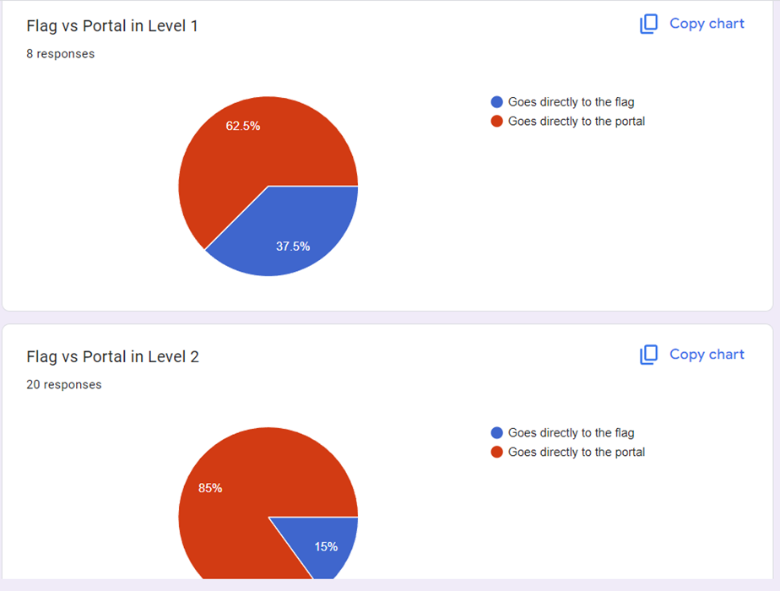

* 40% of the players tried to reach the flag directly in Level 1 vs only 15% in Level 2
* The charts show that players learned from the previous level and did not directly reach the flag once they figured out the portal from Level 1

**[Alpha Survey Feedback 10/28/2024]**

* All the players enjoyed the concept of the game. The most enjoyable aspects were the level rotation and the change in gravity
* Half the players said that learning the game was difficult
* Players were frustrated by the fact that they did not understand the purpose of the power-ups, especially the freeze power-up
* Players did not like that dying at any level made you respawn from level 1
* Some players found it difficult to control rotation and gravity
* Some players found it frustrating not being able to see where the end goal of the game was
* Suggestions given were mostly about designing a tutorial level and giving players more indication about where to go

**[Playtest Feedback 10/29/2024]**

**Tester 1:**

* Understood movement, bullets, and the final goal
* Struggled with the power-ups - did not understand functionality after activating it
* Missed/did not notice the checkpoint mechanism
* Struggled with the difficulty on level 3 - repeated dying

**Tester 2:**

* Was not able to figure out that the jump was controlled by the spacebar
* Could not find the level 2 portal - ignored the tracker and gave up
* Did not understand the power-ups and checkpoints

**Tester 3:**

* Easily completed the game
* Understood the power-ups
* Did not understand checkpointing

**Common issues:**

* Testers struggled with understanding the power-ups
* Testers mostly ignored the checkpointing mechanisms
* Testers ignored the tracker and did not find the portal as the way to get to the final goal

**Staff Feedback:**

* If using checkpoints should spawn the player back at the checkpoint location
* Increase the zoom-in time at the start of the level
* Suggested that if a player figures out one path they will constantly use that path and will not explore the map

**[Playtest Feedback 11/05/2024]**

**Tester 1:**

* Did not understand the portal tutorial
* Used the freeze powerup but did not completely understand the functionality
* Struggled with level 3 difficulty. Tried to speed run by 180-degree rotation
* Did not understand the tracker
* Did not like the auto freeze power-up

**Tester 2:**

* Did not find the portal tutorial helpful - was able to skip the portal and reach the flag
* Did not like the auto freeze although they understood it
* Repeatedly tried to go to the flag without using the portal
* Tried speedrunning level 2 and 3
* Kept falling while trying to collect the shield

**Tester 3:**

* Noticed and followed the portal in level 1
* Understood the platform colors
* Did not notice the tracker
* Kept following the same path
* Did not notice or use the powerups until much later in the game
* Did not like the auto-freeze
* Did not use or understand the angle in the HUD

**Common Issues:**

* All the testers did not like the auto-freeze power-up change made
* Most testers tried speedrunning the game due to the difficulty
* Players struggled with the shield power-up and kept dying during the collection
* Ignored the tracker

**Staff Feedback:**

* Change the path to collect the shield
* Remove angle in HUD - not helpful
* Revert the freeze to the key press activation instead of auto-activation

**[Beta Survey Feedback 11/12/2024]**

* Players appreciated the game design, the smooth mechanics, the tutorial levels and the portals
* Half of the players found the heads-up display somewhat helpful whereas the other half were split between finding it very helpful and not noticing it at all
* 60% of the players found the difficulty progression from the Tutorial to Level 1 well paced whereas the other 40% found it too easy
* 70% of the players found the difficulty progression from Level 1 to Level 2 well-paced, 20% found it too easy and the remaining 10% found it too difficult
* 60% of the players found the difficulty progression from Level 2 to Level 3 well-paced whereas 15% found it too easy and the remaining 25% found it too difficult
* 45% of the players found the difficulty progression from the Level 3 to Level 4 well paced, only 10% found it too easy and the remaining 45% found it too difficult
* Players were almost equally split on the replayability of the game. 35% said they were likely or very likely to replay the game, 32% were neutral and 33% were unlikely to replay the game
* Majority of the players said the features they would like to see the most to ensure replayability were additional levels or a leaderboard

**[Playtest Feedback 11/19/2024]**

**Tester 1:**

* Completed tutorials quickly
* Cleared all levels with ease
* Used free fall in level 3
* Purposefully tried not to not collect or use power-ups
* Used bullets to propel themselves
* Said the bouncy platform was not consistent

**Tester 2:**

* Only played the enemies tutorial and skipped the rest
* Level 1 tried to directly go to the flag
* Saw the portal in the second try but still tried to go to the flag
* Did not notice the HUD
* Used free fall in level 3
* Tried to speedrun level 4 but failed
* Said that the borders were not clear in level 4
* Figured out how to use freeze power up eventually

**Tester 3**

* Found a glitch with the restart after pause
* Struggled in the enemy tutorial
* Ignored power up in Level 2
* Liked the zoom in animation
* Speed ran level 3

**Common Issues:**

* All players speedran level 2 and 3
* Most players did not collect power ups

**Staff Feedback:**

* Breadcrumb the player to where you want them to go
* Introduce a star system to reward players who explore the map

**[Playtest Feedback 11/26/2024]**

**Tester 1:**

* Liked the bouncy platform tutorial
* Liked the shield power up
* Wanted tutorials for all the different types of platforms
* Suggested adding a level restart button
* Suggested power-up regeneration
* Wanted to play the game zoomed out

**Tester 2:**

* Liked the addition of stars
* Explored the entire map
* Struggled collecting the stars
* Suggested a tutorial for the freeze power-up

**Tester 3:**

* Liked the stars above the portal
* Liked enemy tutorial and understood it
* Did not know when to use freeze
* Infinite jump removal made level 2 difficult
* Suggested making star collection optional

**Common Feedback:**

* All the players enjoyed the addition of the stars
* Players gave helpful suggestions about regenerating the power-ups and disappearing platforms
* Players were still a little confused about the freeze power-up

#### **Hypothesized Issues from Feedback (Beta)**

| **Hypothesized Issue** | **Feedback** | **Potential Fix 1** | **Potential Fix 2** | **Fix Timeline (Action Plan)** |
| --- | --- | --- | --- | --- |
| The direction of the final goal (flag vs portal) is unclear | Most playtesters ended up going towards the flag only to realize it was not reachable  Analytics showed that 60% of the players moved toward the flag rather than the portal  6 players in the survey said they did not know which direction to go in | Use a tracker above the player to show the direction in which the player has to go in | Have an inlay map that shows where the goal is | We’re going to introduce a tracker by week 8 so that the players can find out the direction of movement along with a zoom-in at the start of the game |
| Players do not understand the controls | Playtesters did not know how to jump  Some playtesters tried using the mouse to navigate | Have pop-up text in level 1 so that the player can understand how to move and jump | Create tutorial levels so that the player can learn basic controls before moving to the actual game | We will create basic tutorials by week 11 so that players are familiar with movement and control before starting the levels |
| Players do not like the idea of restarting at level 1 after falling | Playtesters were frustrated by the idea of restarting the game from level 1 every time they fell off the map  9 players in the alpha survey mentioned that they did not like the respawn | We will add a checkpointing mechanism so that players that collect these and respawn at the same level | Change the game over logic to make the player not restart at level 1 | We will add checkpointing by week 9 so that this power-up can save the player’s progress through the levels  We will remove checkpoints and change gameplay logic by week 12 so that there is no level 1 restart |
| Players do not use the power-ups provided to them | Playtesters did not understand the concept of the freeze power-up  Half of the alpha survey results said that they did not get the point of the shapes in the level  Playtesters were not collecting the powerups and directly moving toward the goal | Create tutorial levels for the power-ups | Add info-text as a pop-up whenever the power-ups are collected so that the player knows when to use it | We will add info text to the power-ups by week 10.  We will also change the placement of these in the early levels so that players are forced to collect it  We will update the heads-up display to show the player which power-up they have collected |
| Players do not understand the use of the tracker | Most playtesters ignored the tracker while playing or did not understand what it was  One player thought it was something that needed to be controlled by the mouse  Players are still confused about the direction to go in | Make the tracker bigger and more obvious | Create a toggle zoom feature that players can use to view the entire map and remove the tracker | We will create a toggle zoom by week 12 so that players can zoom out and see the entire map |
| Players are able to speedrun the game by turning the map 180 degrees and falling towards the goal rather than interacting with the platforms and power-ups | Multiple playtesters we saw during alpha and beta playtesting were able to fall towards the goal  Analytics measuring the number of jumps showed 50% of the players take less than 5 jumps to clear levels 1-3 indicating that most players exploit the 180 degree turn  Analytics showed that players are interacting with less than half of the platforms in each level from 1 - 3, again indicative of speedrunning | Make the levels harder  Block the goal  Rework level design | Introducing an incentive for players to stay on a platform for more than a second | We will rework the levels by week 11 to increase the difficulty and make more players interact with the map |

#### **Hypothesized Issues from Feedback (Gold)**

**Hypothesized Issue #1**

The direction of the final goal (flag vs portal) is unclear

**Significance**

Since the final goal of the game is not clear, the players are not able to traverse the map and complete the level

**Feedback/Data points**

* Most playtesters ended up going towards the flag only to realize it was not reachable
* Analytics showed that 60% of the players moved toward the flag rather than the portal
* 6 players in the alpha survey said they did not know which direction to go in

**Potential Fixes**

1. Use a tracker above the player to show the direction in which the player has to go in
2. Have an inlay map that shows where the goal is

**Implemented Solution**

We explained the goal of the flag as well as the portal through interactive tutorials.

We also added a tracker in the tutorials that emphasized the direction in which the player needed to go.

We created a toggle zoom functionality that allowed the player to zoom out at any time during the game to view the entire map.

This solution removed any confusion that the player was facing. The tutorialization made the player understand the goals of the game and the zoom out feature helped the player reorient and find where they were on the map with respect to the goal.

We can test the efficacy of this fix by creating a graph of whether a player directly goes towards the flag, moves towards the flag followed by the portal or directly moves towards the portal for different levels.



Portal Tutorial



Before(Green Tracker above the player)



After (Tracker is removed)

**Hypothesized Issue #2**

Players kept dying from bullets in levels 3 and 4 and did not understand the mechanic of the enemies

**Significance**

The presence of bullets in levels 3 and 4 made the difficulty progression to these levels more challenging. Further, without understanding the bullet mechanics and how to leverage the shield powerup, players were not able to move past these levels

**Feedback/Data points**

* Analytics showed that 37% of the players died by being thrown off the map due to bullets
* Triple the number of players said the level progression from Level 2 to 3 was too difficult in the beta survey as compared to Level 1 to 2
* 5 times the number of players said the level progression from Level 3 to 4 was too difficult in the beta survey as compared to Level 1 to 2
* The beta survey showed that players thought the bullets were supposed to kill them and did not understand that it was supposed to displace them

**Potential Fixes**

1. Make levels easier
2. Reducing the number of enemies

**Implemented Solution**

We have added tutorials for enemies and bullets along with information text explaining the bullets.

We also incorporated the use of the shield power-up within the tutorials

We further added safety zones in Level 4 to stop the player from falling off the map

This solution made the concept of the antagonistic mechanic of the bullets more clear to a player. The players also understood the importance of the shield power-up and why it was necessary to collect it. Players further realized they could leverage the displacement of the bullets to push them toward their goal.

We can test this solution by comparing the number of bullet deaths from before the fixes to after the solution was implemented.

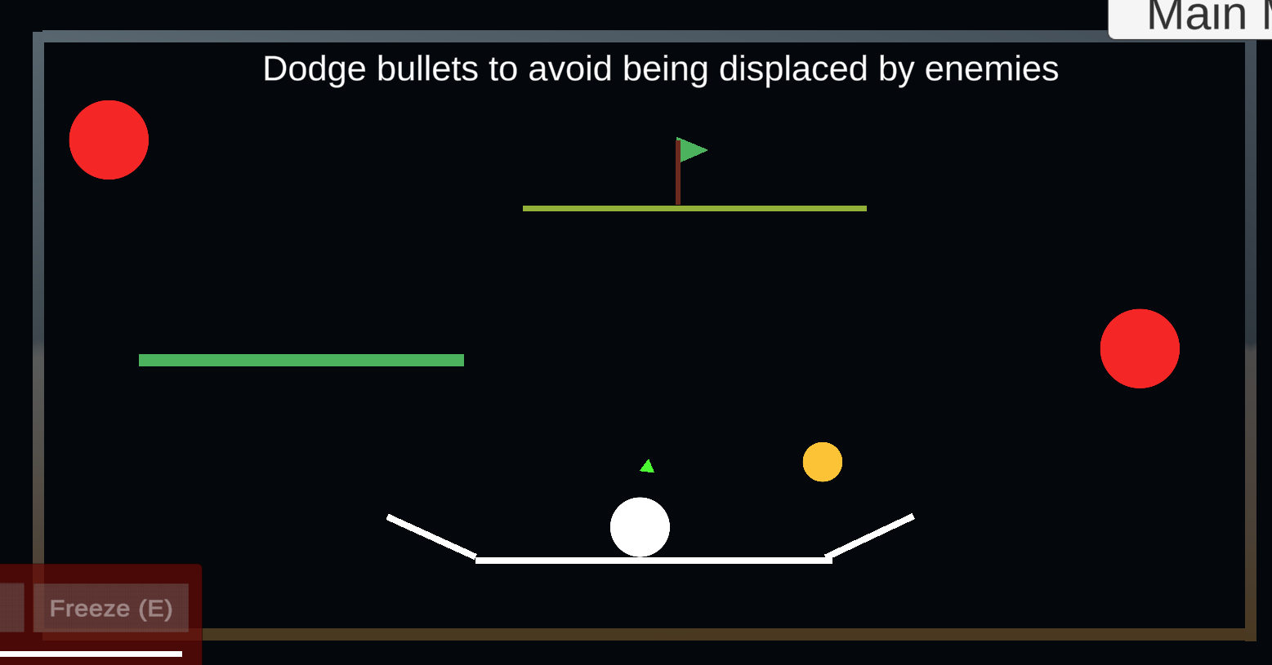

Before

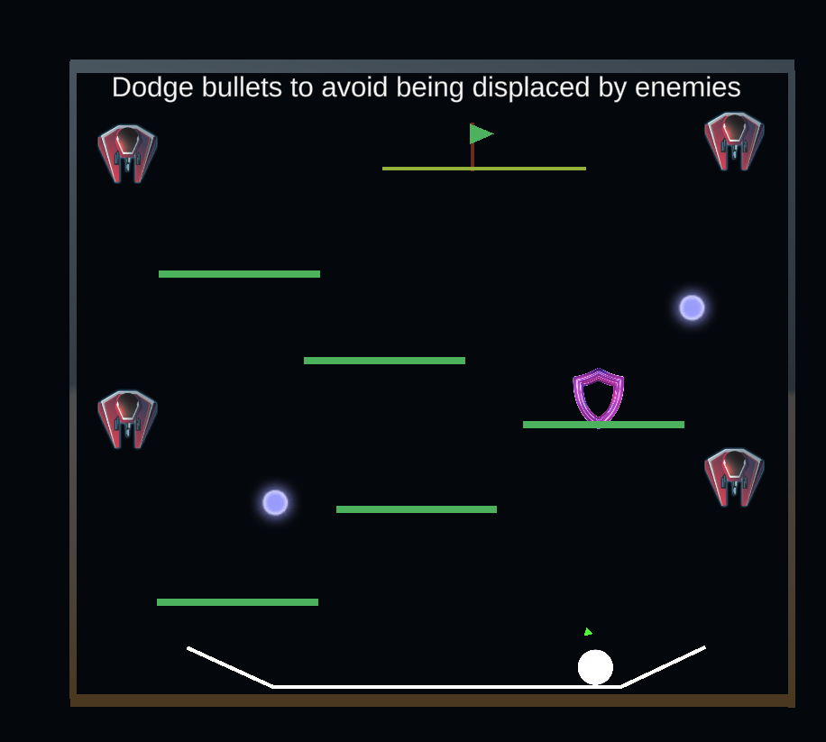

After

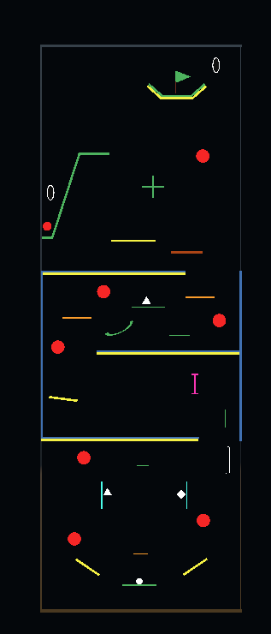

Add the safe border on both sides in the middle of level 4

**Hypothesized Issue #3**

Players did not collect or use the power-ups being provided to them

**Significance**

The power-ups were designed to make the level more fun and easier to complete for a player. However, since players were not collecting these it led to frustration and lesser level completion.

**Feedback/Data points**

* We did not notice many players pick up power-ups or use them during live playtesting. Some players mentioned that they did not notice it
* 7 players mentioned in the beta survey that they did not understand how the power-ups work and that they needed more explanation of functionality
* Analytics show that 68% of the players did not collect the freeze power-up in Level 2
* Analytics show that 54% of the players did not collect the shield power-up in Level 3

**Potential Fixes**

1. Create tutorial levels for the power-ups
2. Add info-text as a pop-up whenever the power-ups are collected so that the player knows when to use it

**Implemented Solution**

We have repositioned the initial locations of the power-ups in early levels to be in the way of the player so that they are forced to collect it once and understand the usage

We have added a tutorial for the shield power-up to show that it automatically activates on collection

We have updated the heads-up display to emphasize which power-ups were collected and how to use the freeze power up

We have redesigned level 4 so that the player has to use the freeze to clear the level

We have added a star system which creates an additional challenge for the player incentivizing them to use the power-ups

Finally we have skinned the power-up to make them more intuitive and added a pulsing feature.

This solution can be tested by creating a graph showing how many power-ups were collected at each level before and after these changes



Tutorial for Shield Power-up

**

HUD without any power-ups collected/activated

** **

HUD with freeze power-up activatedHUD with shield power-up activated

**Hypothesized Issue #4**

Players are able to speedrun the game by turning the map 180 degrees and falling towards the goal rather than interacting with the platforms

**Significance**

The main mechanic of the game is the rotating platforms that have various functionalities. By speedrunning the map, players did not explore the various types of platforms and were often missing easier/intuitive paths that they could take to reach the goal

**Feedback/Data points**

* Staff feedback showed us that the game could be easily completed without the use of platforms or power-ups
* 8 players mentioned in the beta survey that they did not understand what the different platforms were for and 1 even mentioned jumping towards the goal
* Multiple playtesters we saw during alpha and beta playtesting were able to fall towards the goal
* Analytics measuring number of jumps showed 50% of the players take less than 5 jumps to clear levels 1-3 indicating that most players exploit the 180 degree turn
* Analytics showed that players are interacting with less than half of the platforms in each level from 1 - 3, again indicative of speedrunning

**Potential Fixes**

1. Make levels more difficult by blocking the goal and adding more platforms
2. Introduce an incentive for players to stand or touch a platform for more than 1 second

**Implemented Solution**

We added tutorials for the bouncy yellow platform

We blocked the flag area, especially for Level 3

We implemented a star system where players had to explore the map and collect stars only after which the portals towards the flag would be activated. This incentivizes players to interact with the various platforms as well as explore the map. It enhances level design and adds an extra challenge for the player as well.

We also explain the stars mechanism in the portal tutorial to really emphasize the need for collecting them

This can be tested by counting the number of platforms players interact with before reaching the goal as well as the number of jumps taken to complete the level.

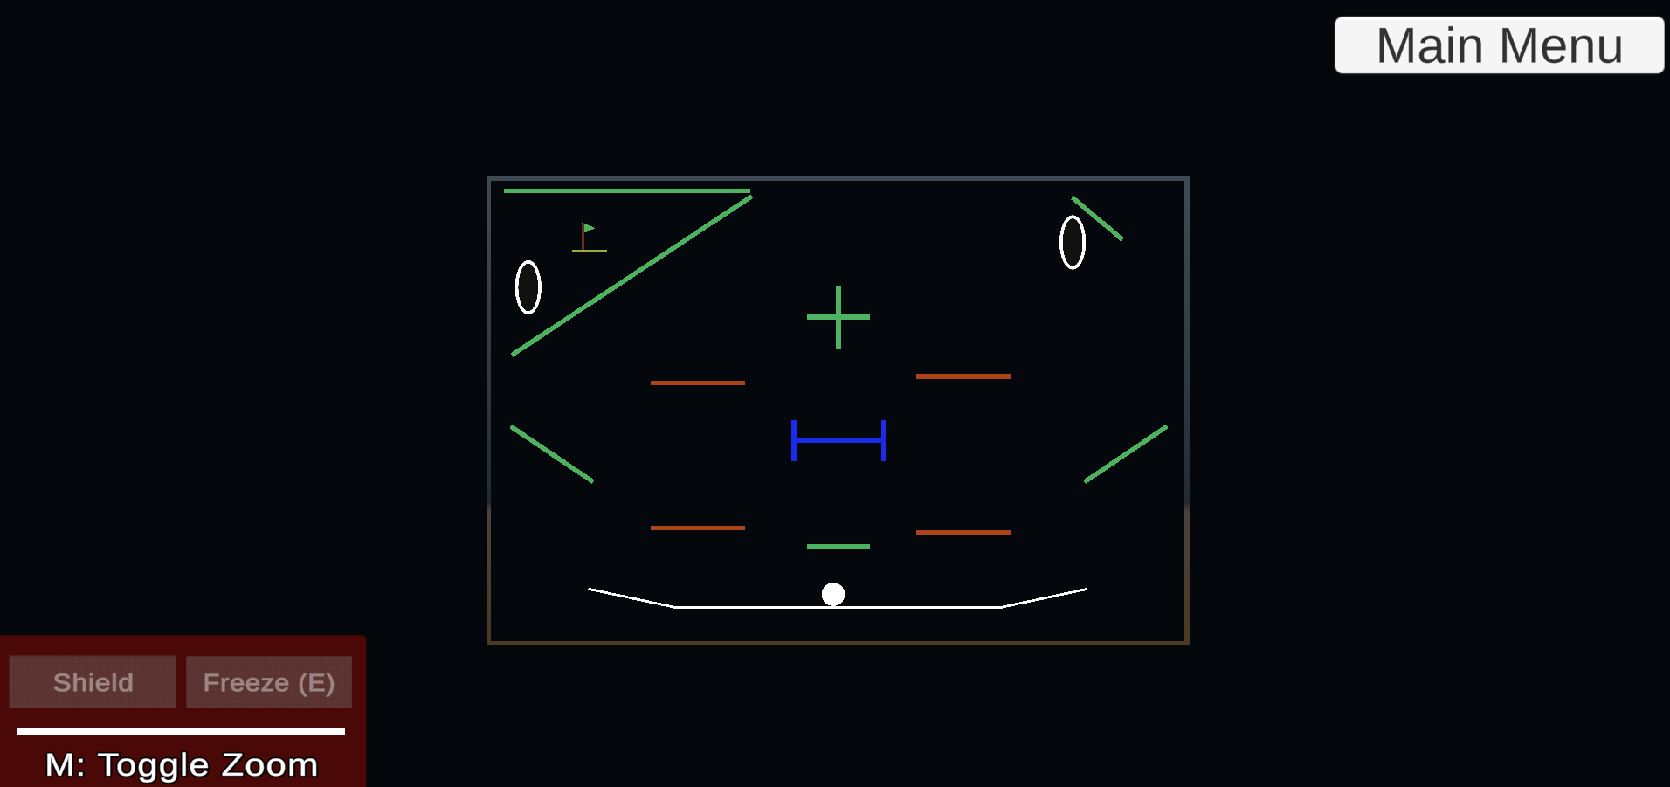

Before

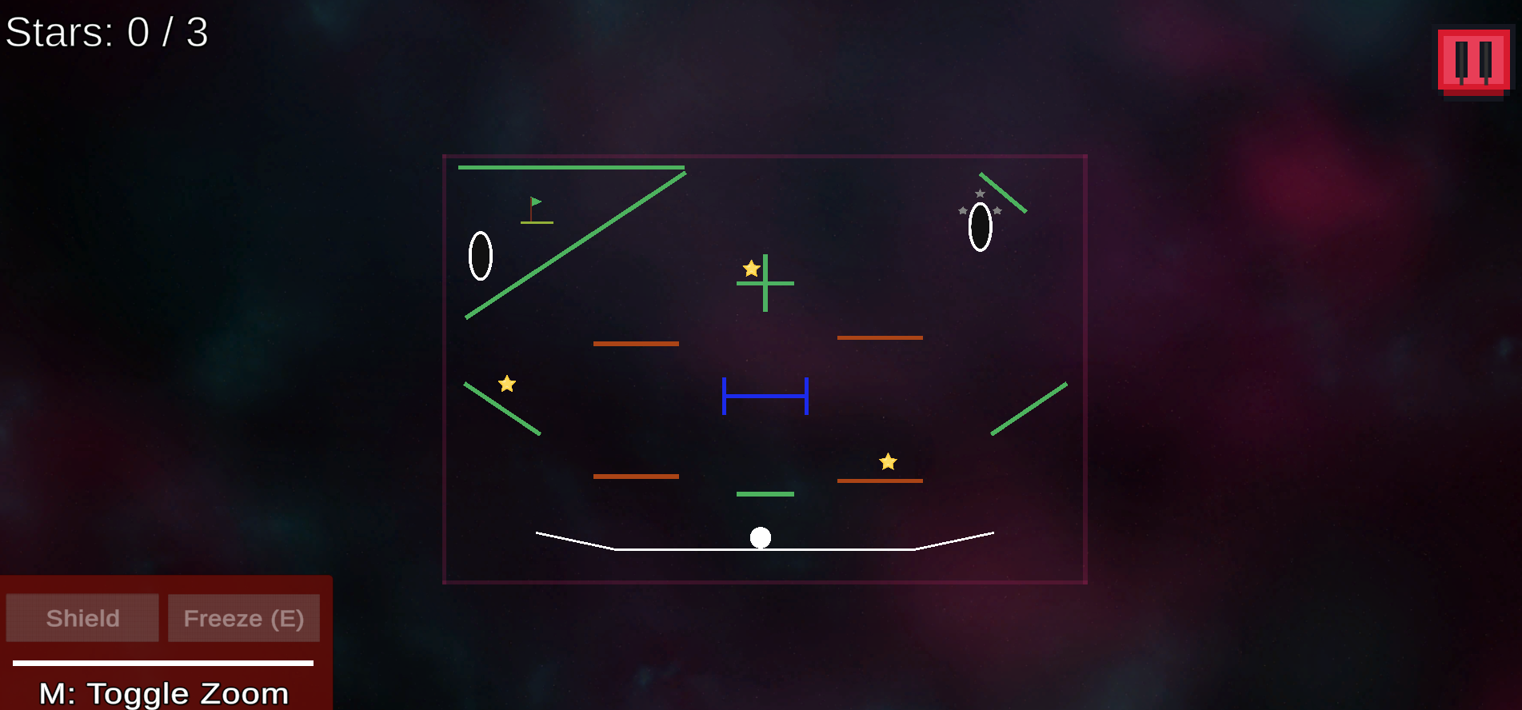

After

# External References

| **Name** | **Link** | **Usage** |
| --- | --- | --- |
| *Menu Background* | [*\*FREE* Skyboxes - Space | 2D Sky | Unity Asset Store*](https://assetstore.unity.com/packages/2d/textures-materials/sky/free-skyboxes-space-178953#content) | *Used for the background of the menu screens* |
| *Level Background* | [*Dynamic Space Background Lite | 2D Textures & Materials | Unity Asset Store*](https://assetstore.unity.com/packages/2d/textures-materials/dynamic-space-background-lite-104606) | *Used for the background of the level screens.* |
| *Freeze Icon* | [*https://www.shutterstock.com/image-vector/freezer-control-icon-automatic-cooling-defrost-2435893837*](https://www.shutterstock.com/image-vector/freezer-control-icon-automatic-cooling-defrost-2435893837) | *Used for the freeze powerup* |
| *Shield Icon* | [*Sheild, protection simple icon. Flat desing. Purple neon on black background.ai*](https://stock.adobe.com/ca/images/sheild-protection-simple-icon-flat-desing-purple-neon-on-black-background-ai/480827191) | *Used for the shield powerup* |
| *Pause and Menu Buttons* | [*https://assetstore.unity.com/packages/2d/gui/icons/2d-simple-ui-pack-218050*](https://assetstore.unity.com/packages/2d/gui/icons/2d-simple-ui-pack-218050) | *Used for the pause and the menu option button* |
| *Star Icon* | [*https://www.freepik.com/premium-ai-image/game-assets-golden-star_61098790.html*](https://www.freepik.com/premium-ai-image/game-assets-golden-star_61098790.html) | *Used for the stars within the levels* |
| *Enemies and Bullets* | [*Space Shooter FREE | Packs | Unity Asset Store*](https://assetstore.unity.com/packages/templates/packs/space-shooter-free-107260) | *Used for the enemy and bullets* |